WEB701 Assessment 1

## Web Technologies Development Project

## Alex Herbert

## 15/07/2025

### 

### Project Brief

###### Charity: Kobra Kai

The Kobra Kai charity is a Food Bank style charity in the Nelson region who offer their free, home cooked meals delivered to people in need in the local community.

We need a website for the Nelson region for members of the charity to provide the free cooked meal delivery.

The purpose of the new website is to help with the distribution of the service or product by members of our charity to customers. Like a “food bank”, the website lets members register and describes the service or products they are providing, the number and frequency of the offerings.

The website lets members of the community (beneficiaries) access the service, by providing tokens that can be “spent” in the service. To achieve our goal, we would like to have an online token function on our website that let a beneficiary access a limited number of tokens, for example the system needs a mechanism that verifies that a member of the community is accessing the service and that the token belongs to a particular community member. The website needs some homepage text about general information of our products and services such as types, characteristics, quality factor, usage and benefit.

We require the following features on the website:

1. Charity members and beneficiaries can register, log in and administer their own accounts.
2. Members use the website to register their products and services, and beneficiaries use the system to acquire tokens.
3. Interactive element(s) that engages the website user.
4. The system provides an interface that the members can use to accept a token in a transaction.

## Short- and Long-term Goals

The following is a list of short and long-term goals that are the focus of the Kobra Kai charity website development project. These goals are intended to guide and direct the decision-making process when designing and implementing the features and functionality of the Kobra Kai website, resulting in a usable, scalable, and well performing platform that can be used by both the charity employees and the beneficiaries.

###### Short-Term Goals

* Launch a fully functional website platform that allows charity members to create an account, and list free home-cooked meals available for beneficiaries to receive.
* Enable beneficiaries in the Nelson region to create accounts, browse available meals, and request/purchase meals using digital tokens or vouchers.
* Allow delivery of cooked meals to beneficiaries from charity members, delivery days are scheduled by the charity members via the charity members dashboard.
* Facilitate efficient communication and transactions between the charity members and the beneficiaries.
* Promote the charity to the Nelson Region, helping to build exposure and audience awareness.

###### Long-Term Goals

* Platform expansion to support additional services such as donations, grocery packs, hygiene products etc.
* Integrate mobile friendly experience or a stand-alone mobile application for easier access.
* Implement automated reporting tools to track meal distribution, business analytics, and beneficiary satisfaction.
* Scale the system for use in other regions as the charity gains popularity and new branches of the charity open in other regions around the country.

## Intended Audience

Due to Kobra Kai being a charity that provides meals to beneficiaries in the Nelson region, the websites audience will vary between contributors and recipients. The following is a list of the potential target audience.

###### Primary Audience

* Beneficiaries from the Nelson region who require access to free, home-cooked meals due to hardship and personal circumstances.
* Charity Members and volunteers of Kobra Kai who donate time, money, resources, and meals to help the community.
* Charity Administration and Staff who work for Kobra Kai and require access to inventory management, donation details, and meal requests from beneficiaries.

###### Secondary Audience

* Social Services and support workers for Work and Income assisting clients in accessing food support.
* Donors or Community partners that are interested in supporting or promoting the charity.
* Developers that are maintaining and developing the platform.

### Website Appeal and Interest

“Why will people visit the website?” is an important question to answer during the design and analysis phase of the project’s life cycle. This can help to drive design decisions and prioritise the important features and functionality that is crucial to launching the platform for use by the public. The following is a list of reasons why certain audiences will visit the Kobra Kai website.

###### Beneficiaries will visit the website to:

* Register their accounts and receive digital “tokens” or “vouchers”.
* View available meals, review dietary information, order meals, and request meal delivery.
* Manage their accounts, track token/voucher balance, and view recent orders/transactions.
* Request information or support from the Kobra Kai’s support team via the websites “About” section.

###### Charity Members will visit the website to:

* Donate produce, resources, and money to the charity using the donation section of the website.
* Manage their user profiles including personal details, business details, and donation details.
* View information about the Kobra Kai charity if they are not currently members of the charity but are interested in donating.

###### Charity Administration Staff will visit the website to:

* View and manage donation requests made by charity members and meal requests made by beneficiaries.
* Track and manage donations made such as produce, money, or time volunteering.
* Answer support requests made by beneficiaries or charity members.

## Defined Kobra Kai Audience

The Kobra Kai Charity has two distinct user/audience groups, the beneficiaries, and the charity members/staff. Defining the audience for the Kobra Kai charity website is crucial the features and functionality that is expected by the users of the platform, this will help make informed decisions during the analysis, design, and development phases of the project’s life cycle.

#### Beneficiaries

###### Demographic – Individuals or Families in the Nelson region experiencing financial hardship.

*Technical Proficiency* – Proficiency varies from low to moderate technical abilities and experience, platform interface must be simple, mobile-friendly, and accessible.

*User Needs*

* Easy registration/login process.
* Account management and order history.
* Clear display of available services and meals.
* Token tracking and balance display.
* Privacy and data security must be compliant with New Zealand privacy law to promote trust in the platform/charity.

#### Charity Members

###### Demographic – Local community volunteers, hospitality businesses, and charity partners.

*Technical Proficiency* – Moderate to High technical skills.

*User Needs*

* Ability to register, login, and manage charity member accounts.
* Interface to list meals/services provided (description, quantity, delivery schedule).
* Token redemption/order confirmation process.
* Communication and transparency with beneficiaries.

### User Scenarios

###### Scenario 1

Aroha is a single mother of two that lives in the Richmond area and has recently been made redundant from her job. She is investigating the type of assistance she can receive online and finds the Kobra Kai website during her search. After reviewing the services available on the Kobra Kai website, she registers for an account and receives 10 tokens to be used to purchase meals from the charity providers. She browses the available meals on the website and orders a Roast Beef meal from one of the charity members, the order is placed using 1 of the tokens. The website confirms her purchase, places the order with the charity member business, and the meals are delivered later that evening.

###### Scenario 2

Jackson is a father of two and husband to Jennifer, he has recently been experiencing hardship due to a lack of work available in his profession as an orchard foreman. He is looking into how he can get support from the local community for him and his family online and discovers the Kobra Kai charity website. He browses the websites available services and decides to create an account with Kobra Kai. After registering for an account using his community services number, he receives 10 tokens to be used to order meals. Jackson browses available meals from the charity members and chooses to order three of the Lamb Shank meals from one of the local restaurants, he is charged three tokens from his account balance, the order is confirmed, and the order is delivered later that afternoon.

###### Scenario 3

Mike is a retired Chef and has been living and working in the Nelson region for the past 15 years, he wants to give back to the community using the skills he has acquired during his career. He discovers the Kobra Kai website and after reviewing the services available, he registers for a Charity Member account. Once he has entered his details and the account registration is completed, Mike lists 10 roast chicken meals that he has prepared for donation. The system allows him to specify what days he is available for delivery, so he sets the delivery days to Monday, Wednesday, and Friday. When beneficiaries use their tokens to order meals from Mike, he receives a notification with the beneficiaries’ delivery address, and marks the meal as delivered once the order has been fulfilled.

###### Scenario 4

Tania, a social service worker for WINZ, helps multiple families to get set up to use the Kobra Kai services. She uses the website’s public-facing information to understand how it works, then assists families and individuals experiencing hardship to register for an account and shows them how to use the tokens they are provided. She also coordinates with the Kobra Kai charity staff and administration team by giving them feedback she receives from beneficiaries via a contact form on the website.

## Competitive Analysis

To fully understand the Kobra Kai website functionality and user experience, analysing other competing charity organizations websites will help to inform better design decisions for this project. This process will reveal design choices and functionality being used by other charity web platforms that can be utilized in the Kobra Kai website project, resulting in a more defined set of functional requirements and better user interface designs.

#### Competitor 1 – Foodbank NZ

###### Website URL - <https://www.foodbank.co.nz>

Foodbank NZ is a online directory for all the foodbanks in New Zealand, it provides users with a easy to navigate interface that can be used to discover foodbanks in each region, town, and city in New Zealand. Users can find the contact details for each foodbank, as well as find information and criteria on how to apply for food parcels. Users that wish to donate or promote specific food banks can do so via a payment portal that is available on the websites interface.

###### Features

* Serves as a directory for local Foodbanks in each region in New Zealand.
* Foodbanks searches can be selected by region and then filtered by city/town.
* Provides users with information on how to apply to receive food parcels from the selected food banks.
* Allows users to donate via debit/credit card to the foodbank services.
* Advertising sponsorships are available to donors to help promote a specific foodbank.
* Foodbank details are displayed for each town/city, allows users to contact them directly, or to visit the physical location.

###### Strengths

* Centralized directory of foodbanks across New Zealand.
* Basic, and easily navigable website interface.
* Donations are made easy via a payment portal that is linked directly to the website.
* Foodbank information is easily accessible.
* Information regarding applications for food parcels is clear, easy to find, and provides adequate details on who is eligible for support.

###### Weaknesses

* No online interaction with the Foodbanks via the website, users must contact the Foodbanks through other means.
* Limited information on the food that is provided by the foodbanks on the website.
* No token or voucher functionality is implemented allowing users to order food parcels via the website.

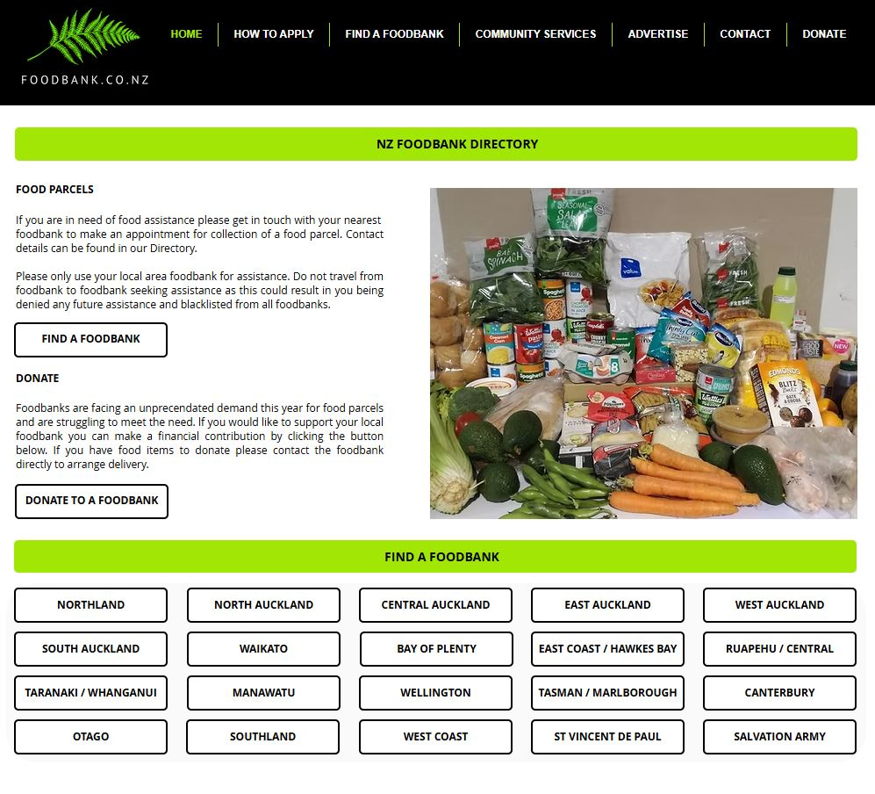

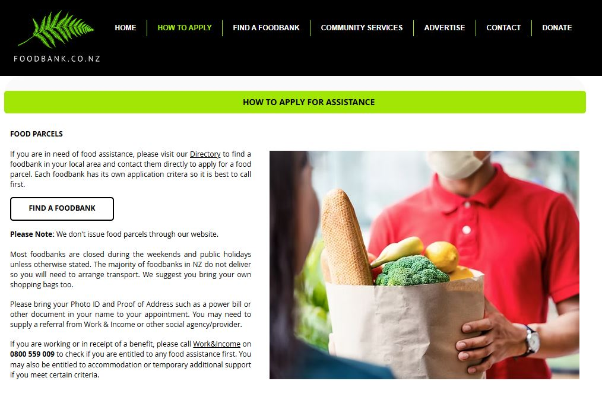

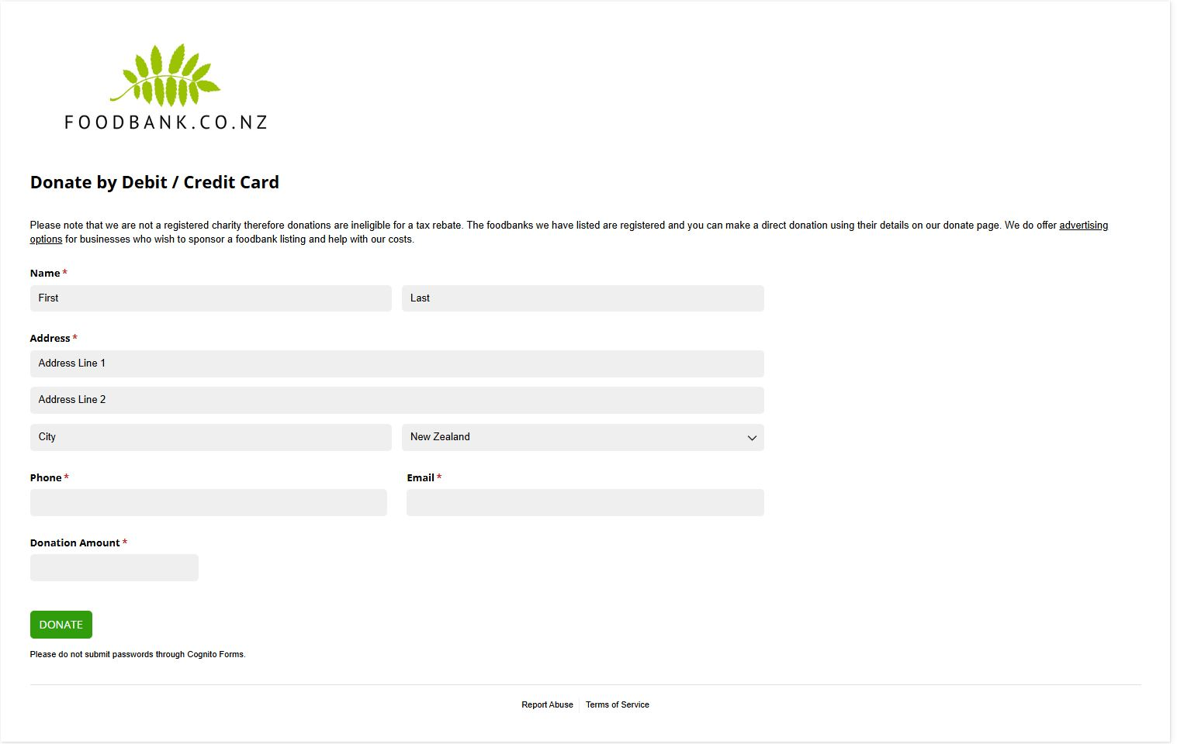

(Images taken from Foodbank NZ website. <https://www.foodbank.co.nz>)

#### Competitor 2 – Bellyful

###### Website URL - <https://bellyful.org.nz>

“*Bellyful is a volunteer-led charity nourishing whānau and connecting communities by delivering free meals to families with babies and young children who are without a support network.*” (Bellyful. 2025.)

Bellyful is a nationwide charity organization that provides families with babies, or children under the age of 12, in need of support due to financial hardship or difficult life circumstances with healthy, homecooked meals free of charge. The meals are delivered to the beneficiaries by the charity and is well supported through funding, donations, and grants given by community organisations.

###### Features

* Comprehensive information about the charity and how it operates is provided to the user on the website.
* A full list of the Bellyful branches is made available via the website’s navigation.
* Support request forms are available to the user via the website for each branch.
* Users can order/requests meals directly from the website interface, additional contact with the charity is made to confirm the requests.
* Donations are made possible via the website donations page; payments are made via Stripe without needing to be redirected from the website.
* Website is easy to understand and navigate.

###### Strengths

* User interface is engaging, easy to navigate, and contains concise information regarding the charity’s operations and goals.
* Website content includes translations in Te Reo Māori, some are bi-lingual by default, such as the navigation bar, allowing native language speakers to be included.
* Request forms and Donation forms are comprehensive, easy to understand, and provide users with multiple options about how they wish to be contacted and receive/donate support.
* Bellyful branches are easily discoverable and accessible via the website navigation.
* Call to Action buttons are bright and highly visible to the user, making navigating the website easy for all users.

###### Weaknesses

* Some of the website “About” and “Get Involved” pages are quite verbose and contain a lot of information that may not be relevant to the beneficiaries. It can be overwhelming when searching for specific information.
* Website does not contain a search functionality, allowing users to quickly find the services/branch they are looking for.
* The addition of Te Reo in the website navigation can make finding specific services or pages difficult due to additional text in navigation drop down menus. This could be improved via having the website translation optional for all the website content and not having Te Reo as a default in some website elements.

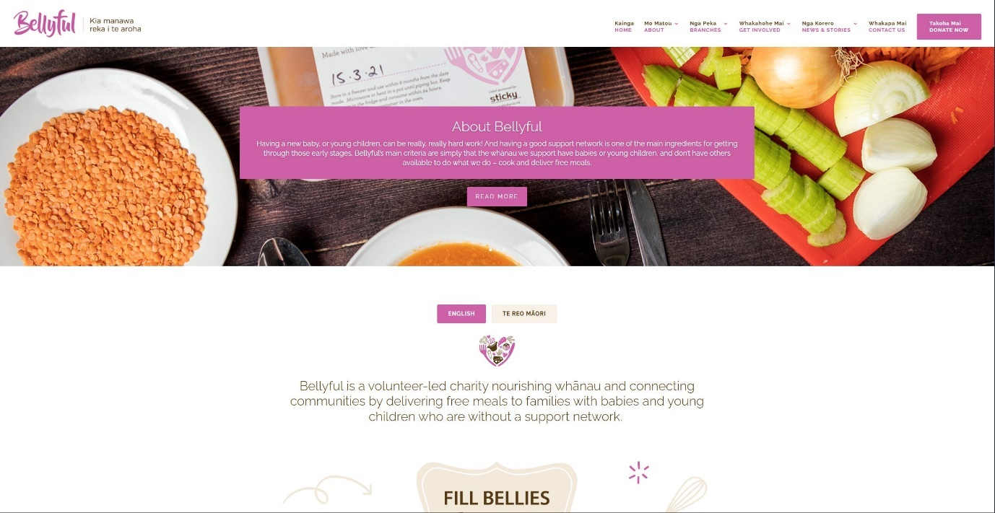

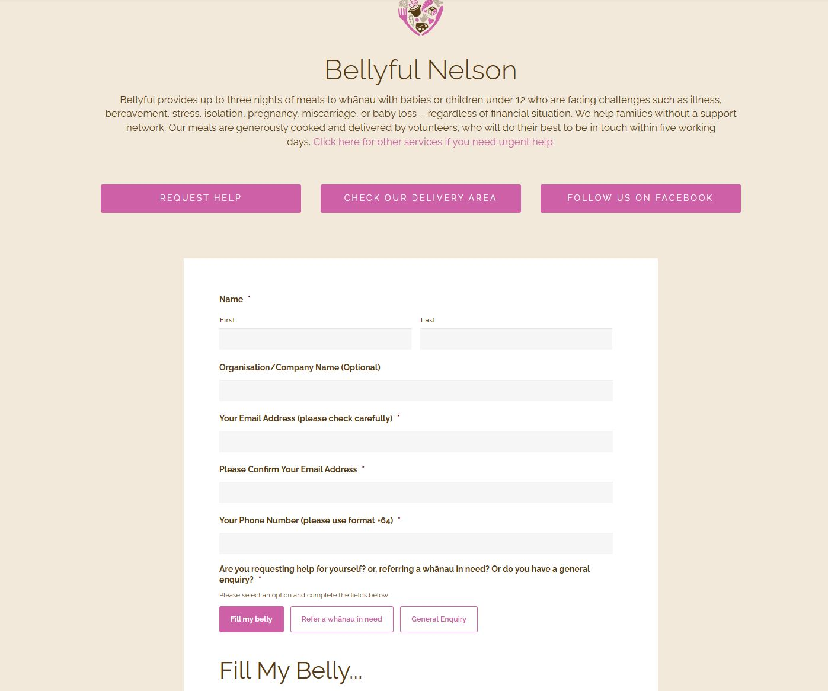

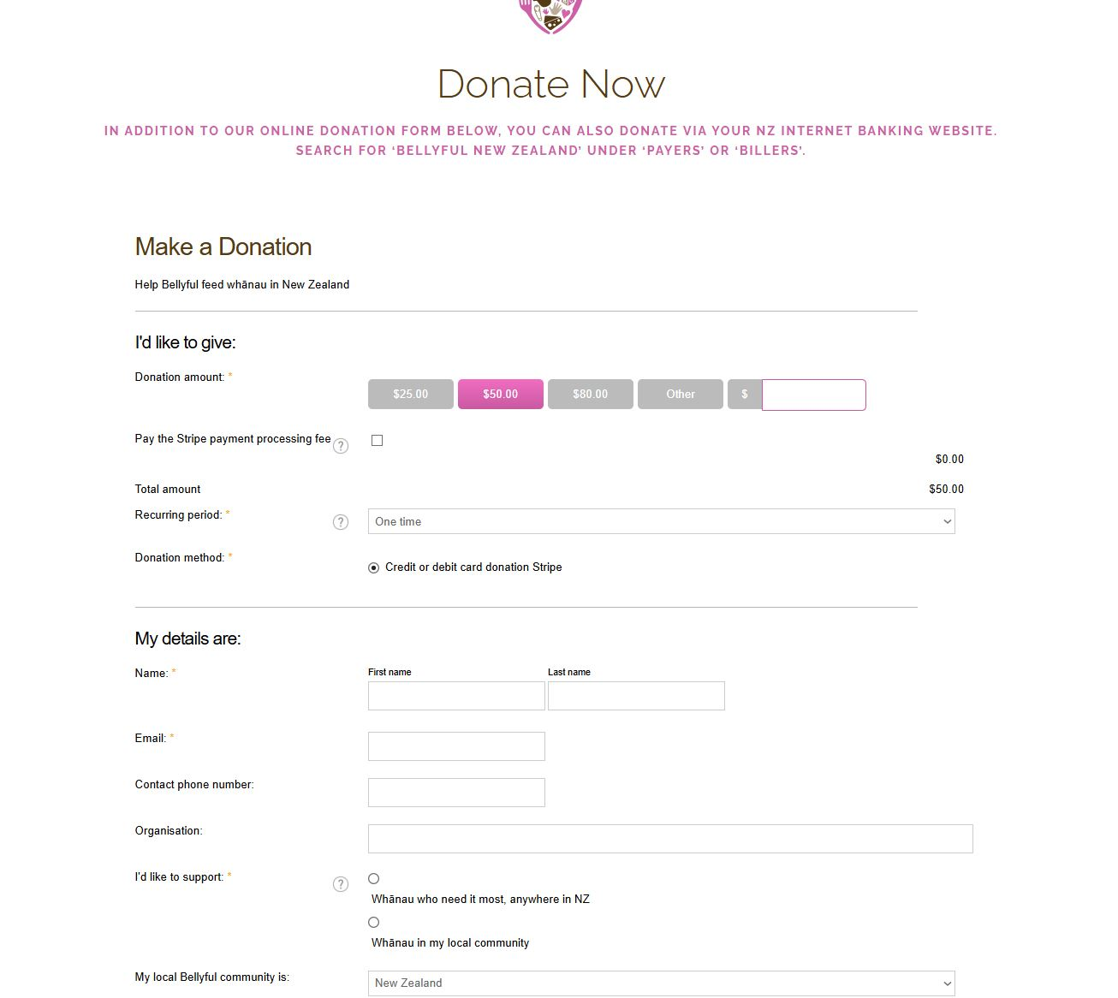

(Images taken from the Bellyful website. <https://bellyful.org.nz>)

## Website Content

The following table outlines each page of the website, and the expected content on each page, this will be used to inform design decisions, functionality, website navigation, and the content that is expected to be displayed.

|  |  |
| --- | --- |
| ***Page/Section*** | ***Content Description*** |
| Home page | Overview of the Kobra Kai charity’s purpose, mission/goals, services offered, beneficiary testimonials, how it works, and a call to action for user account registration and donation. FAQ’s are located at the bottom of the home page. |
| Meals Page | Displays charity member businesses/organizations with available meals, each member business/organization meals that are available with detailed dietary information, quantity available, delivery schedule, ordering form/functionality with token exchange. |
| About Page | Background and origin of the charity, future vision, meal delivery system information, charity member/donor details. Contains Privacy Policy, terms of service, and Legal information. |
| Contact Page | Charity details, contact form, email address, phone number, physical location charity office address. |
| User Login/Registration | Forms for entering user credentials for login, registration form for new account creation. |
| Account Management | Beneficiaries account information, token balance, order history. Charity Members account information, meal details/management, delivery orders/history. |

## Functional Requirements

The following is a list of the expected functionality and features of the Kobra Kai website platform, these will be used by the developers to design and develop the website’s functionality as well as the code implementation.

#### Functional Requirements

###### User Account Registration and Management

* Both User types (beneficiaries and charity members) must be allowed to create accounts and login to their accounts using a secure authentication interface.
* Two registration forms must be implemented, one for each type of user, containing the fields that are required by the business for both types of users.
* Beneficiary Users must be able to view and manage their account information from an Account Management Dashboard, this includes token balance, order history, and account information update/deletion features.
* Charity Members must be able to manage their account information and the “Meal” information that they have available; this includes CRUD operations for meal details, quantity, dietary information, and delivery schedule from the Account Management Dashboard.

###### Browsing, Ordering, and Managing Meal Delivery

* Beneficiary Users must be allowed to browse Charity Member Businesses, available meals, dietary information, quantity available, and order meals using tokens from the “Meals” page on the website user interface.
* Orders made by beneficiaries must display an order confirmation message.
* Beneficiary Token balance must be updated after orders have been placed.
* Charity members must have new orders added to their “Pending Orders” section of the Account Management Dashboard upon order confirmation.
* Charity Members must be given the option to fulfil the order upon delivery, adding the order to the “Completed Orders” section of the Account Management Dashboard.
* Charity Members and Beneficiaries must be given the option to cancel an order due to unavailability, mistakes, or errors.
* Beneficiary delivery information such as addresses and preferred delivery dates must be included in the Order information that is displayed to the Charity Members in the Account Management Dashboard.

###### System Level Functionality

* The system must contain and API that handles http requests and responses, this API serves the front-end user interface with the content for each page and handles the requests for Ordering and Account management/authentication functionality.
* The system backend must contain a database that stores the platforms data securely and efficiently, data retention policies must comply with New Zealand Privacy law.
* The system must use JWT (JSON Web Tokens) to encrypt/decrypt user credentials for a secure login and authentication process.
* Backend logic must contain CRUD operations and functionality that is inline with the features and functionality of the front-end user interface.
* Service/business logic must validate user inputs and requests from the front-end user interface input, and handle errors and invalid inputs gracefully, displaying error messages to the user with details and suggestions for correct input requirements.

#### Non-Functional Requirements

###### User Interface

* The User Interface must contain website navigation that is easy to use for all skill levels, be direct and descriptive, and viewable from each page on the platform.
* Website design, colour scheme, fonts, and content placement must be readable, easy to navigate, and representative of the Kobra Kai charity marketing/branding.
* Buttons and Call to Action elements of the user interface must be easily noticeable, descriptive of the actions they invoke, and clickable by the user.
* Website content must be clearly displayed, relevant to the page that is describing, and make sense to the user.
* Charity Member information must be viewable and displayed to the user clearly as part of the “Meals” page.
* Dietary information for meals must be displayed for each meal that is available for order/delivery.
* Beneficiaries Token balance must be displayed on the user interface whilst browsing for available meals.
* Confirmation messages and Error messages must be clearly displayed to the user and contain relevant information that informs the user of the completed/incomplete action.
* The interface should comply with accessibility best practices (ARIA roles, alt text) and render effectively on mobile devices.

###### System Level Requirements

* The system must be designed and implemented to accommodate scalability for future growth of the charity.
* The system must have high levels of performance, fast loading times, and handle user traffic when being used by 100-200 users simultaneously.
* The performance of the system must be optimized to allow for future growth of the charity and is expected to reach 1000 concurrent users in the future.
* The database must be able to handle multiple transactions simultaneously without hindering performance.
* Data transfer must be secure and encrypted to ensure high levels of security and to protect users’ data from potential interception and cyber-security threats.

## Site Content Groups and Labelling

To make sure that the Kobra Kai website has an intuitive and accessible user experience, the content for the website is grouped into logical categories based on the user roles and common tasks that will be performed. These groupings are labelled with clear, user-friendly navigation terms that match the expectations of the users and the Kobra Kai web platforms goals.

###### Main Navigation Structure and Labels

|  |  |  |
| --- | --- | --- |
| ***Navigation Label*** | ***Group*** | ***Description*** |
| Home | General | Introduction to the Kobra Kai charity platform, overview of the services provided, calls to action (Register/Login, Order), beneficiary testimonials. |
| Meals | Beneficiaries | Displays the available meals from each Charity member available to order, sorted by the provider and contains dietary information. |
| About | General | Charity background, founders, and origin story, mission, vision, goals, privacy policy, and legal disclaimers. |
| Contact | General | Kobra Kai contact information such as phone, email, address, and opening times. Donation and Support details are also located here. |
| Login/Register | Authentication | Login and Registration forms for both User types. Allows users to login, and/or register for an account. |
| Dashboard | Authenticated Users | Account Management Dashboard containing User details, Orders (current and pending), token balance, and meal/order management for Charity Member users. |

###### Account Management Dashboard Content Grouping

|  |  |  |
| --- | --- | --- |
| ***User Role*** | ***Dashboard Sections*** | ***Description*** |
| Beneficiary | * Token Balance * Order History * Personal Details * Delivery Details | Contains the beneficiaries account details (updateable), tracks current/completed orders, displays token balance. |
| Charity Member | * Meal Details * Pending Orders * Completed Orders * Delivery Schedule | Allows Charity members to view/add/modify/delete available meals, manage delivery schedule, and view current/completed orders. |

###### Footer Content

|  |  |
| --- | --- |
| ***Navigation Label*** | ***Description*** |
| FAQ’s | Directs the user to the FAQ’s section on the Home page. |
| Privacy Policy | Directs the user to the Privacy Policy on the About page. |
| Terms of Service | Directs the user to the Terms of Service on the About page. |
| Donate/Support | Directs the user to the Donation/Support information on the Contact page. |

## Site Structure – Metaphor Exploration

To create a logical, intuitive, and memorable user experience for the Kobra Kai’s charity website, three types of metaphors have been established and investigated. These metaphors are the Organizational, Functional, and Visual metaphors. These metaphors are designed to map a real-world scenario and relate that to the websites structure, functionality, and how it is interacted with by the Users. These will help to guide the platforms’ structure, features, and visual presentation, making it easier for the users to understand and navigate the website.

#### Organizational Metaphor – “Community Centre”

The Kobra Kai website has been organised in a similar way to a Community Centre, where members of the community come together to either offer or receive help and support. The community centre acts as a centralized location for services, events, and support for beneficiaries or charity members are located or directed from.

The navigation of the website is also organized to direct the users to the correct sections that they are interested in exploring, much like the signage in a community centre that directs people towards the services/support desk that they wish to interact with.

Just like a community centre has various rooms for different purposes, the Kobra Kai website has been separated into different sections that are relevant to the type of service or feature that it provides. For example, the home section acts as the entry point for the user, much like the reception/entrance way of a community centre. The Meals section of the website shows the different services and meals that are available to the user and allows them to order or request those services, much like an office or service desk dedicated to organizing and supplying food packages in a community centre.

Each User has a “space” where they interact with the system or platform, charity members have their own dashboard where they manage their available meals, much like an office or service desk in a community centre. The beneficiaries interact with the system via ordering meals or managing their account information, much like interacting with a representative or service desk at a community centre.

#### Functional Metaphor – “Marketplace / Foodbank Counter”

Functionally, the Kobra Kai’s website operates much like a digital food bank or marketplace, where beneficiaries can redeem/order meals using tokens they are provided, much like the real-world counterpart being a Foodbank or marketplace located at a physical location.

The beneficiaries spend their ‘tokens’ in exchange for meals from the charity members, much like how food banks distribute food parcels to people in financial hardship or difficult circumstances, or how marketplaces facilitate transactions between suppliers and recipients. The charity members “stock the shelves” with available meals, update the availability, and confirm when meals are delivered, much like how suppliers or wholesalers distribute produce to businesses/marketplaces.

The token system that is implemented into the Kobra Kai’s website system, mimics the real-world currency transactions between businesses and customers or coupon systems used in charitable organizations. Whilst this is not a real currency, it is being used to facilitate and limit beneficiaries order meals from the charity via the online platform.

#### Visual Metaphor – “Restaurant Menu Board”

Visually, the Kobra Kai website acts as a digital “menu board”, much like the ones placed on the walls of restaurants to display the available menu items they are serving. The Meals page/section of the website emulates this concept into a digital format, where the users can browse the menu of available meals and choose the ones they wish to be ordered and delivered. This digital menu also contains details and information about the food’s dietary components, and quantities that are available to order, much like a real-world menu that you would see in a restaurant.

Icons and cards are used in the digital menu to display the different food items, and their suppliers, much like dishes are displayed on a restaurant menu, allowing the user to view what they are ordering prior to its delivery. The tokens that are used to order the meals from Kobra Kai, emulate a real-world implantation of Point-Of-Sale (POS) system that you would find in a business or restaurant, the digital version of this is the transaction of tokens taken from the users account balance, and transferred to the Charity in order to complete the order.

## Website Structure Listing

To being understanding the Kobra Kai website structure and navigation, mapping out the pages and page content is crucial for designing the websites page hierarchy. Using this hierarchical map of the website, the navigation can be fully understood and then translated into the website’s architecture designs, and eventually, the implementation of the pages and navigation during the development process. The following is the text-based hierarchical map for the Kobra Kai website project.

#### Home

* Hero Section – mission, call to action.
* Overview of the Kobra Kai services.
* Beneficiary Testimonials section.
* “How it Works” infographic section.
* FAQ’s preview and links.
* Footer Links (Privacy, TOS, Contact).

#### Meals

* Ordering Information/Overview.
* Meal Providers Listing/Info.
* Meal Listings from each Meal Provider.
* Order Meal Button/Call to Action.
* Token Balance.

#### About

* Charity Background and Biography.
* Mission and Goals section.
* Meal Delivery System Explanation.
* Charity Members/Staff section.
* Privacy policy.
* Terms of Service.

#### Contact

* Contact Form.
* Phone and Email details.
* Office Address.
* Donation/Support information.
* Additional Support Information.

#### Registration/Login

* Login Form (using authenticated credentials).
* Registration Form (Beneficiary).
* Registration Form (Charity Member).

#### Account Dashboard

###### Beneficiary

* Account Details (Add/View/Update/Delete).
* Order History/Current Orders.
* Token Balance.

###### Charity Member

* Manage Meal Listings (Add/View/Update/Delete).
* View Orders (Current/Pending).
* Delivery Schedule (Add/View/Update/Delete).
* Account Details (Add/View/Update/Delete).

#### Footer

* FAQ’s
* Donate / Support Us.
* Social Media Links.
* Contact Information.
* Privacy/TOS.

## Architectural Blueprints

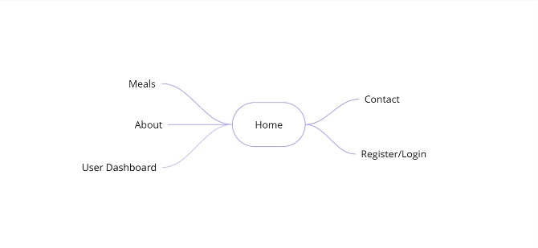The following diagram is a visual representation of the website’s pages, hierarchical structure, and the navigation links starting from the homepage. This diagram will be used to help organize and understand the websites page content and tasks needed to be completed during the development phase, as well as providing insight into the CRUD operations that will need to be conducted for each section of the website.

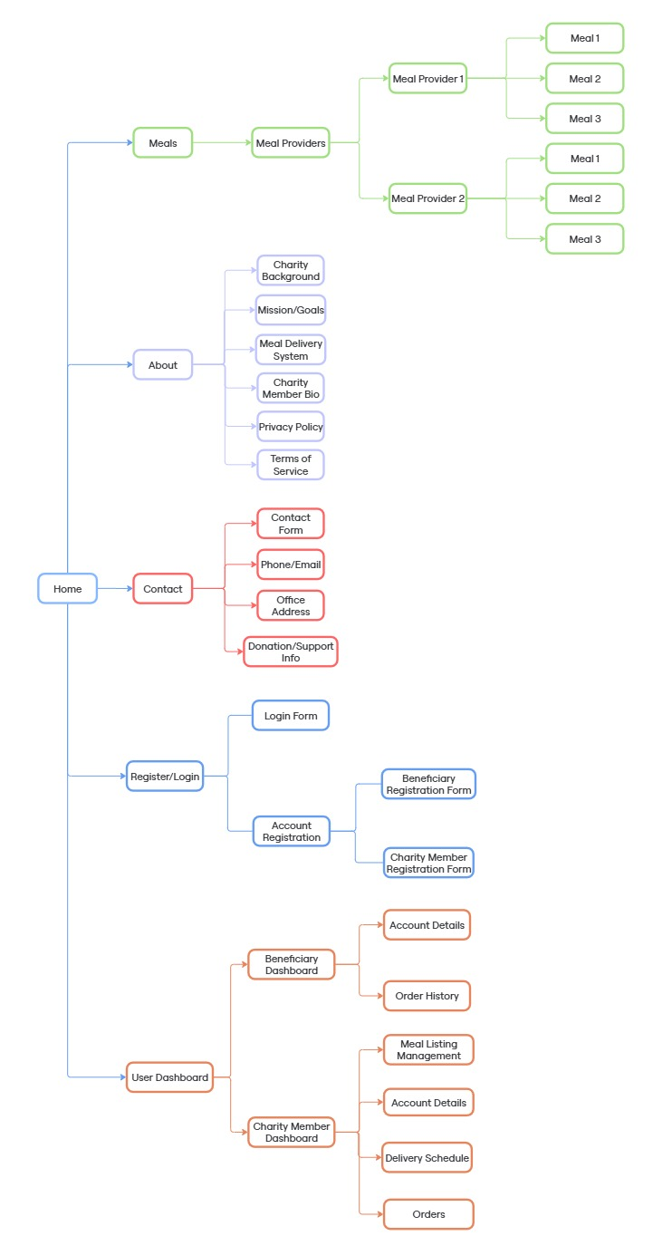

## Global and Local Navigation Definition

To provide a consistent user experience, the Kobra Kai website implements a combination of Global and Local navigation for site-wide access and role-specific/context specific tasks that will be performed by the user.

###### Global Navigation

The Global Navigation is persistent across all the user-facing interfaces in the form of the navigation bar and footer, this provides access to the primary sections of the website and supports the movement between the key areas of the website for all user types.

Global Navigation Bar (located in the header)

* Home
* Meals
* About
* Contact
* Login/Register (User Dashboard if already logged in).

Global Footer Navigation

* FAQ’s (navigates to the FAQ section on the homepage).
* Privacy Policy.
* Terms of Service.
* Donate / Support Us
* Social Media Links.

###### Local Navigation

The Local Navigation is role-specific and is dependent on the user’s account type (Beneficiary or Charity Member), this provides access to the actions that are relevant to their user type. This will be in the form of Dashboard Navigation and Meal ordering as each user type has a different view available to them.

Local Navigation for Beneficiaries

* View Token Balance.
* Order History/Current Orders.
* Update Personal/Account Details.
* Browse/Order Meals.

Local Navigation for Charity Members

* Manage Meal Listings.
* View Pending / Complete Orders.
* Update/Manage Delivery Schedule.
* Manage Account Details.

The User types will dictate the types of functionalities that are allowed for either global or local navigation. The different user types (beneficiary or charity member) will require different hierarchical navigation structures to display different views and features of the Kobra Kai website platform.

## Visual Design

The following page mock ups and grid layout designs have been created to provide the developers with an initial starting point to begin to implement the websites features and functionality. These designs will be used as a style guide, containing the websites colour scheme, font style, and image references as well as the over all structure of each page.

### Low Fidelity Grid Layout Designs

#### Home Page

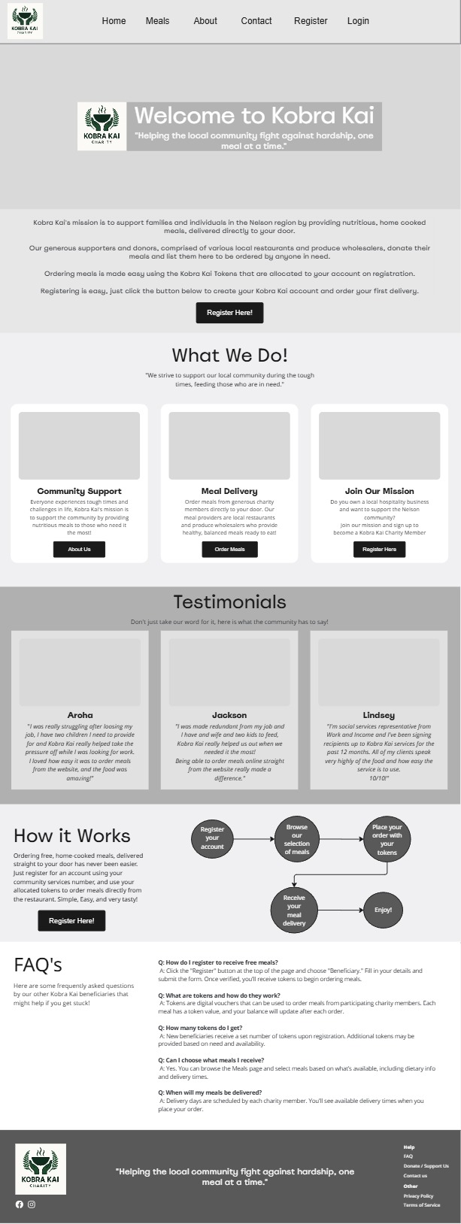

#### About Page

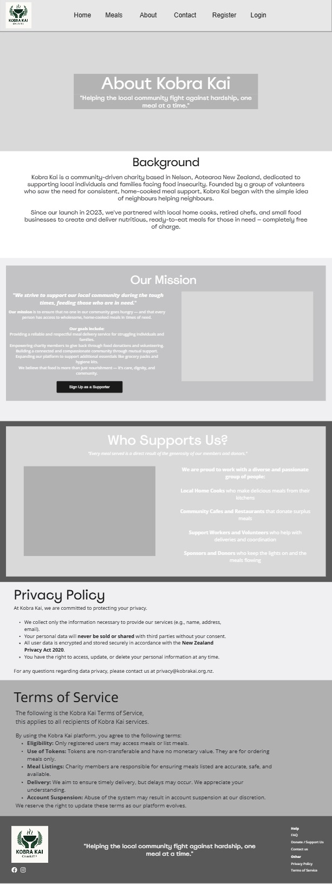

#### Meals Page

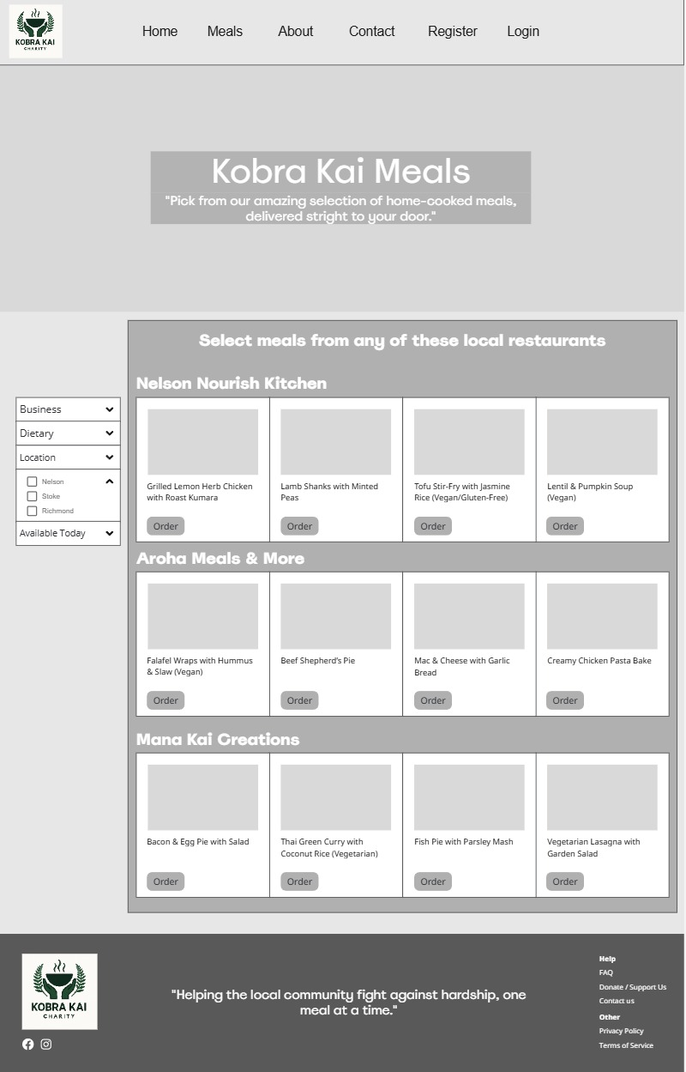

#### Contact Page

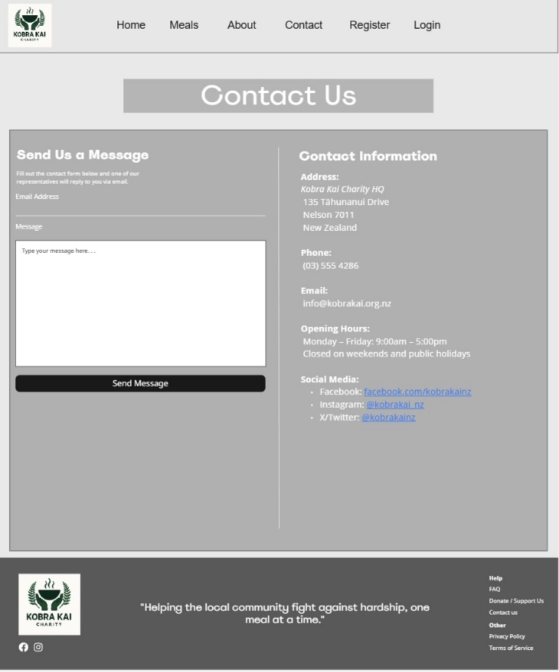

#### User Login Page

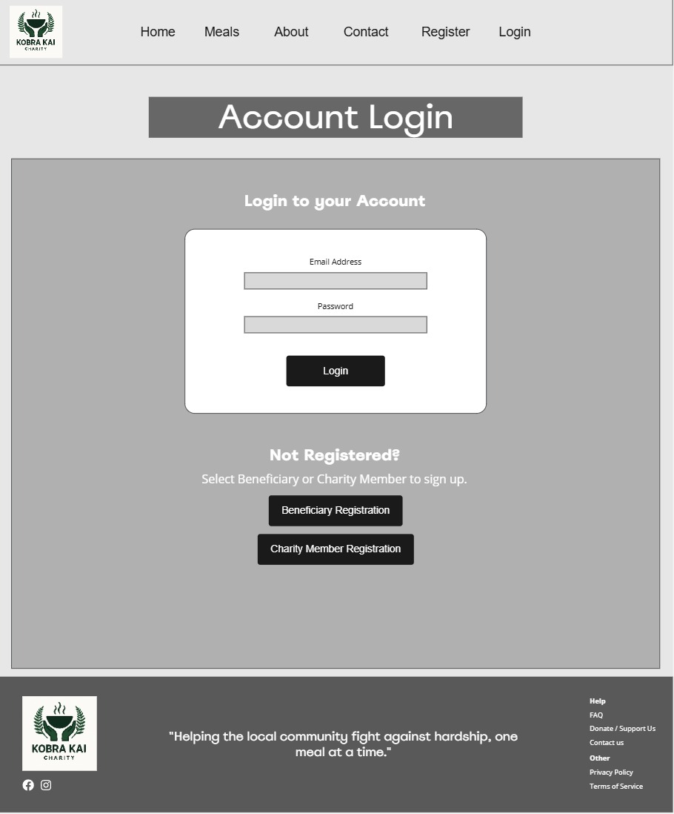

#### User Registration (Beneficiary View)

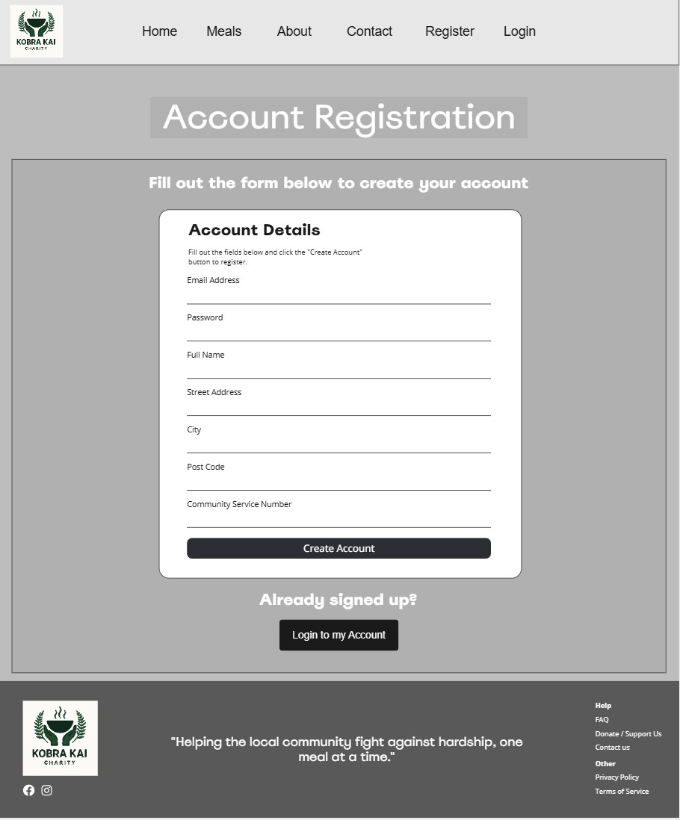

#### User Registration (Charity Member View)

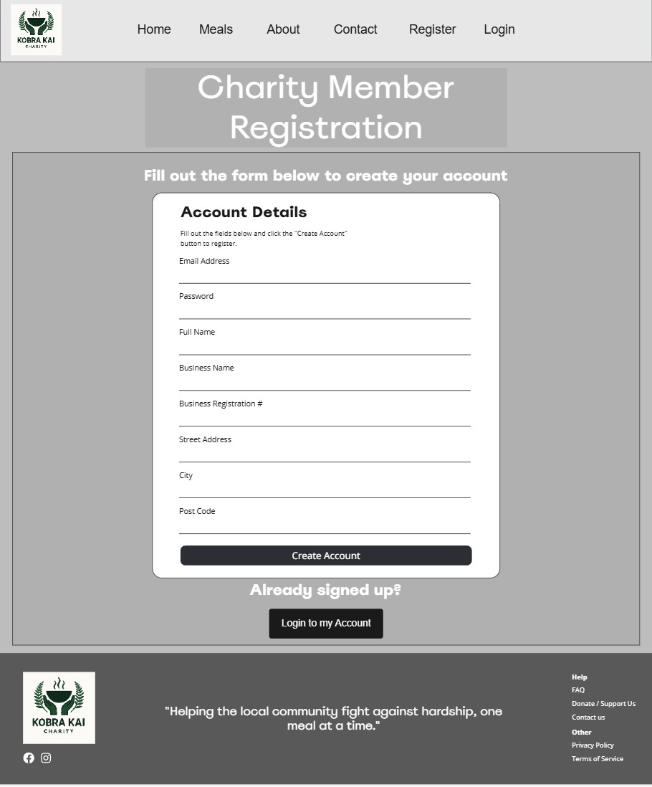

#### User Account Dashboard (Beneficiary View)

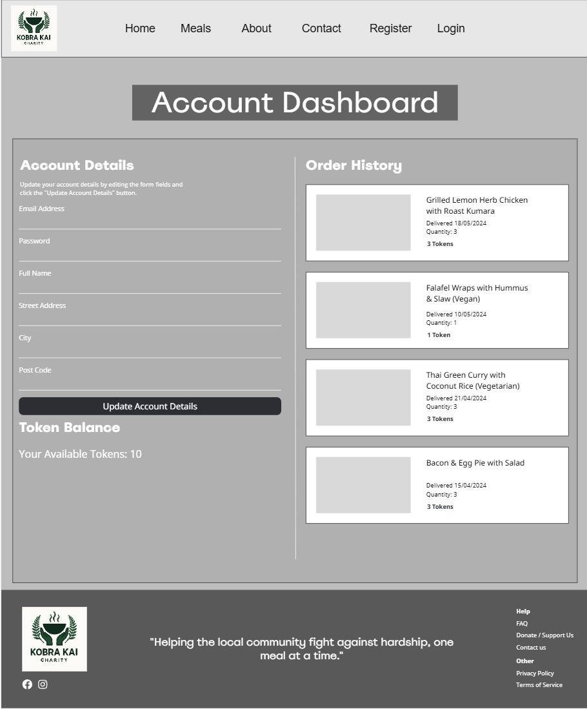

#### User Account Dashboard (Charity Member View)

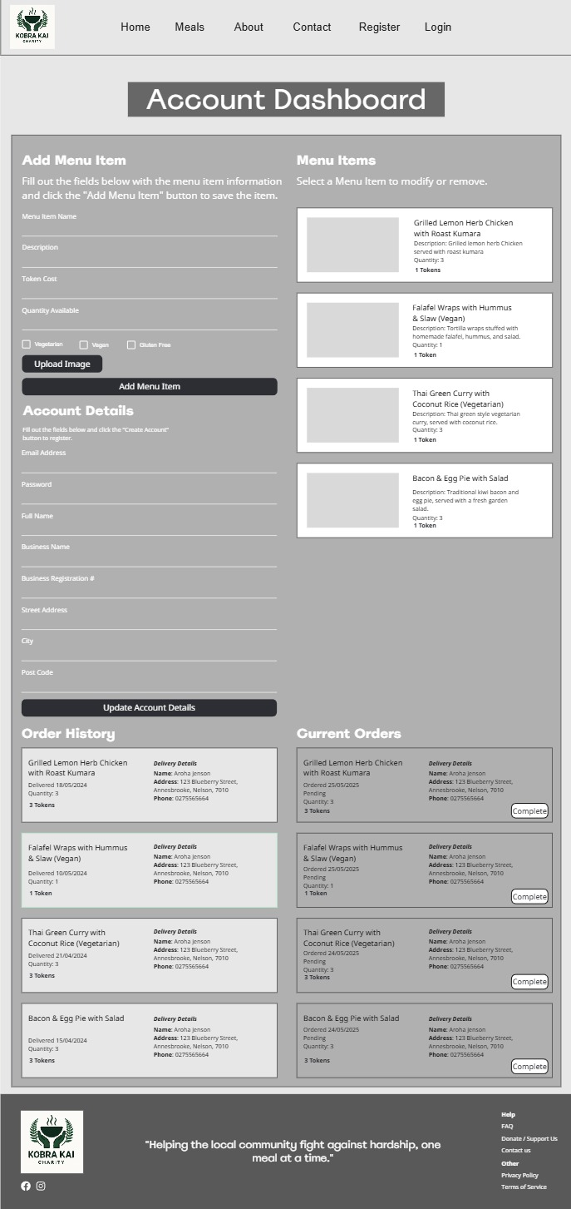

### High Fidelity Mock-ups

#### Home Page

#### About Page

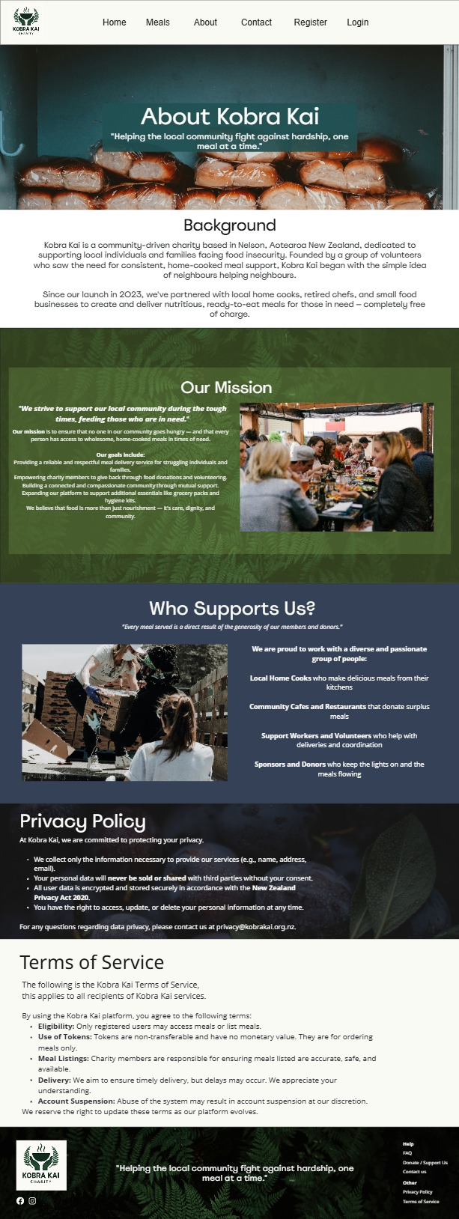

#### Meals Page

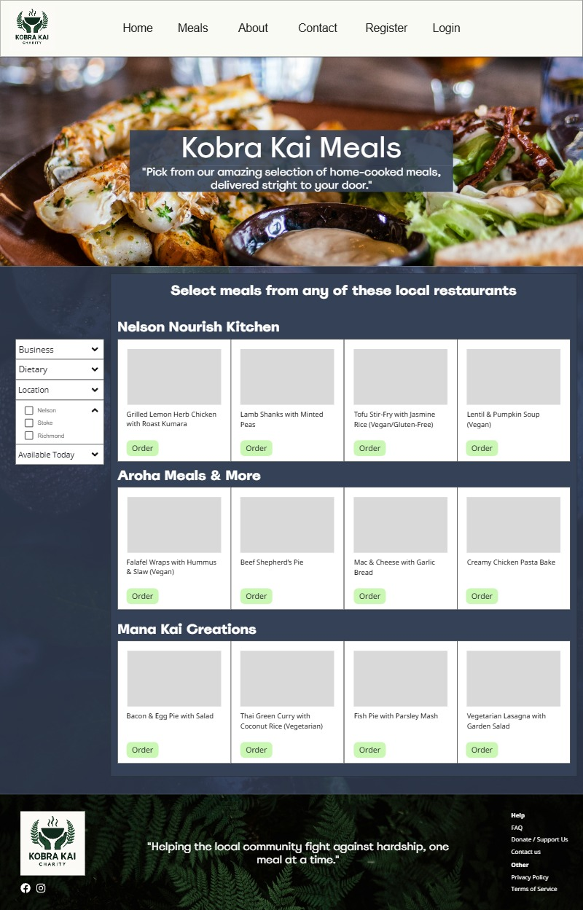

#### Contact Page

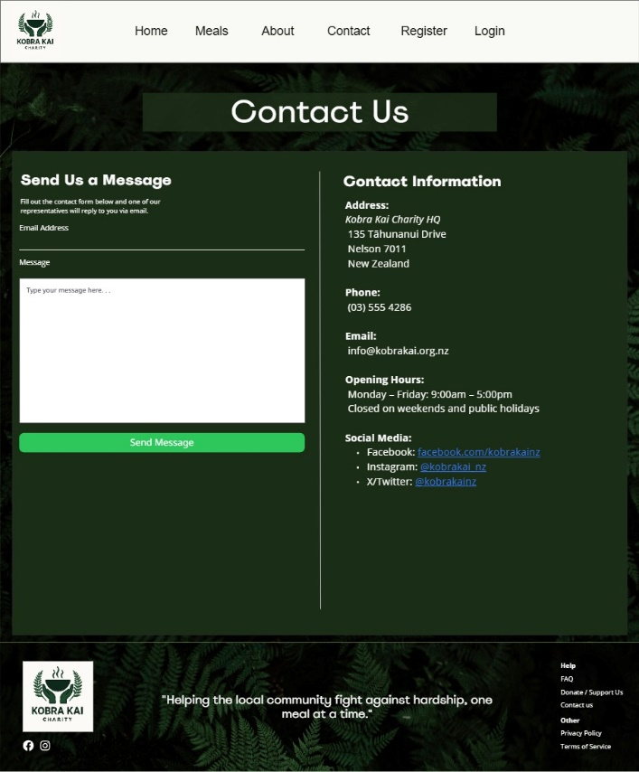

#### User Login Page

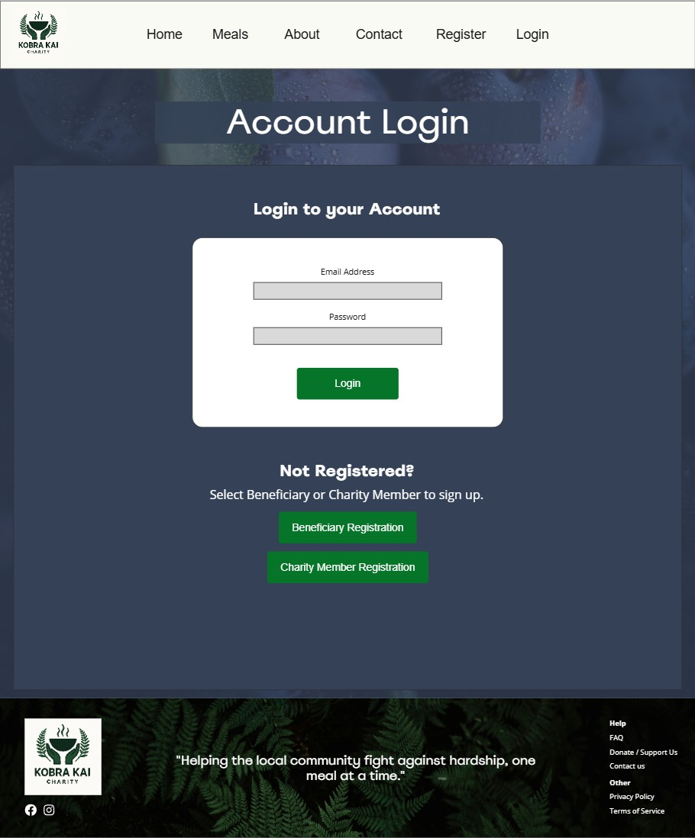

#### User Registration (Beneficiary View)

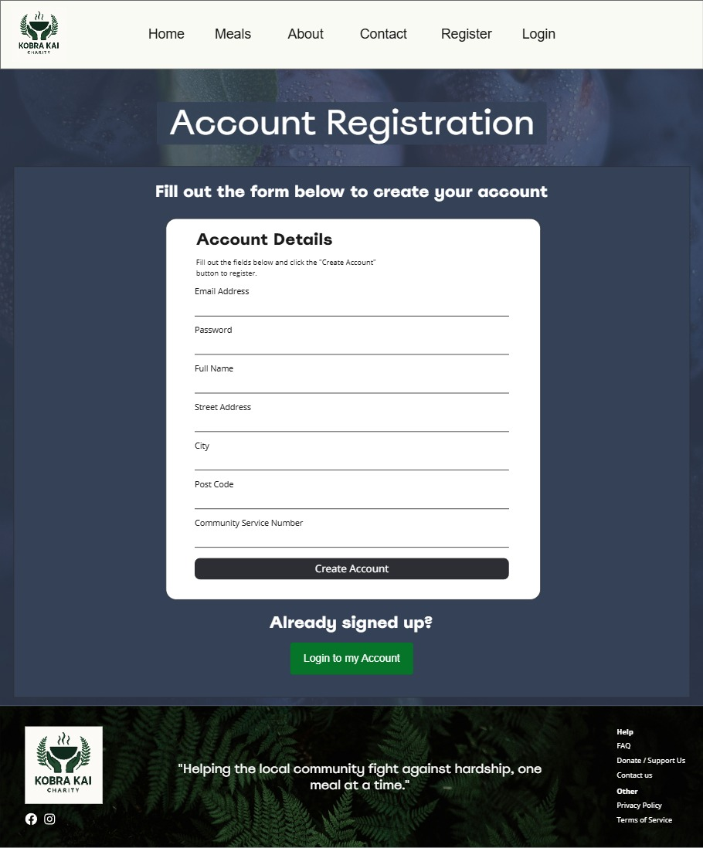

#### User Registration (Charity Member View)

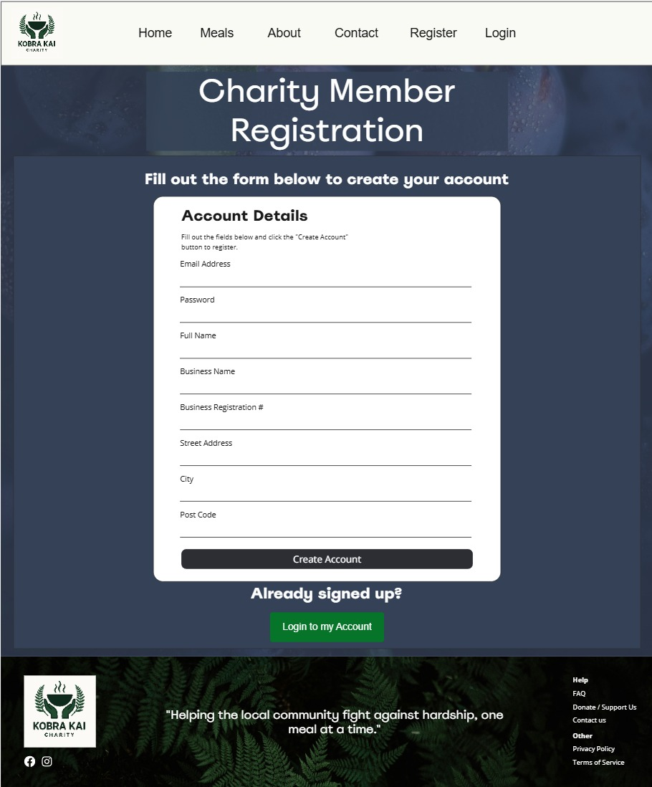

#### User Account Dashboard (Beneficiary View)

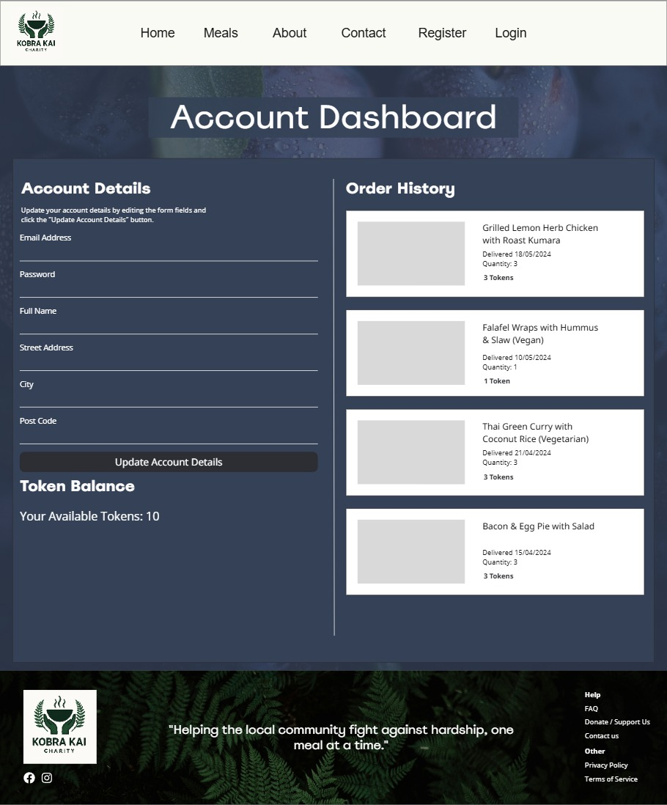

#### User Account Dashboard (Charity Member View)

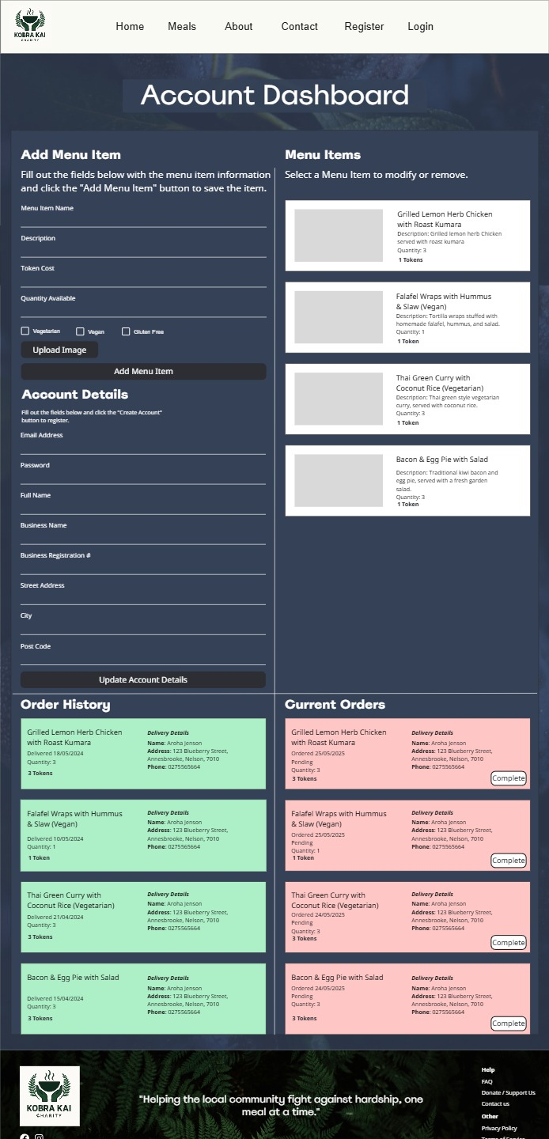

## CRUD Analysis and Table

This CRUD analysis section outlines the expected actions taken by the user and the relevant API method that needs to be performed. These methods are in the form of Create, Read, Update, and Delete (CRUD) and translate to API calls that are performed to invoke actions in the database or application logic. This is crucial prior to development as it informs the developers of the types of methods that need to be implemented into the API controllers as well as the routes and API endpoints that are expected to be used.

#### CRUD Table

|  |  |  |  |  |
| --- | --- | --- | --- | --- |
| **DB Entity / Table** | **User Story / Functionality** | **CRUD Operation** | **Description** | **Required**  **Fields/Columns** |
| **User (Beneficiary / Charity Member)** | Register for an account. | Create | Add a new user to the database. | Id, name, email, password, role, address, tokenBalance. |
|  | Login | Read | Authenticate User credentials. | Email, password, id |
|  | Update delivery address / account details | Update | Modify user details in database. | Address, name, email, phone. |
|  | View account dashboard | Read | Retrieve user profile information, meal listings, order history/pending orders, and token balance. | Id, name, email, password, role, address |
| **Meal** | Create a new meal listing (Charity Member) | Create | Add a new meal listing under the user’s account, to the database. | Id, title, description, dietaryTags[], portionsAvailable, deliveryDays[], provider |
|  | View All Meals | Read | Retrieve meal information to be displayed on the user interface. | Id, title, description, dietaryTags[], portionsAvailable, deliveryDays[], provider |
|  | Edit an existing meal listing (Charity Member) | Update | Modify the title, description, quantity, dietary, and image for a meal listing. | Id, title, description, dietaryTags[], portionsAvailable, deliveryDays[], provider |
|  | Delete or pause a meal listing (Chairty Member) | Delete / Update | Hard delete or soft disable a meal listing so it is not displayed on the user interface. | Id |
| **Order** | Place an order using tokens. | Create / Update | Create a new order entry and deduct token from user token balance. | Id, mealId, userId, status, orderedAt |
|  | View Order history | Read | Retrieve all orders for a user account. | userId, mealId, status, orderedAt, |
|  | Cancel an order | Delete / Update | Remove or mark order as cancelled. | Id |
|  | Mark order as completed (Charity Member) | Update | Change order status to “Delivered” with the delivery date. | Id, status |
|  | View pending/completed orders. (Charity Member) | Read | Query orders by status. | userId, status |
| **Token** | Allocate tokens on sign up (beneficiary) | Create / Update | Set initial token balance on user account. | userId, tokenBalance |
|  | View token balance | Read | Fetch token balance for user account. | userId, tokenBalance |
|  | Deduct Token on order submission | Update | Subtract token count on successful order. | userId, tokenBalance |
|  | Return token balance on cancelled order | Update | Add the token value that was returned to the user token balance. | userId, tokenBalance |
| **Contact** | Submit a contact of support message | Create | Save/send message to the database. | id, userId, name, email, message, sentAt |
|  | View messages (admin/future use) | Read | Fetch messages saved to the database. |  |
| **Auth Session (JWT)** | Login / Validate / Logout | Create / Read / Delete | Create session token, validate the user credentials, logout on client end. | userId, email, password |
| **Static Pages (Privacy / TOS)** | View site policies and FAQ’s | Read | Content is static, no DB changes needed. |  |

## API Endpoint Tests using Postman

The initial API controllers, routes, and models have been implemented for the core API functionality, as well as a MongoDB local instance was created to be used for testing the request and responses from the POSTMAN API tests. The following screen shots are the completed tests and the responses that were received.

#### Create Beneficiary User

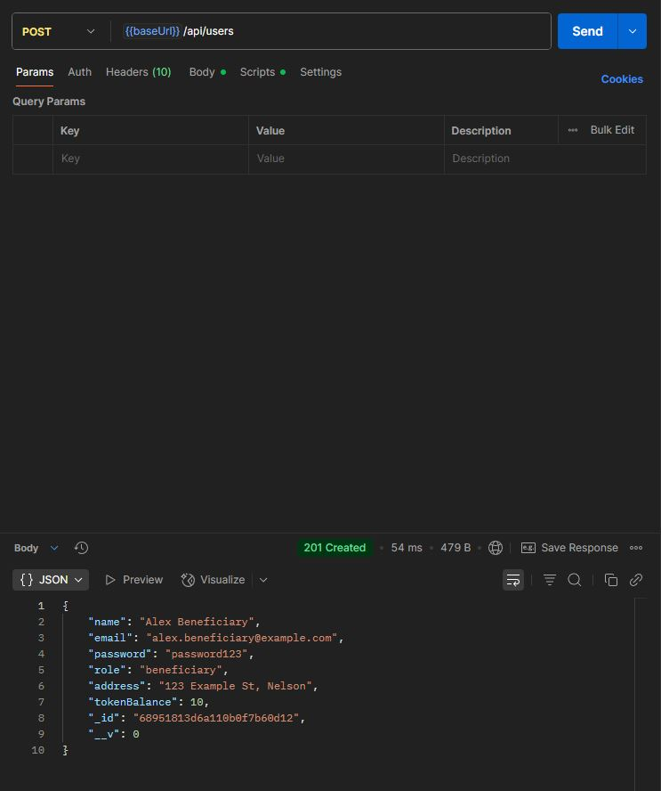

#### Create Charity Member User

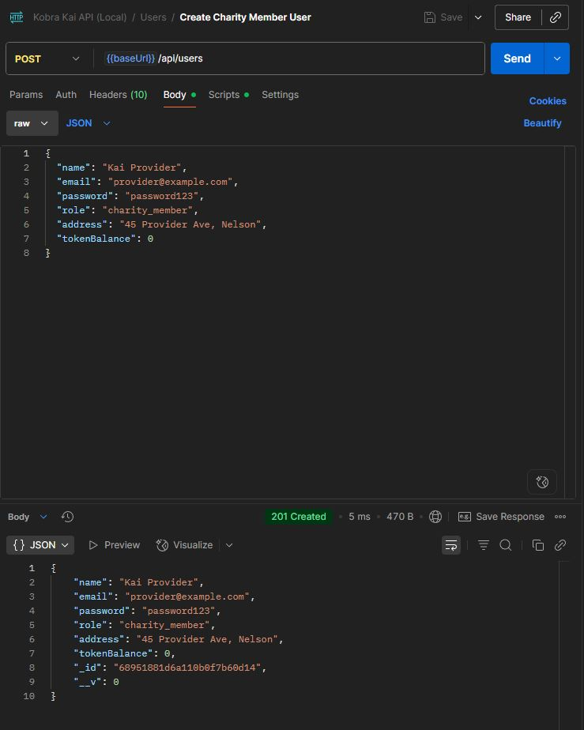

#### Get User By ID

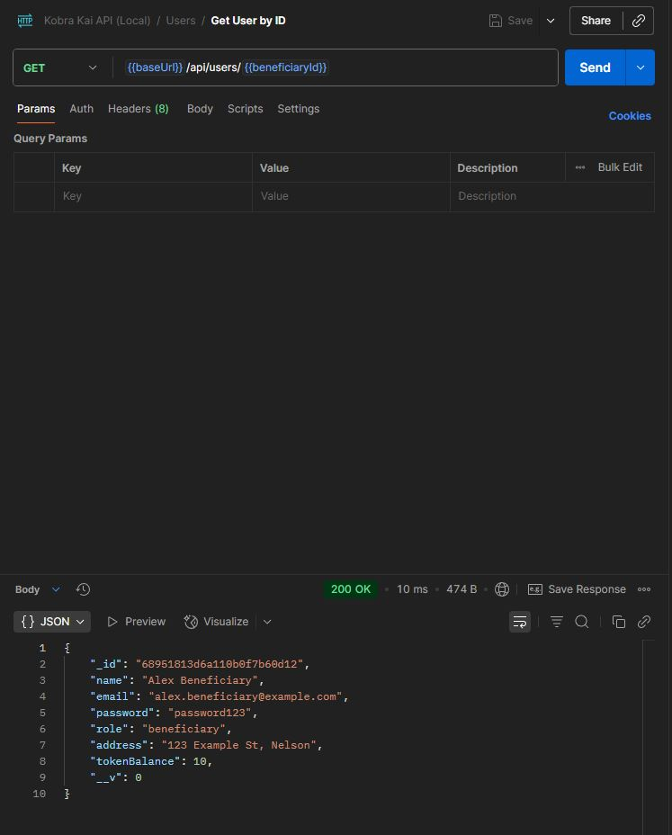

#### Update User Address

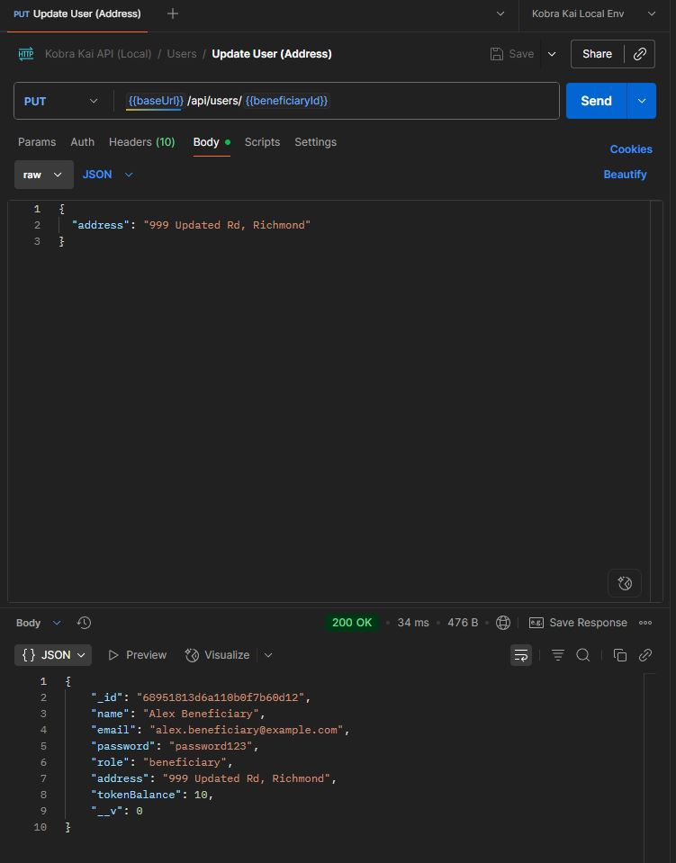

#### User Creation in MongoDB

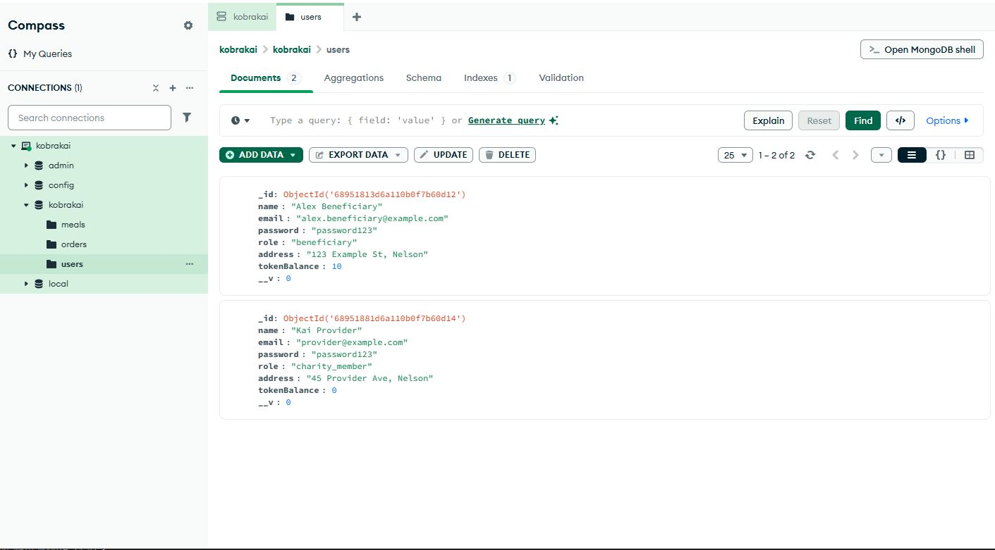

#### Create Meal

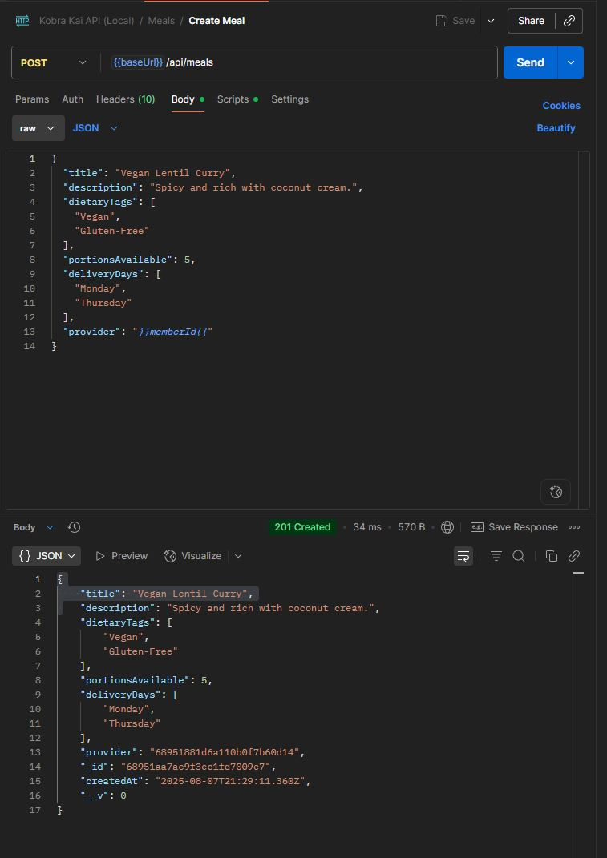

#### Get All Meals

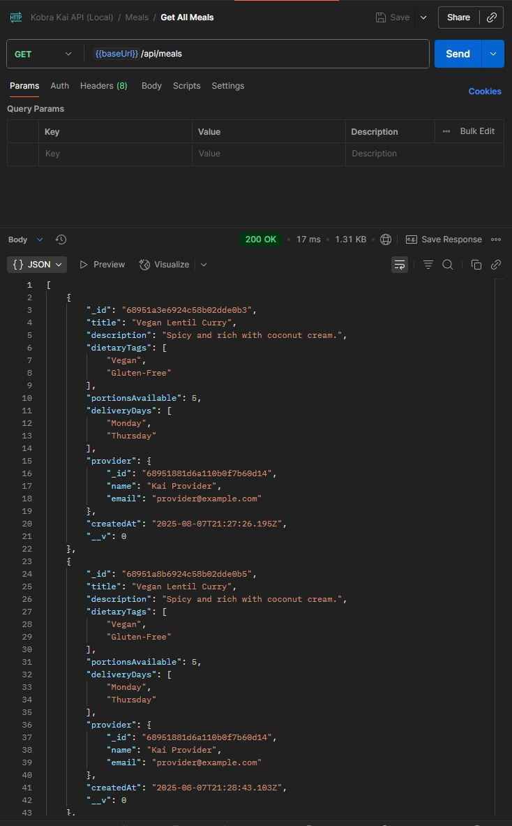

#### Get Meal By ID

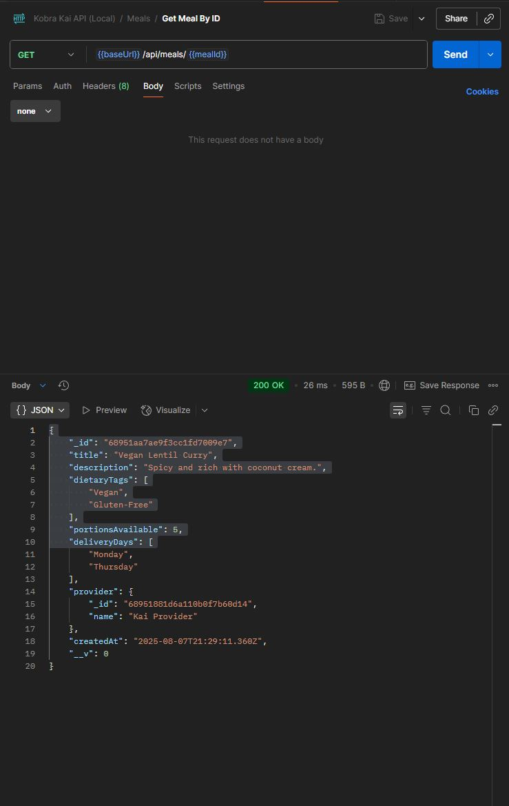

#### Update Meal Portions

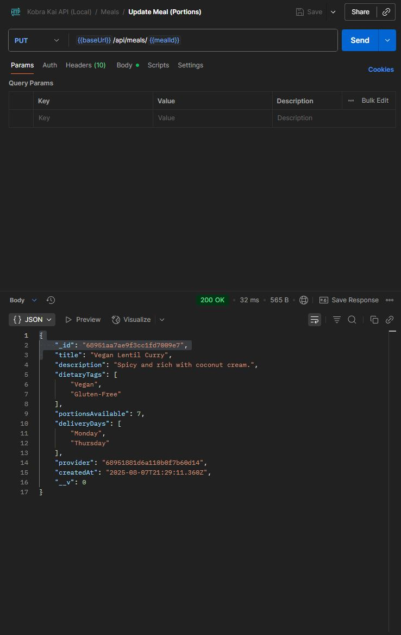

#### Place Order

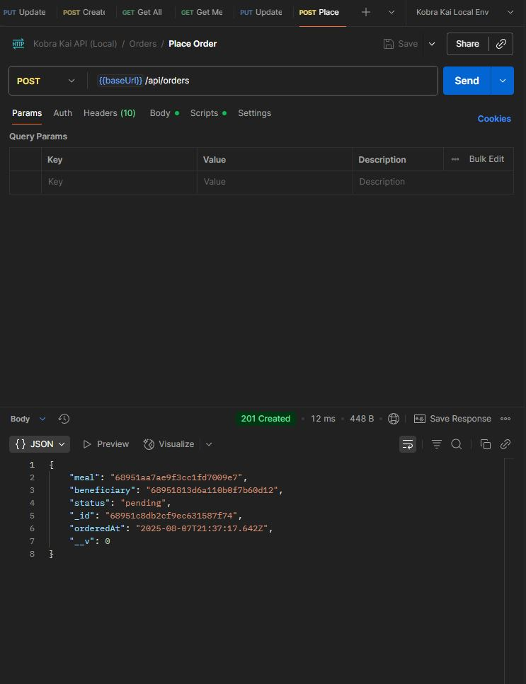

#### Get All Orders

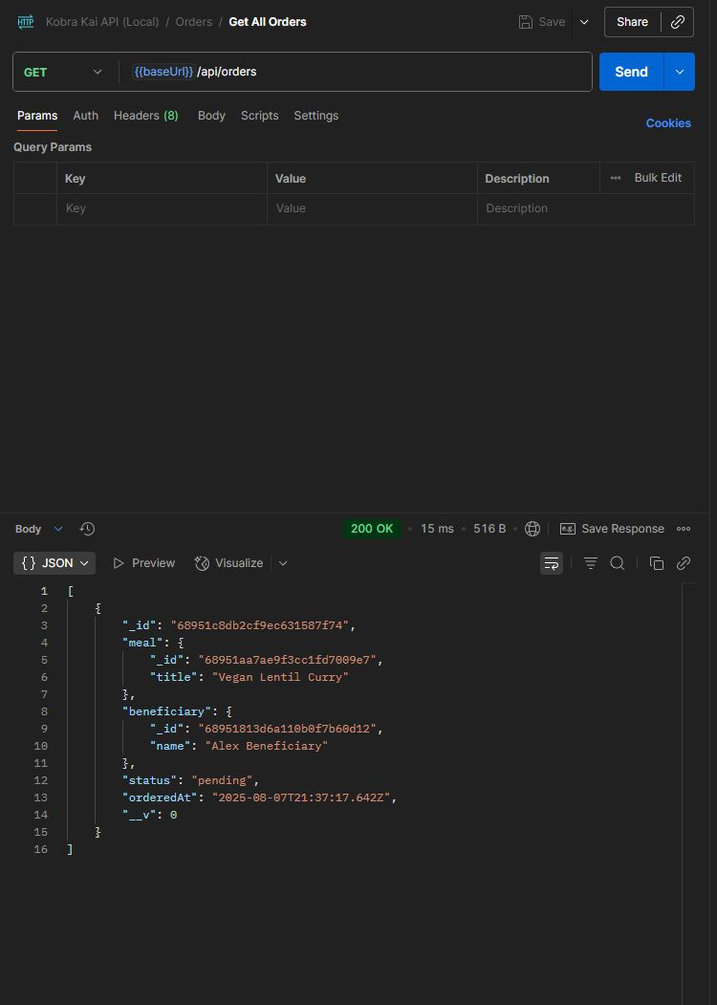

#### Update Order Status

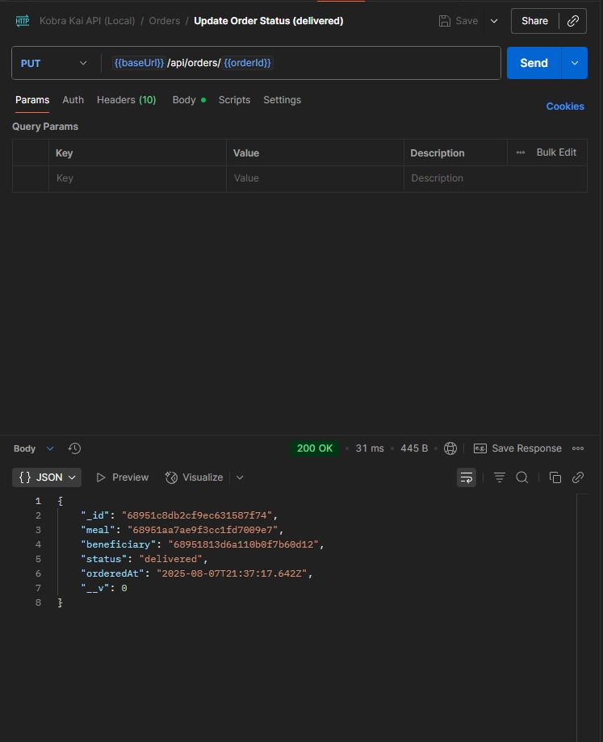

#### Mongo DB Tables after POSTMAN Tests

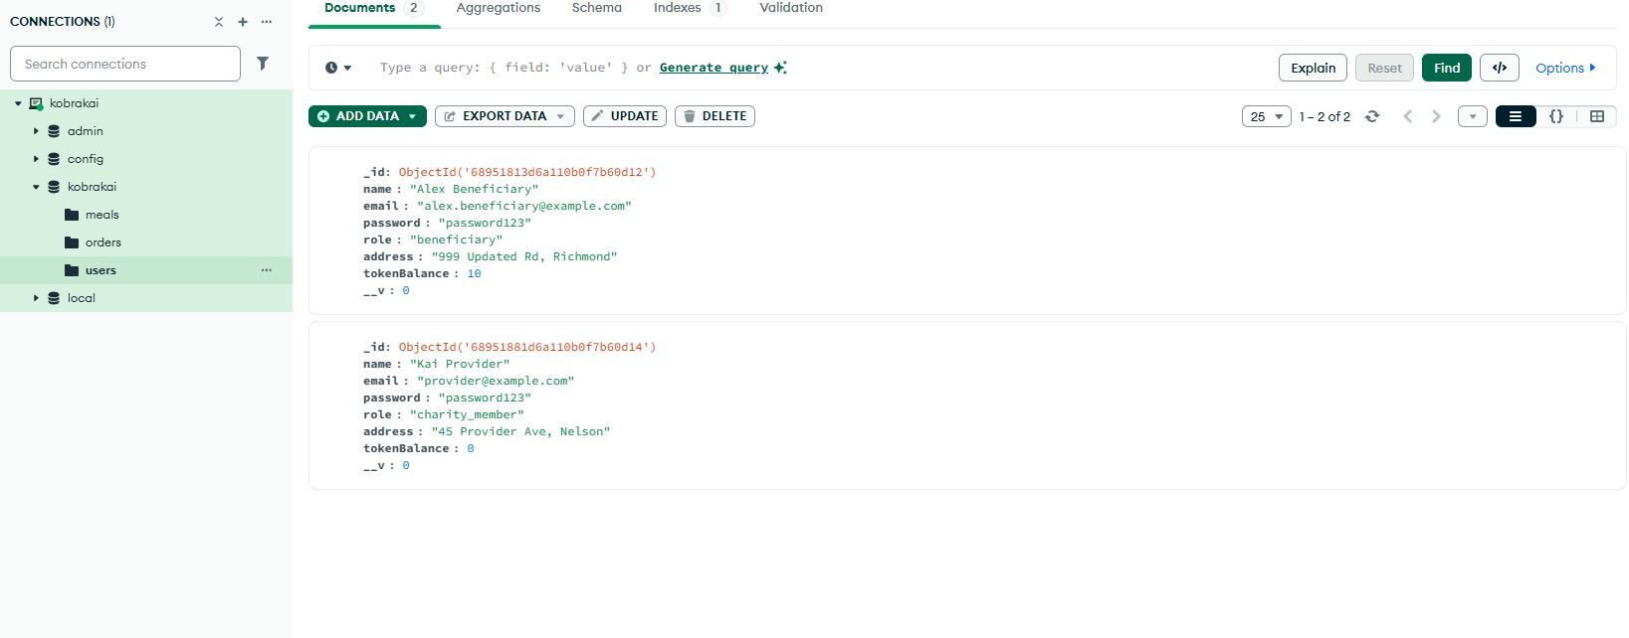

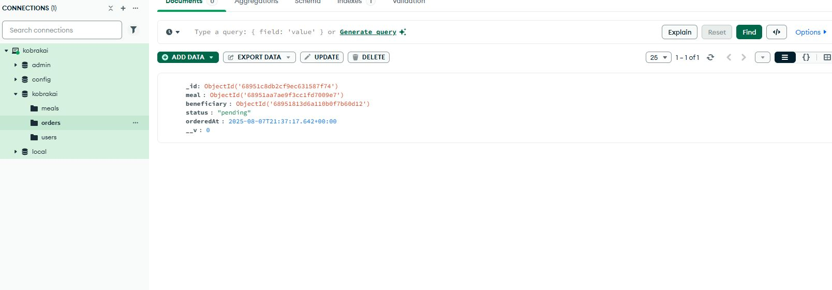

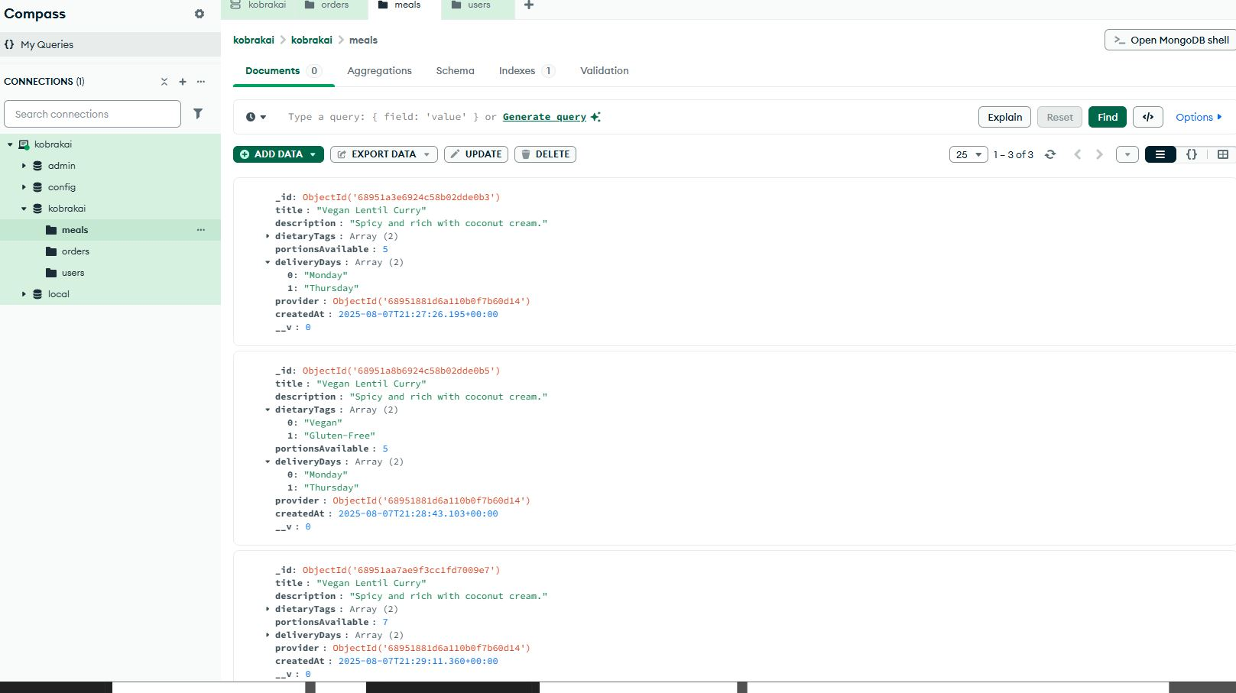

Framework Evaluation

## Evaluating Web Technology Stacks, Frameworks, and Prototyping

## 19/08/2025

### Framework/Stack Overview

In web development, a Framework or Stack refers to a collection of technologies that provide developers with libraries and tools that are used to build, deploy, and maintain web applications efficiently. Frameworks were created to help reduce development time, provide consistency, and allow developers to use prebuilt components for common web application requirements such as routing, data management, user authentication, and user interface rendering. Instead of developers having to manually code and design fundamental web components, frameworks provide all the expected functionalities, allowing the developers to focus on implementation, business logic, and features that are required to complete a web application project to the stakeholders’ requirements.

*“Server-side web frameworks (a.k.a. "web application frameworks") are software frameworks that make it easier to write, maintain and scale web applications. They provide tools and libraries that simplify common web development tasks, including routing URLs to appropriate handlers, interacting with databases, supporting sessions and user authorization, formatting output (e.g., HTML, JSON, XML), and improving security against web attacks.”* (MDN web docs. 2025)

Common framework features that are found across the various frameworks include:

* **Routing and Controllers** – Manages incoming http requests and directs them to the correct application logic and services.
* **Database Integration / ORM** – Connects the web application to a database and allows querying through data models and DTO’s e.g Mongoose for MongoDB, Entity Framework in .NET, and Eloquent in Laravel.
* **Authentication and Authorization** – Many frameworks contain built in libraries and mechanisms for user registration, login, sessions, JWT’s, and role-based access.
* **Template Rendering / UI Components** – Frontend frameworks like React and Angular provide pre-built user interface components, views, and UI rendering capabilities.
* **Form Handling and Validation** – Valdation for user inputs and sanitization to prevent errors and potential security issues.
* **API’s and Middleware** – Some frameworks are used to support RESTful and GraphQL endpoints, and middleware that allow cross-cutting concerns such as CORS, logging, and error handling.
* **Security Features** – Password hashing, CSRF protection, input sanitization, and secure cookie handling for added security for user data and protection from cyber-security threats.
* **Testing Tools** – frameworks often provide or integrate with testing libraries and suites, such as Swagger, to ensure the application is reliable and helps developers with debugging and fixing errors in the codebase.
* **Deployment and Scalability** – Some frameworks are used to configure hosting, containerization, and cloud integration.

The Kobra Kai charity project will need to incorporate multiple frameworks to build the full stack web application, most likely containing the following functionalities:

* **User Authentication and Authorization** - Due to the Kobra Kai platform catering to two user types (beneficiaries and charity members), each user type will require authentication and role-based access and views for the user interface to allow for the different use cases and features that are expected from the platform.
* **CRUD Operations** – The website is expected to utilize CRUD operations for various actions and inputs from the user, this includes viewing meals, creating meal listings, ordering, and so on.
* **Database ORM/Integration** – This will be used to store user account data, meal listing information, token balances, and order history in the selected database.
* **Routing and Middleware** – Used for managing http requests and facilitating the flow of data from the user interface to the business logic and database DTO’s/models.
* **Form Handling and Validation** – User registration and login forms, ordering confirmation, and meal listing submissions, will require input validation and input sanitization to ensure inputs are correct and free of errors.
* **Security Features** – User credentials and personal data must be encrypted using JWT’s during transit to prevent data breaches and potential interception by cyber-security attackers.
* **UI Components / Interactivity** – The user interface must be intuitive and easy to use, it must also contain user dashboard functionality and ordering workflows, best rendered using Framework UI components.

Using an appropriate “Stack” of web technologies, integrating multiple frameworks that are compatible with each other and provide the expected functionality and features for the Kobra Kai website project is crucial to building and deploying a successful web application. The next section of this report will focus on evaluating two emerging web technologies that are going to be implemented into the Kobra Kai web application project.

### Emerging Web Technology Selection and Overview

Due to the advancements in Web technologies and the increasing use of Artificial Intelligence that is now being implemented in a lot of web applications, it is worth investing potentially useful emerging technologies that could be implemented into the Kobra Kai web application. Implementing emerging technologies can give the Kobra Kai platform an edge over the competition and allow for additional future proofing and features that would increase the platform’s longevity and user experience.

#### Option 1 - Passkeys / WebAuthn (Passwordless Authentication)

*“Passkeys and WebAuthn are complementary, not competing technologies. WebAuthn serves as the foundational framework that enables passkeys to function securely and efficiently across platforms.*

*Passkeys are also a significant part of the FIDO Alliance's efforts to eliminate traditional passwords. FIDO passkeys are a way to advance their mission of securing online authentication through public-key cryptography.*

*A passkey is a digital credential securely stored on your device, typically accessed through biometrics like fingerprints or facial recognition. Meanwhile, WebAuthn is the protocol that enables secure communication between browsers and websites for passkey-based authentication. These two technologies work hand in hand to create a seamless and highly secure user experience.”* (Passkeys.com. 2025)

Most mobile devices used in the present day have biometric identification features included in the device’s hardware and software. This includes fingerprint recognition and facial/voice recognition technology which allows the user to authenticate and access services without the need for a password. This has been deemed as a more secure and reliable form of user authentication as each human’s fingerprint is unique and hard to replicate virtually and physically. Implementing a technology like this would not only improve the security of the Kobra Kai web application but also improve the user experience, allowing the user to login using their mobile device biometric identification technology instead of needing to enter user credentials, speeding up the login process.

Whilst Passkeys / WebAuthn is an effective technology and implemented in a lot of larger web platforms for mobile devices, it may be difficult to implement and could cause additional development times, it could also be considered overkill for an application that is only being used once or twice as week as apposed to being used multiple times a day such as an online banking application or social media platform.

#### Option 2 – Progressive Web Apps (PWAs) + Web Push Notifications

“*Progressive Web Apps (PWAs) are applications that you build by using web technologies, and that can be installed and can run on all devices, from one codebase.*

*PWAs provide native-like experiences to your users on supporting devices. They adapt to the capabilities supported by each device and they can also run in web browsers, like websites.*

*When installed on a device, PWAs function just like other apps. For example:*

* *PWAs have their own application icons that can be added to a device's home screen or task bar.*
* *PWAs can be launched automatically when an associated file type is opened.*
* *PWAs can run when the user signs in.*
* *PWAs can be submitted to application stores, such as the Microsoft Store.*

*Advanced capabilities*

* *PWAs also have access to advanced capabilities. For example:*
* *PWAs can continue working when the device is offline.*
* *PWAs support push notifications.*
* *PWAs can perform periodic updates even when the application is not running.*
* *PWAs can access hardware features.”*

(Microsoft. 06/25/2025)

The implementation of PWA’s and Web Push notifications in the Kobra Kai project would increase the functionality of the platform, allowing users to receive notifications of their device, notifying them of crucial interactions such as Ordering confirmation, low token balance, and alerts for charity members for order placements. Implementing this emerging technology also provides the advantages of the web application becoming more cross-platform (mobile, offline-capable, and native) without the need to development for each platform individually. Essentially, PWA’s blur the lines between these different platforms, enabling features and functionality to be available from one codebase, reducing the development times, and providing the User with different options on how the wish to access the services available from the Kobra Kai web application. The addition of web push notifications also increases the user experience and value to the consumer as they can receive valuable notifications directly to their device, regardless of if they are using a mobile or desktop device. This can also be implemented for both user types as the notification system can be used for both order confirmations and token balance, as well as notifying charity members of new orders, reducing the need for constant site checking.

### Emerging Technology Selection for the Kobra Kai Project

After reviewing the two different types of emerging technologies for the Kobra Kai web application, the Progressive Web Application (PWA) + Web Push Notification technology has been selected to be implemented into the project. This choice was made due to the clear advantages of implementing this technology and its usefulness to both user types. Implementation of PWA and Web Push Notifications will increase the platforms User Experience, as well as it’s cross-platform abilities without a dramatic increase in development time and resources.

Whilst the Passkeys / Authn could have provided a smoother and secure method for user authentication using device biometric capabilities, the additional development time and low potential frequency of use by the user outweighed the potential benefits of implementing that technology into the Kobra Kai web application project. This could be integrated later into development, but it is not a priority to produce an MVP that can be used by the organization.

#### Rationale, Impact, and Future Implications for PWA and WPT Implementation

###### Rationale

Progressive Web Apps have been in development/conception since 2015, with the idea being to integrate native/mobile application functionality into web applications that are accessible through a web browser. Whilst PWA’s were first proposed several years ago, they can still be considered and emerging technology as the widespread adoption of the technology has only recently become viable due to support being implemented across all major web browsers and mobile platforms. The following quote from Julian Neagu from his article on Medium explains the key statistics for PWA’s and explains how there are only 54,000 websites currently using the technology, which in comparison with how many websites exist in today’s digital landscape, only a small percentage have adopted and implemented PWA’s.

*“Key Statistics*

1. *The PWA market is set to reach $10.44 billion by 2027.*
2. *The travel industry sees a 3x increase in conversions with PWAs.*
3. *Only 54K websites currently use PWAs.*
4. *PWAs boost conversions by up to 50%.*
5. *PWAs load in under 2 seconds, reducing bounce rates.*
6. *PWAs improve user retention by up to 180%.*
7. *Developing a PWA is 3–8 times cheaper than a native app.*
8. *PWAs cater to over 6.3 billion smartphone users globally.*
9. *PWAs offer offline access and push notifications for an enhanced user experience.*
10. *PWAs have 60% fewer security vulnerabilities than native apps.*

*Data from BuiltWith reveals that as of October 2023, more than 54,097 customer websites are using PWAs.*

*Considering the vast number of websites available globally, PWAs still have immense potential for further adoption.*

*Various sectors, such as e-commerce, media, and travel, have recognized the effectiveness of PWAs in engaging users and boosting conversions.*

*It’s important to note that the current count of 54k PWAs is relatively low when compared to the 200 million active websites as of June 2023.”*

(Julian Neagu. (November 2023). Medium.)

###### Impact on the Kobra Kai Website Project

The PWA and WPT technology has been selected to be implemented into the Kobra Kai we application project for the following reasons:

* **Features and Functionality** - The Kobra Kai’s core features and functionality such as meal ordering, redeeming tokens, order status updates, and new order placements will benefit directly from real-time updates and push notifications.
* **Cross Platform Compatibility** - PWA’s are cross-platform and can be used to reach the target audience (beneficiaries and charity members) that mostly use mobile devices and allow them to access the services using those devices.
* **Ease of implementation with MERN** - The implementation of PWA’s can be achieved using the MERN stack, specifically the React Framework, whilst this Stack has not been evaluated yet, it does add extra weight to the decision process when selecting the Stack and frameworks that will be used for the project.
* **User Benefits** - This technology provides benefits for both user types (beneficiaries, charity members) which gives additional reasons to implement this as the emerging technology being implemented into the platform.
* **Improved Accessibility and User Engagement –** User’s will not be required to install separate apps on their device; all the services and features of the platform can be accessed directly through the web browser.
* **Future Proofing –** PWA’s are becoming indistinguishable from native apps, which benefits smaller organizations such as Kobra Kai as they can compete with larger organizations with more resources to develop both native apps and web applications separately with larger teams of developers and more resources.
* **Reliability and Consumer Trust –** Users will receive push notifications when completing important actions such as ordering meals, token balance usage, and receiving meal orders for charity members. These will increase the users trust in the platform and provide them with a better experience when using the web application.

In conclusion, implementing the Progressive Web Application (PWA) and Web Push Notification technology into the Kobra Kai project will increase the overall user experience, providing real-time notifications for order confirmations, token balance alerts, and meal order updates for charity member users. Additionally, PWA’s promote cross-platform capabilities, reducing the need to develop a separate native or mobile application and increases the reach of the platform to more users that mostly use mobile devices to access the platform. As PWA’s progress and become indistinguishable from native apps or mobile applications, the future of web development will become a more fluid and less time-consuming process, having all the functionality of a native application from within a web browser will reduce the need for multiple versions of the same application to be developed specifically for different platforms and devices.

## Web Framework Stack Prototypes and Evaluation

PROTOTYPE REPOSITORY: https://github.com/AlexHerbertGit/WEB701-Evaluation-Prototypes.git

To effectively select a web framework stack that will be implemented and used to build the Kobra Kai charity website, I have selected five different web technology frameworks/stacks to create basic prototypes that emulate the required functionality of the platform. These frameworks/stacks are as follows:

* MERN (MongoDB, Express.js, React.js, Node.js)
* MEAN (MongoDB, Express.js, Angular, Node.js)
* MEVN (MongoDB, Express.js, Vue.js, Node.js)
* .NET 8 / Blazor (. NET 8, ASP.NET, Blazor Web App, LocalDB)
* Python / FastAPI (Python, uvicorn, SQLModel, bcrypt)

In the following sections I will provide the framework/stack overviews and the code examples of each prototyped functionality with commented code screenshots for each of the requirements for the Kobra Kai charity website platform.

Each prototype in the following sections fulfils the requirements 1, 2, and 3 from the marking grid and meets the following criteria:

* Users (Beneficiary or Member) can register/create and account using personal details, and Login to their account using the registered credentials.
* A JWT is issued at login and used to access the protected API endpoints (/api/users/me).
* A front-end interface that stores the JWT and shows a dashboard with role-based UI for both types of Users.
* Members can create meal listings, manage current orders) using the dashboard interface.
* Beneficiaries can view meals and order meals using the front-end UI and view their token balance and pending orders via the Dashboard UI.
* Basic account management functionality is implemented but not available on the front-end UI at this stage.

# MERN Stack Evaluation

The following sections showcase the required functionality and criteria of the MERN prototype implementation.

### Requirement 1 – Registration/Login + Account Self-Management

###### User Registration

This screenshot shows the UI and network status when loading the registration page, in the network section the ‘me’ request that is highlighted red is checking to see if an authenticated user is logged in with a valid JWT cookie, which there isn’t at this stage. User credentials are entered into the form fields, and the account is created.

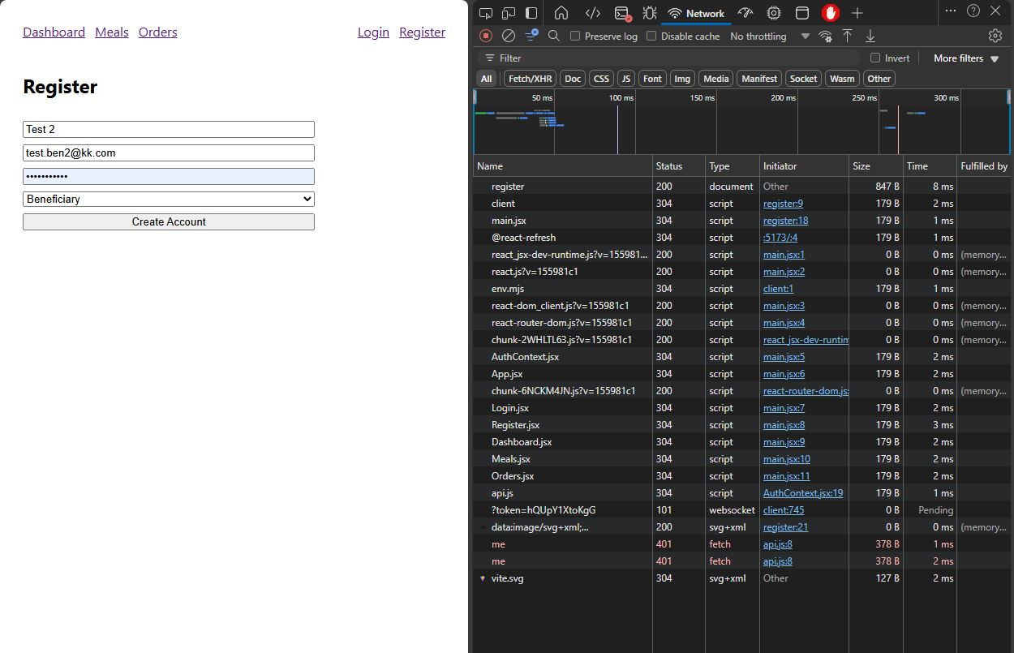

###### Registration Success with JWT signed and validated

Once the User is registered, they are automatically logged in and redirected to the Dashboard UI where they can view their account details and token balance. The network tab shows the successfully registration request status code “(201) Created” with the “Set-Cookie” showing the JWT token in the Response header. Access control options are also set and shown in the subsequent request response header.

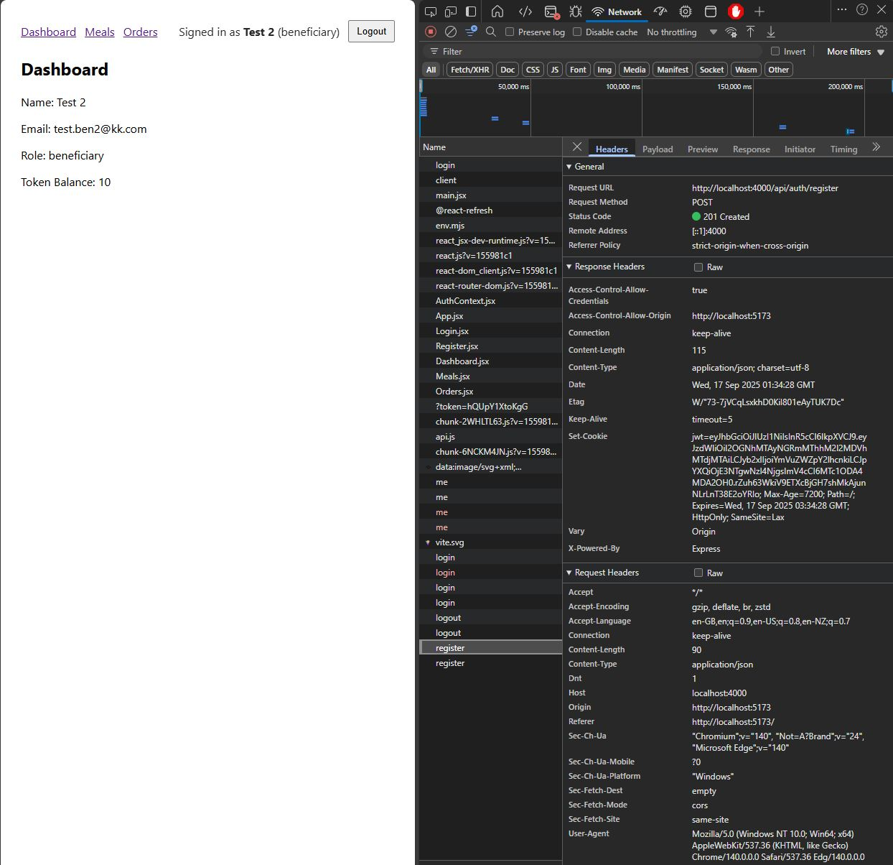

###### Registration Success with Access Control Options Set

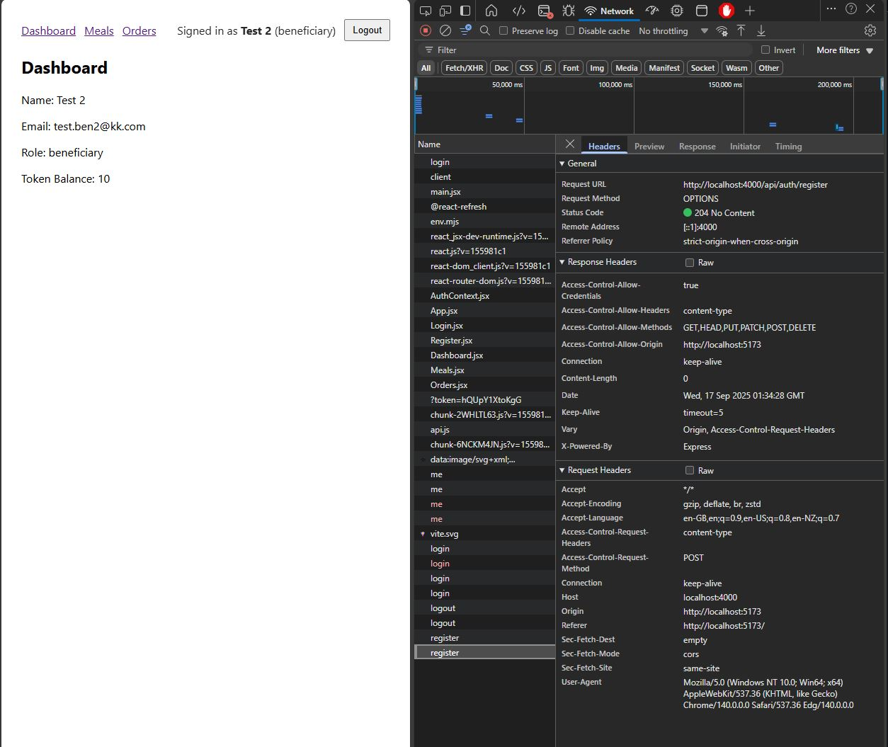

###### Login Success with signed JWT Cookie

The User logs in with their credentials and is redirected to the dashboard page showing their account details and token balance. The user’s ‘role’ is also established, determining the UI that can be displayed, and the Action Control authorization options are set to allow for meal ordering and account management actions (updating account details etc.)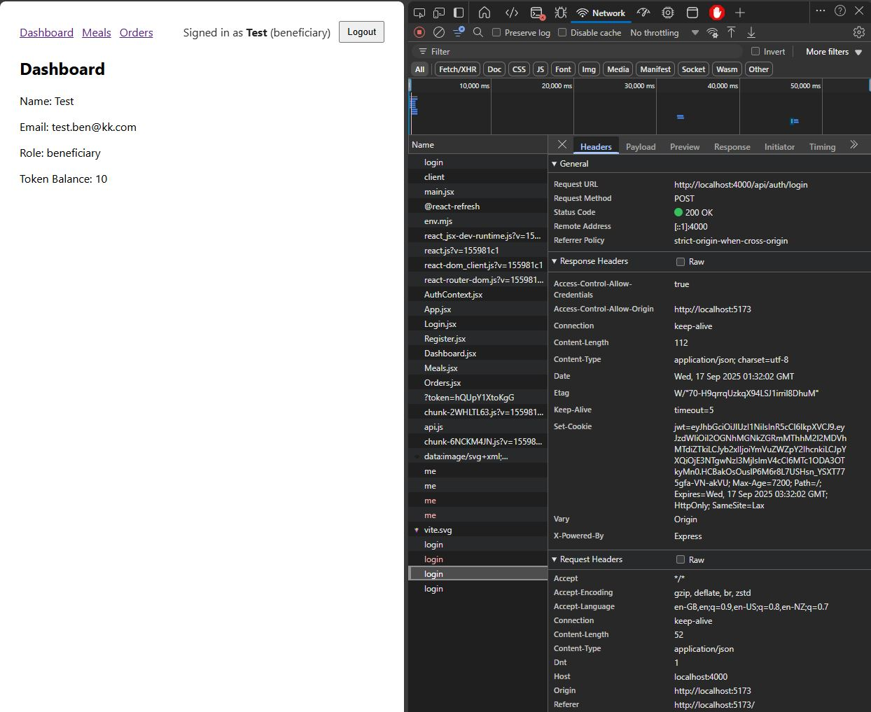

#### Requirement 1 Evaluation

The MERN prototype handles user management end-to-end across the stack. On registration, the React front-end pages present a form component that the user can use to fill out their details, create a password, and select either ‘beneficiary’ or ‘member’ as their account type, this then assigns their role for the account when submitted. The data is then sent to the Express/Node API, which creates a new user record in MongoDB. The Login works by submitting the user credentials in the login form, which is sent to the API where they are validated against the stored, hashed passwords, and a JWT is issued on successful validation. The JWT is then stored as an HttpOnly cookie (for prototype/dev purposes) which means it is automatically sent with subsequent requests while remaining inaccessible to client-side scripts for security. The JWT contains the user’s ID and role, allowing the backend to authenticate and enforce role-based access controls for specific functionality on the frontend. The React frontend uses the ‘AuthContext’ to fetch the current user via the’/auth/me’ endpoint to keep the users state across the applications interfaces. This allows the system to gate UI features to specific roles as well as making sure the user is authentic.

### Requirement 2 *–* Token Transaction System and JWT Authentication

###### Viewing Meal Listings on the Meals page as a Beneficiary User

This screen shot of the MERN prototype is viewing the Meals page when signed in as a beneficiary user. This is where meal listings, the available quantity, the dietary information and meal descriptions are displayed. The network tab shows the response headers running through the stack checking for the user’s role and authentication status prior to loading the UI on the webpage, this is to only show the ‘read-only’ version of the page and not displaying the ‘Create Meal’ form that is only authorized for ‘member’ users.

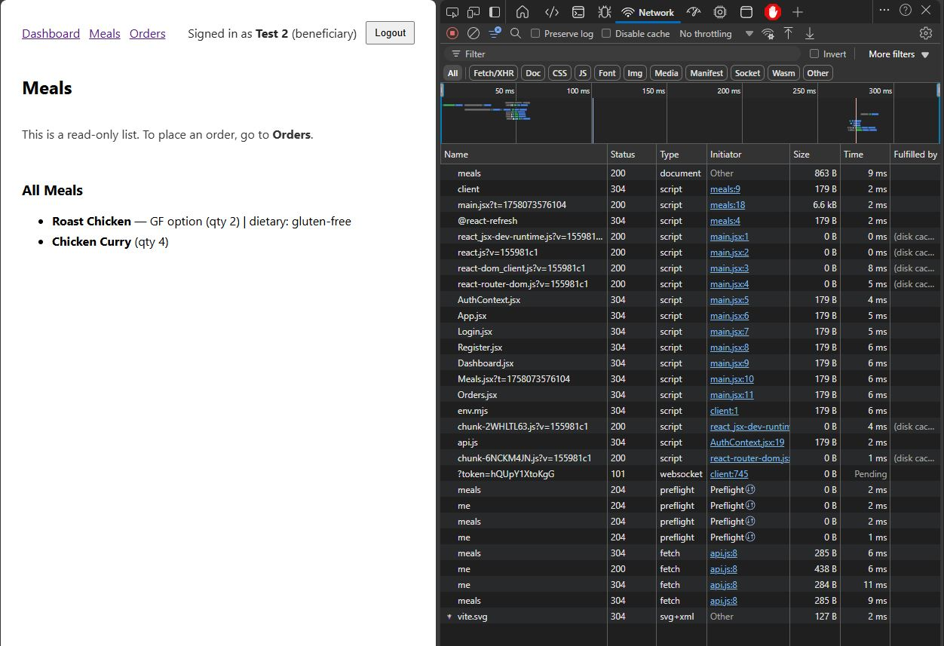

###### Ordering a Meal using Tokens as a Beneficiary

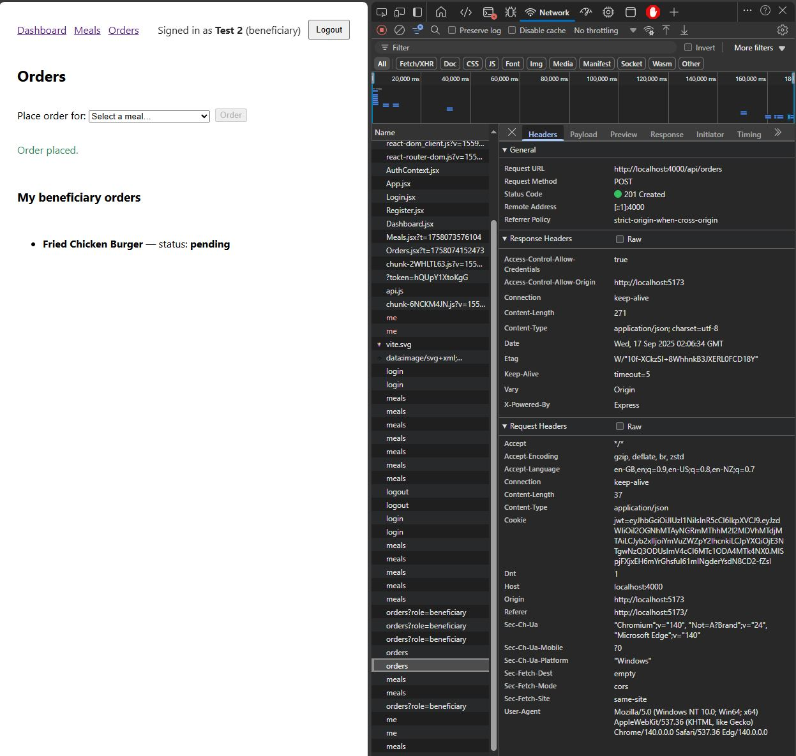

###### Member Accepting Orders using the UI

This screen shot shows the Order that was placed by the Beneficiary User in the previous section showing up in the Member’s Orders page, the Member then clicks the “Accept” button to confirm the order which changes the orders status from pending to accepted. The Network tab shows the request and response headers for completing that action.

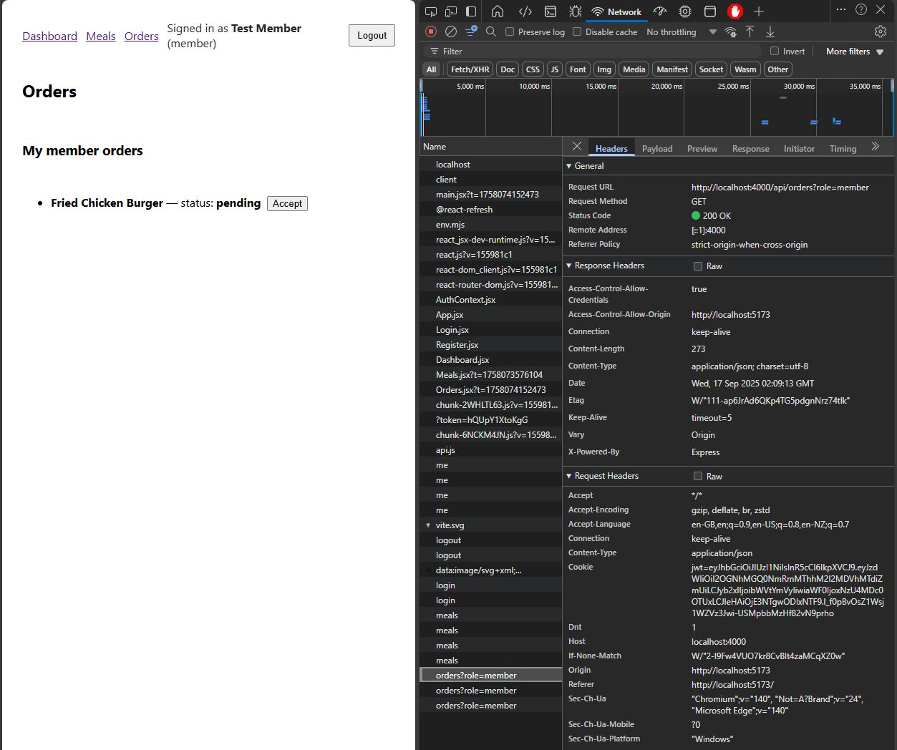

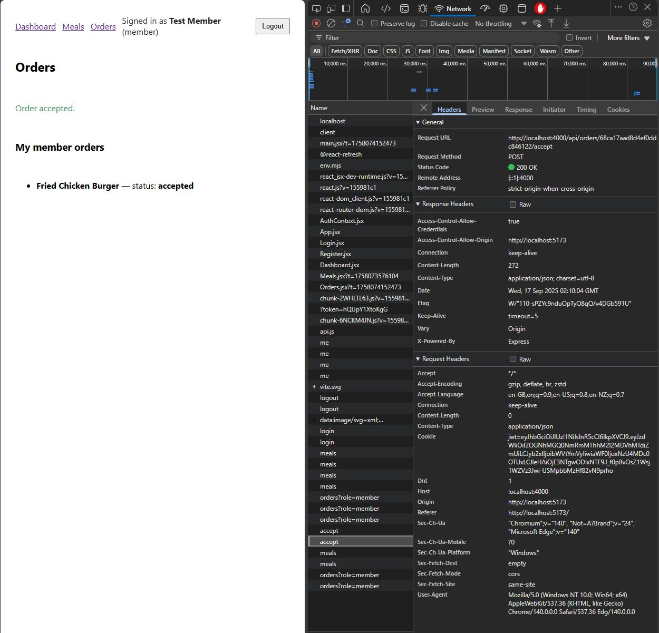

###### Beneficiary Order Accepted and Token Balance Decremented

The following screenshots shows the Orders page from the Beneficiary account that ordered the previous meal that was accepted by the Member. Additionally, once the order was accepted by the Member the Beneficiaries token balance was also decremented by 1 token which is shown in the screenshot below. The network tab shows the request and response headers when these UI elements are being viewed.

Order Accepted (Beneficiary Account)

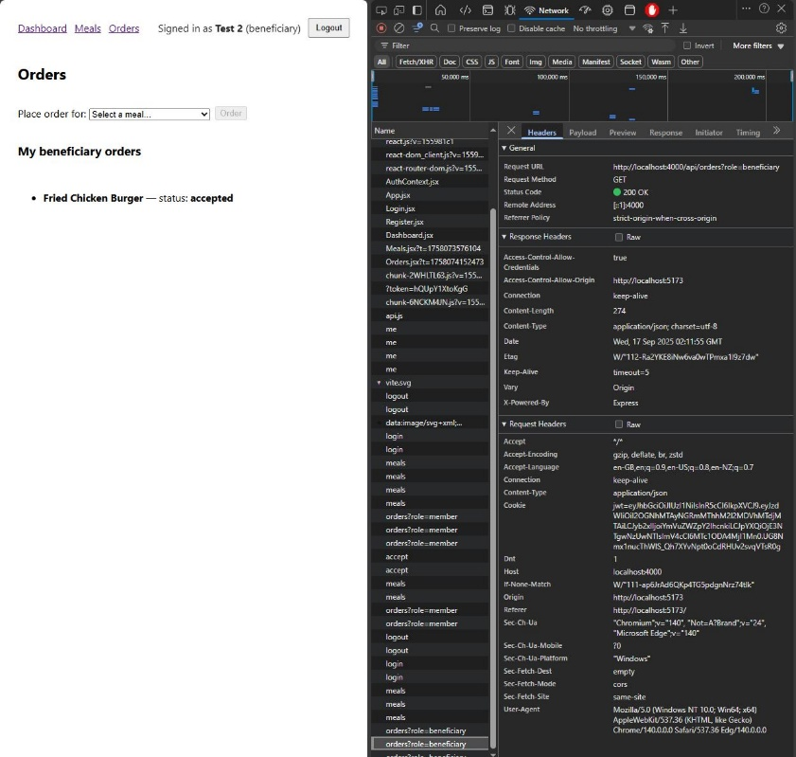

Token Balance Deducted

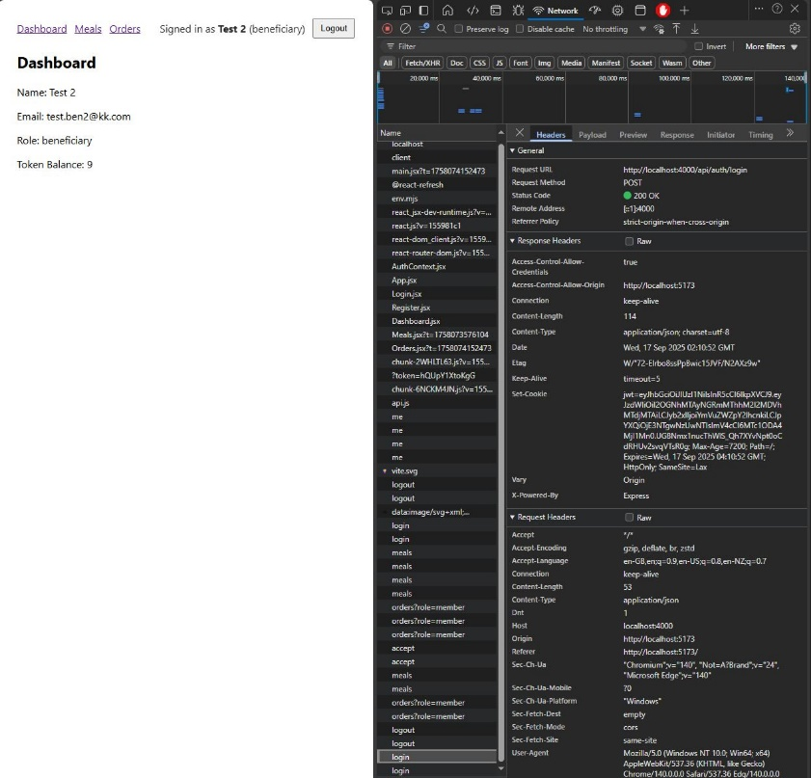

#### Requirement 2 Evaluation

The MERN stack prototype implements the ‘token’ based transaction functionality through the controlled API endpoints that enforce the role checks and authentication process. When a beneficiary places an order, the React frontend sends the selected meal ID to the Express/Node API, the JWT is then verified in the backend to confirm the user’s identity and ‘role’. Once verified the user’s token balance is then decremented by the value of the meals ‘cost’ in MongoDB, whilst simultaneously reducing the quantity of that meal in MongoDB. The order is then entered into the database with the status of ‘pending’, the Member users access the same endpoint with their own JWT which filters the Orders based on their ID allowing them to see orders that were placed containing meal listings that they created. When the Member accepts the order, the API again validates the JWT from the Member user and updates the order status from ‘pending’ to ‘accepted’, finalizing the token transaction and removing the token officially from the Beneficiaries account balance. This prototype demonstrates how MongoDB persists transactional states, Express routes and controllers validate request and enforce business rules, and how the React frontend provides immediate feedback to both user types, creating a complete loop for token transactions.

### Requirement 3 – Data Storage and Retrieval

###### Member User Entering Meal Listing into the Database using the UI

The following screen shot shows the Meal listings page when logged in as a ‘member’ user, the user enters the meal details into the form and clicks the “Add Meal” button to create the listing. This example shows adding the “Fried Chicken Burger” to the Meal listing.

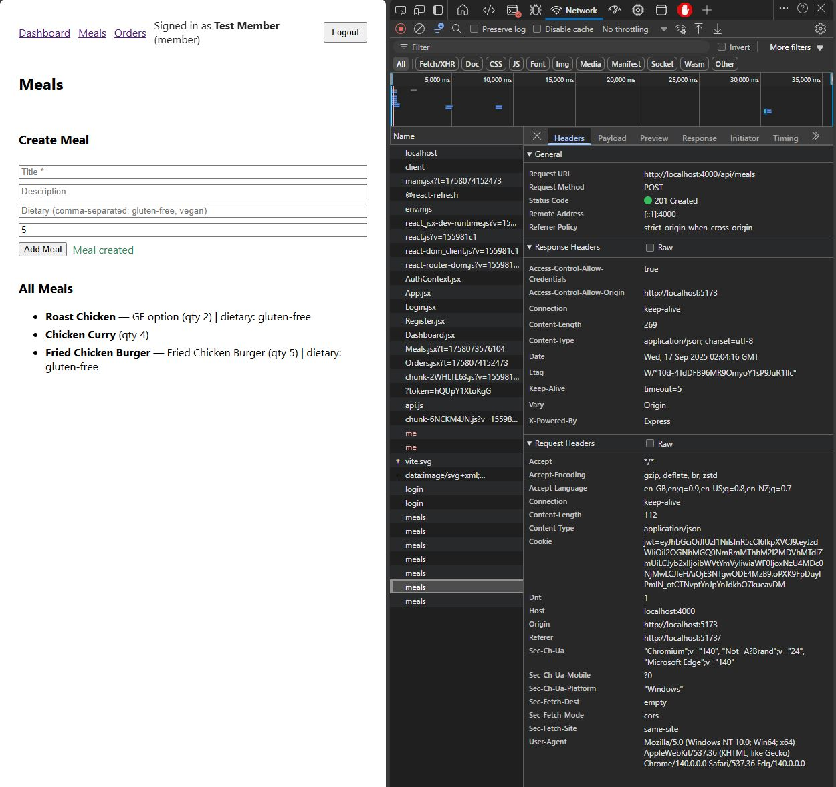

#### Requirement 3 Evaluation

The MERN stack prototype handles user generated data, such as meal listings, by storing them directly in the MongoDB database, with the Express/Node API using Mongoose models to provide the structure of the meal listings and middleware providing authentication and validation. When a member creates a new meal listing, the React frontend submits the form data to the API, which validates the required fields before saving the meal document in MongoDB. Each meal document is tied to the member who created it via their unique ID, and includes attributes like description, dietary tags, and quantity available. This data is the retrieved to be displayed by the React front end to beneficiary users who can then review the details of the meal prior to placing and order. The React frontend state is refreshed after meal creation, so the new meal listings are displayed immediately after creation without the need for a full refresh, this is very useful for ensuring user experience and efficiency when using the platforms user interface.

# MEAN Stack Evaluation

The following sections showcase the required functionality and criteria of the MEAN prototype implementation.

### Requirement 1 – Registration/Login + Account Self-Management

These screenshots show the MEAN stack prototype registration page and network tab when a user is not logged in, users can enter their details into the registration form and click the ‘Create Account’ button to submit their credentials and create an account. The network shows the ‘me’ request has been made to check for current user state and JWT tokens on page load, this fails as no user or JWT token is present.

Account Creation (Beneficiary and Member)

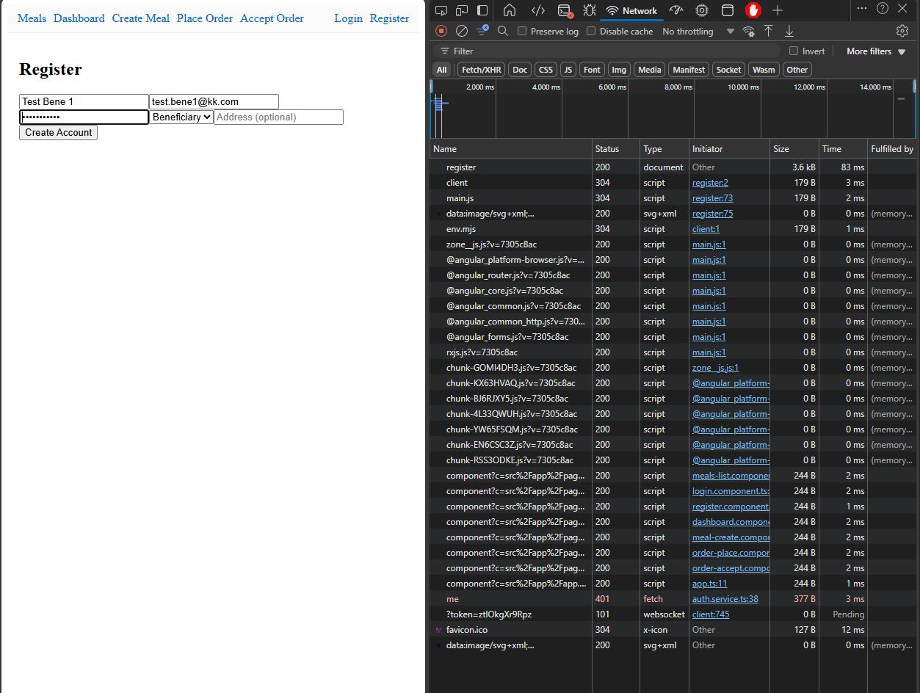

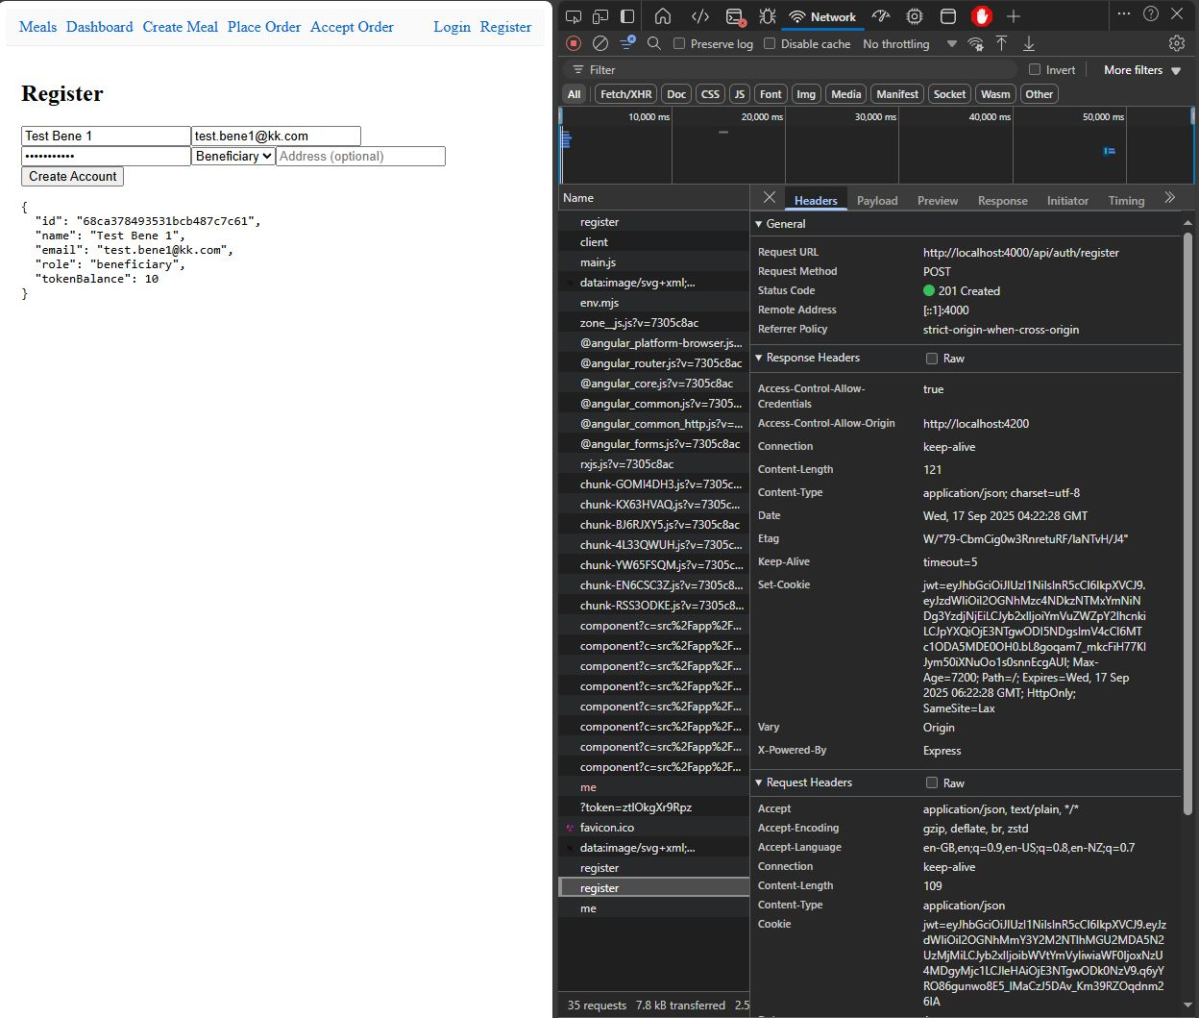

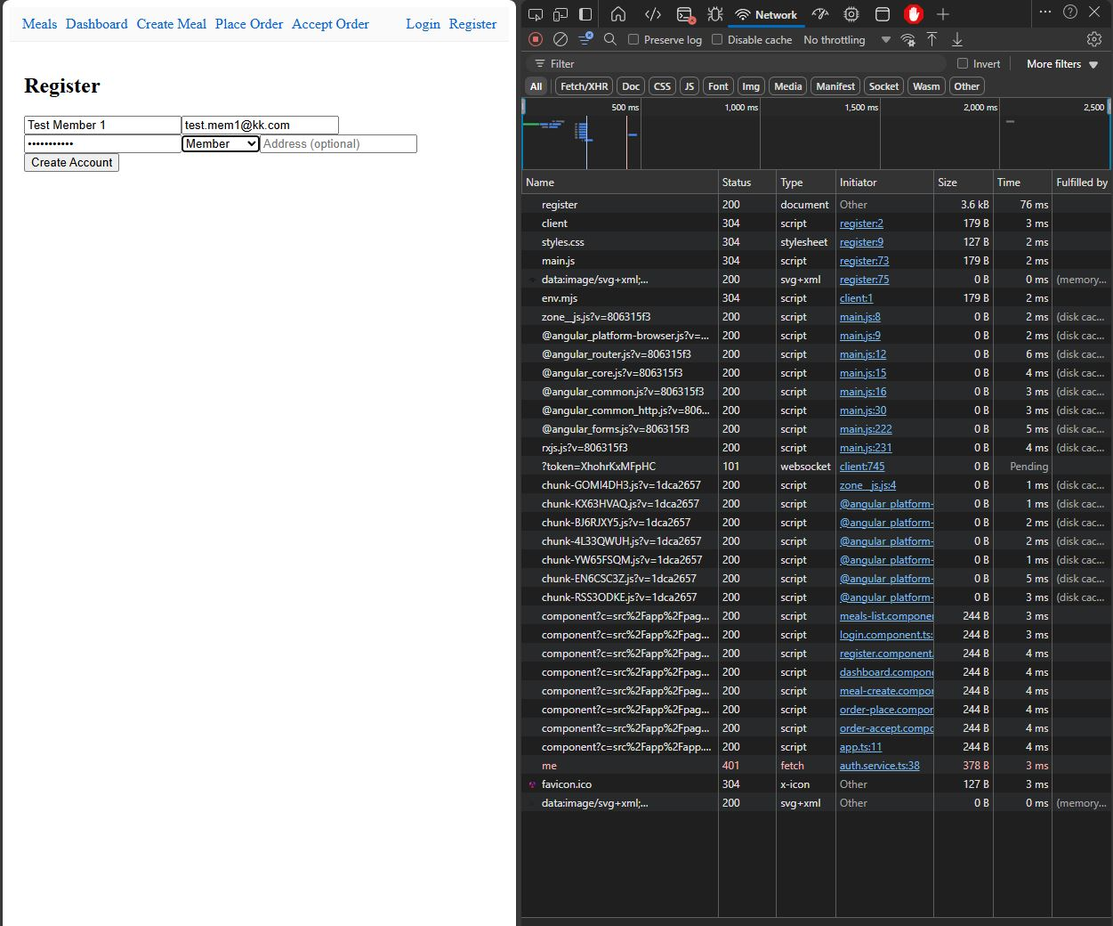

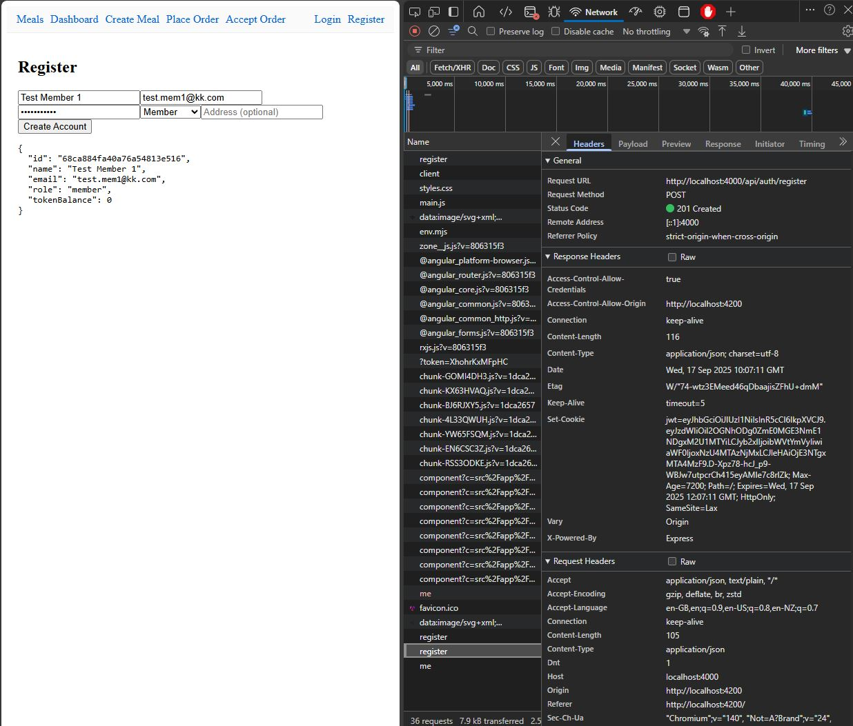

#### Requirement 1 Evaluation

Once the user has entered their details and created their account, they are logged in and a JWT token is signed creating the session for that user. The users account type or ‘role’ determines the functionality they can access whilst using the frontend user interface, Angular handles assigning access controls to that user on login. The authentication flows are cookie-based and are handled by a minimal Angular AuthService as well as the Express API endpoints, when users create an account their password is hashed and stored in the MongoDB database, and signs the JWT using a server side secret and returns it as an HttpOnly cookie so it can’t be accessed by JavaScript, the same is applied to Logins with the exception of checking the hashed password against the stored password for users account in the database. The ‘/auth/me’ endpoint is used to retrieve the user’s role and the validate the users authentication status prior to rendering and frontend pages and helps to gate access to functionality based on their access control permissions and ‘role’.

Requirement 2 *–* Token Transaction System and JWT Authentication

The following screenshots show the MEAN stack prototypes ‘Token’ transaction system in action. Beneficiary users can view meals on the Meals page and place and order using the Angular frontend interface. Once the user has ordered a meal, the meal document is created in the MongoDB database with the status of ‘pending’ with the meal ID and member ID assigned to it to allow for that Member user who listed the meal to accept the order. Once the Member has accepted the order, the status of the order is updated to ‘accepted’ and the Beneficiary who placed the order has the ‘cost’ value of the meal decremented from their token balance.

Beneficiary Placing and Order

### 

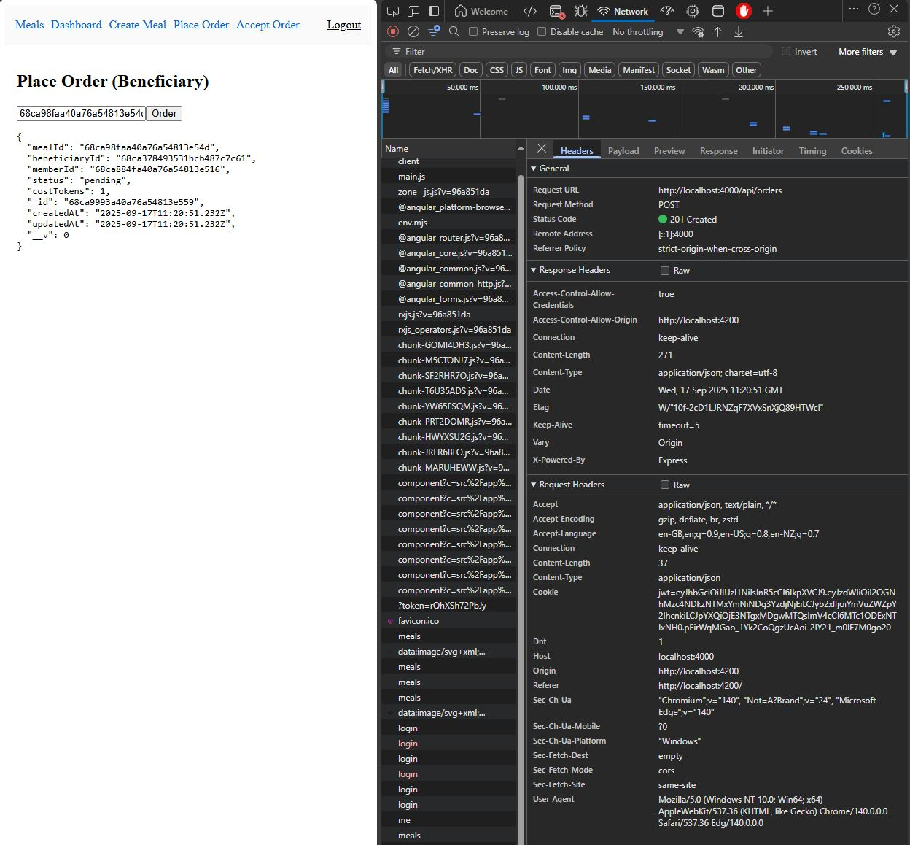

Member Accepting the Order

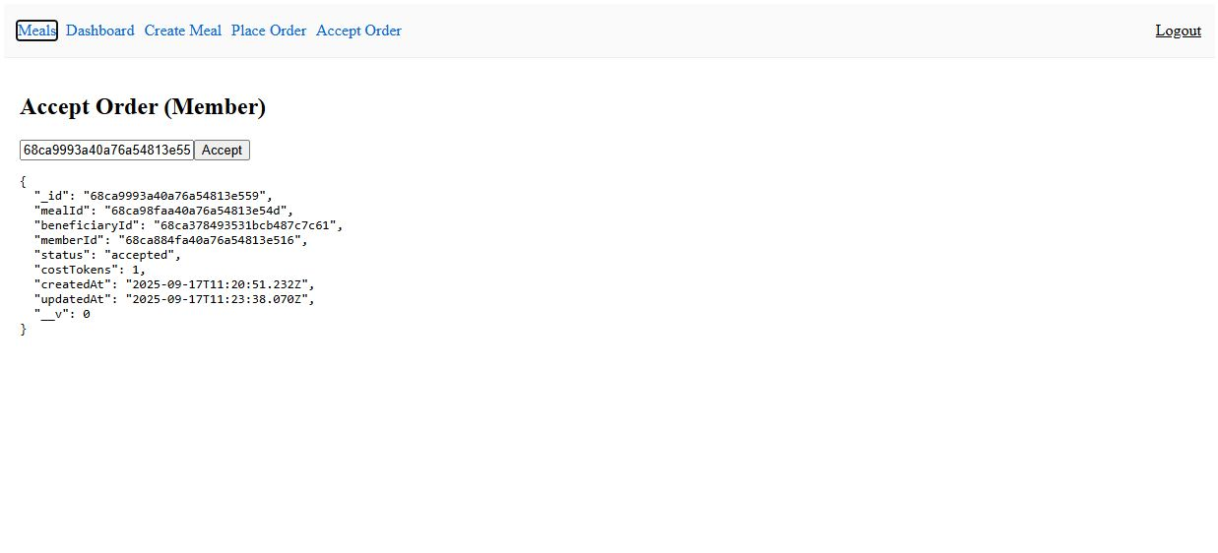

#### Requirement 2 Evaluation

In the MEAN prototype ‘tokens’ are the unit a beneficiary spends when ordering meals and a member confirms the order by accepting it. When the beneficiary places and order, the client sends a cookie-authenticated request to the API, with their credentials, which validates the meal, quantity, and the users current token balance, enforcing business rules prior to creating the new order document in MongoDB. Whilst the order is ‘pending’ prior to acceptance by the member, the ‘token’ is reserved to prevent the user from overspending tokens prior to acceptance of their orders. The same is repeated for when the Member accepts the order, sending and cookie-authenticated request to the API which checks the users’ credentials against the created order document to ensure the member is the user that created the meal listing and updated the order ‘status’ to ‘accepted’. All updates happen on the server so that the state stays authoritative and safe, the Angular client simply reflects the changes on the frontend and refreshes the pages after changes have been made.

### Requirement 3 – Data Storage and Retrieval

The following screenshots showcase the MEAN prototypes Meal listing creation and handling of user created data. Member users can enter Meal listing details into the form fields on the Angular frontend interface, create the meal listing, which is then sent to the API for validation via a cookie-authenticated request. Once the meal listing has been validated by the Express API, a document is then created in the MongoDB database and is then displayed on the Meals page to be viewed and ordered by beneficiaries. At this stage, the prototype only handles meal creation but there is placeholder functionality in the Express API controllers to handle the management (update/delete) of meal listings, but the frontend interface does not contain the relevant controls to complete these actions.

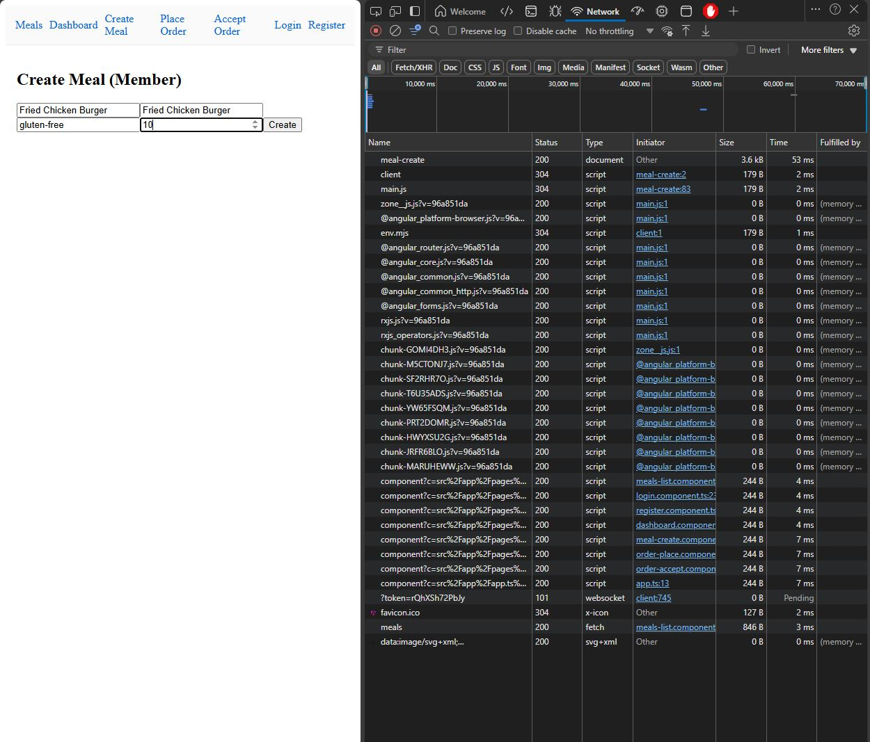

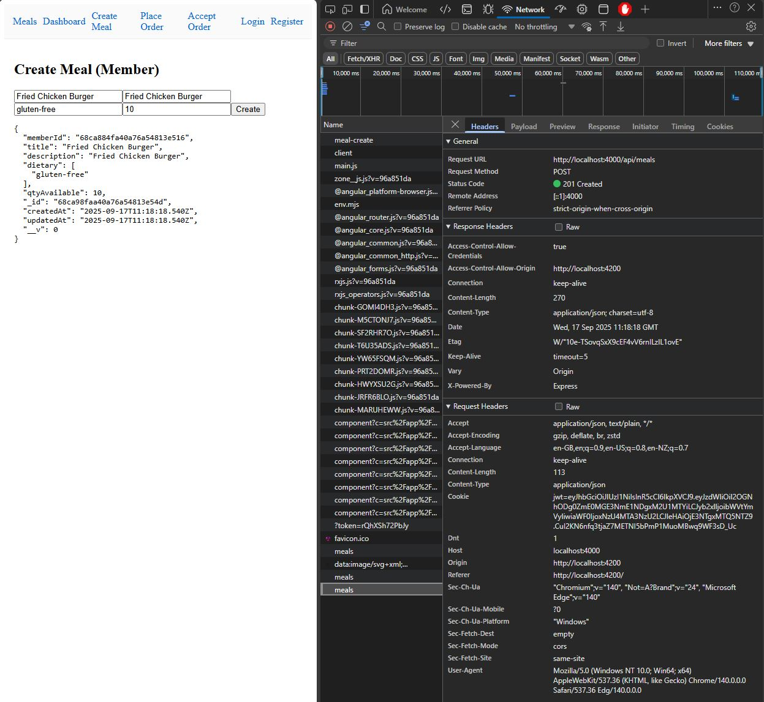

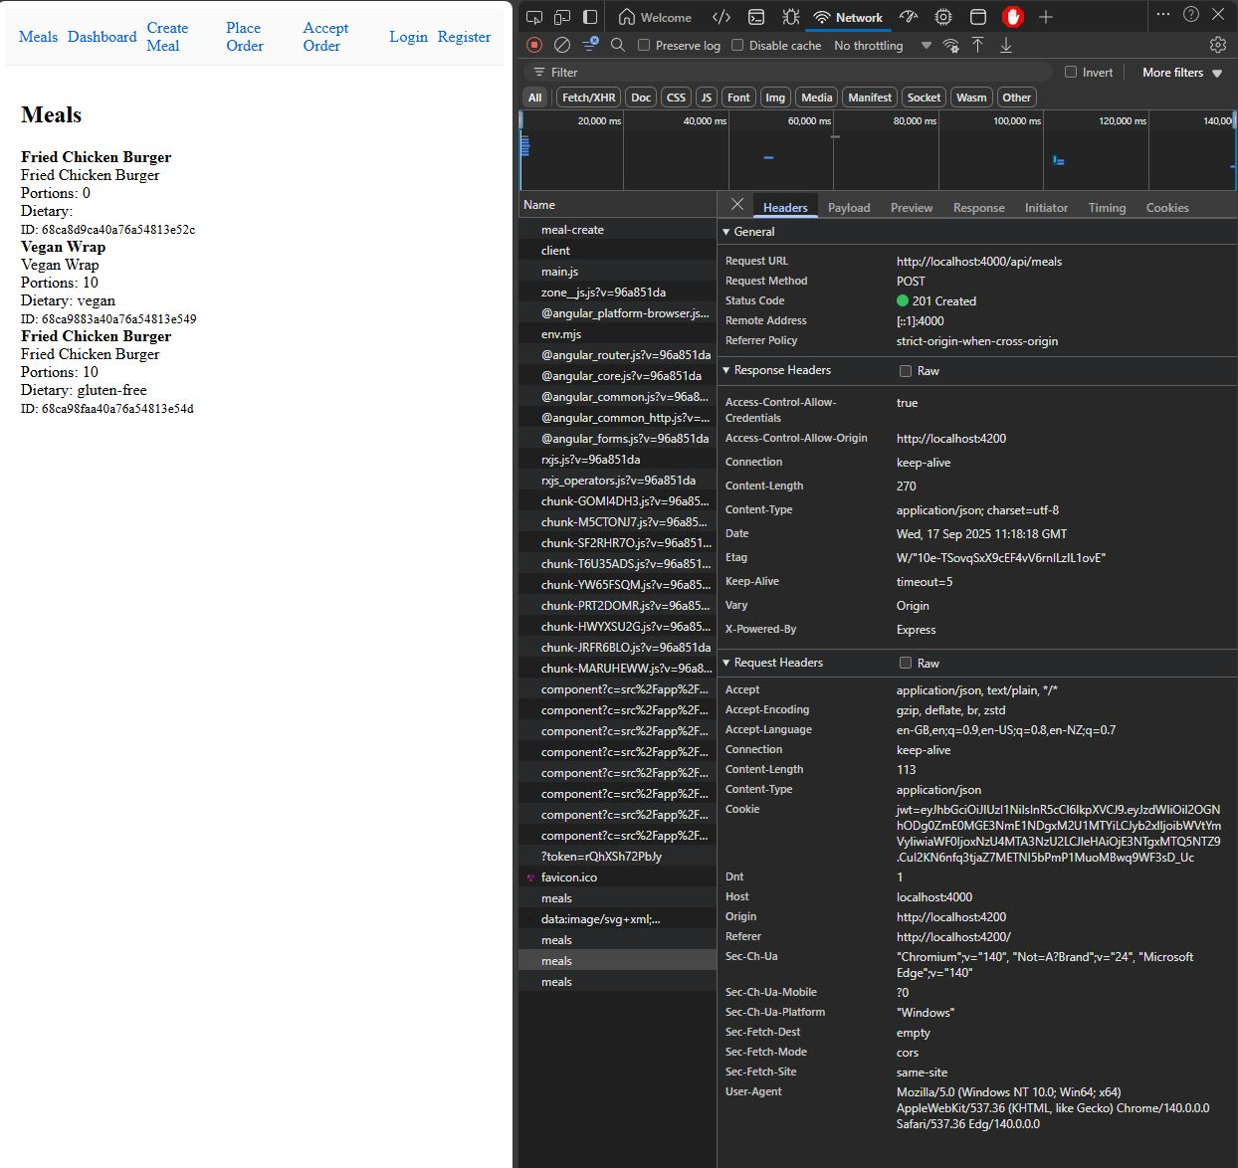

#### Requirement 3 Evaluation

The MEAN stack prototype handles user generated data, such as meal listings, by storing them directly in the MongoDB database, with the Express/Node API using Mongoose models to provide the structure of the meal listings and middleware providing authentication and validation. When a member creates a new meal listing, the React frontend submits the form data to the API, which validates the required fields before saving the meal document in MongoDB. Each meal document is tied to the member who created it via their unique ID, and includes attributes like description, dietary tags, and quantity available. The Angular frontend interface then displays the meal listings that are pulled from the MongoDB database for the beneficiaries to review and order.

# MEVN Stack Evaluation

The following sections showcase the required functionality and criteria of the MEVN prototype implementation.

### Requirement 1 – Registration/Login + Account Self-Management

The following screenshots show the MEVN prototype’s registration, login/logout, and account management functionality. Users can enter their details into the registration form and click the ‘Create Account’ button to submit their credentials and create an account, Vue then uses Axios to send the request to the Express API. The network shows the ‘me’ request has been made to check for current user state and JWT tokens on page load, this fails as no user or JWT token is present.

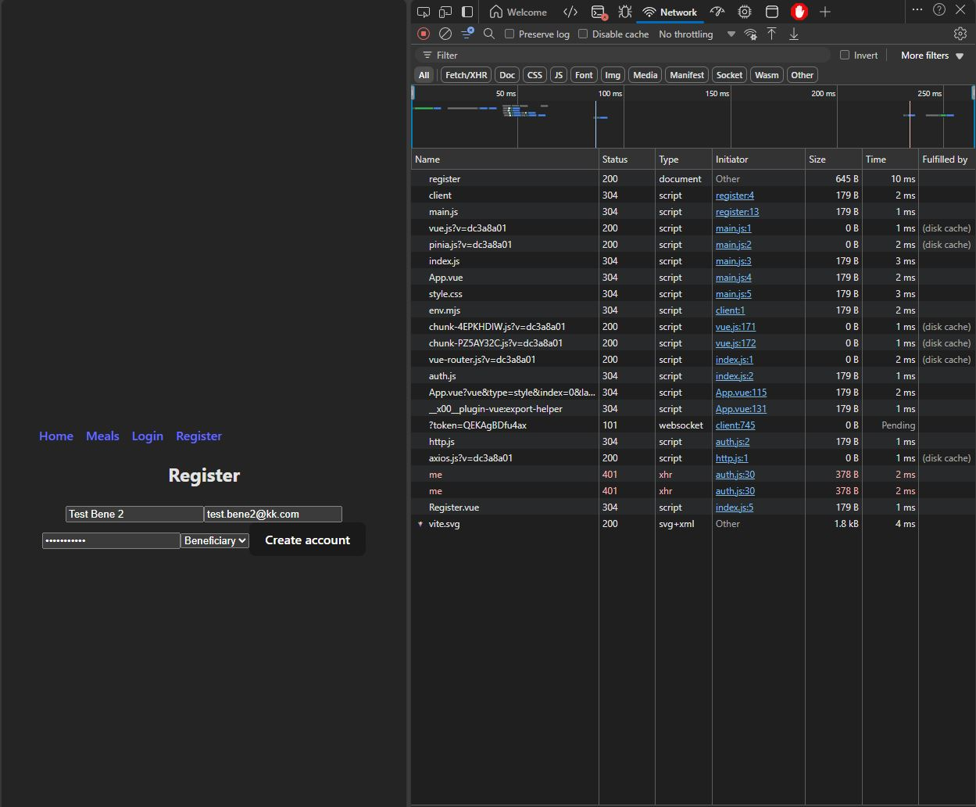

###### Account Creation Success + Login

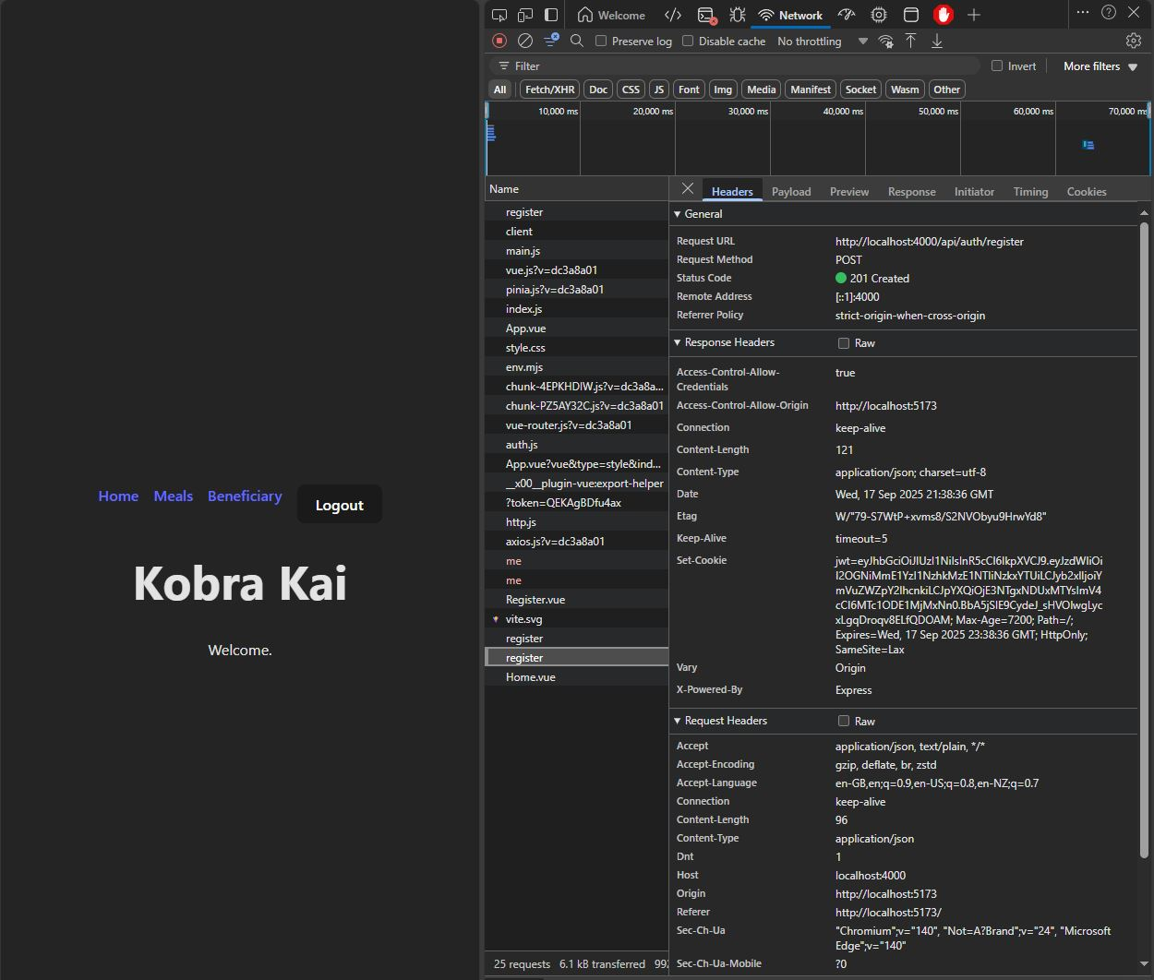

###### Beneficiary Dashboard

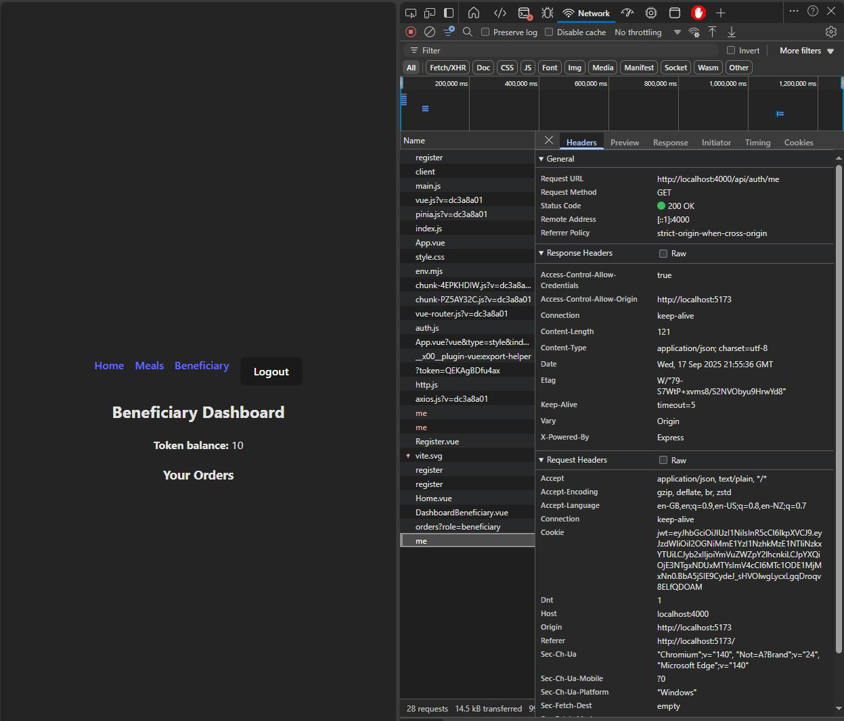

###### Account Logout Success

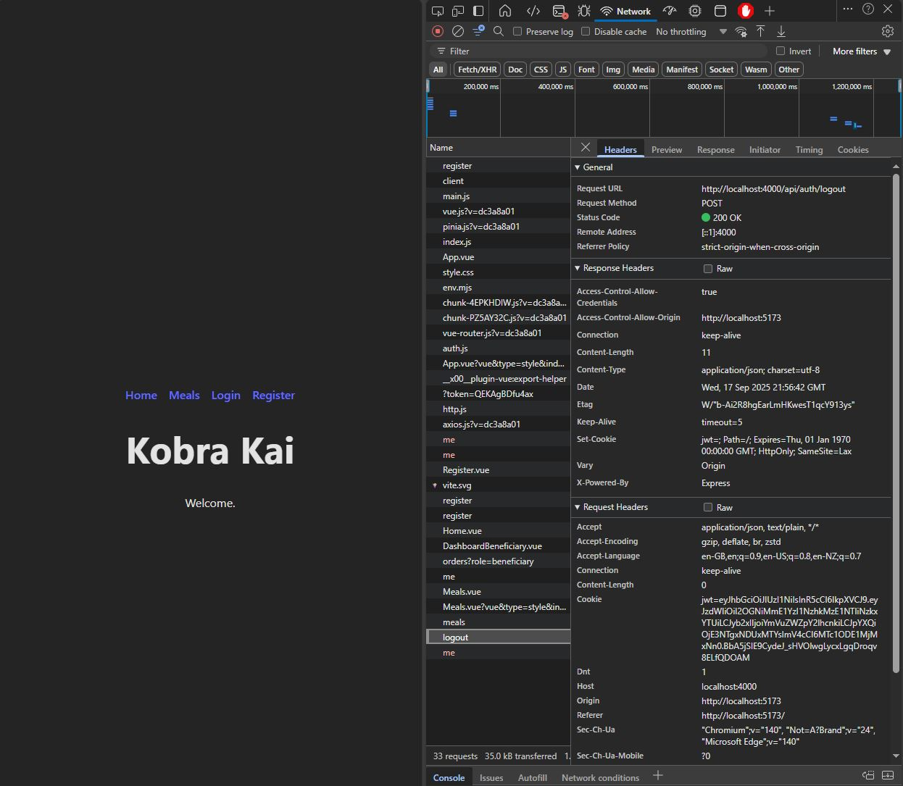

#### Requirement 1 Evaluation

The MEVN stack prototype implements user authentication and state management using a combination of Express, Mongoose, JWT, and Vue with Pinia. When the user enters their details using the form in the Vue client, the payload is sent to the Express API with a hashed password, where is validated and finally creates a document in the MongoDB. On successful registration or login, the API signs a JWT containing the user’s ID and ‘role’, which is then set as a secure HTTP-only cookie to manage the session. Once the JWT has been signed this is used for each subsequent request to authenticate the user and allow for specific functionality from the Vue client, such as locking meal creation to members only and so on. For the frontend, Pinia handles the centralized state management, which helps with hydrating the store with the users’ details after authentication and updating it when actions like Logout or token deduction occurs.

Requirement 2 *–* Token Transaction System and JWT Authentication

The following screenshots show the MEVN stack prototypes token transaction system by implementing meal ordering (beneficiaries) and order acceptance (members). The beneficiaries token balance is decremented by the “cost” value of a meal when ordered, the order document is created using the beneficiaries ID, members ID, and the meal ID, as well as setting the order status to pending. Once the member has accepted the order, the meal listing quantity is updated as well as the status being changed to ‘accepted’.

###### Meal Order (Beneficiary)

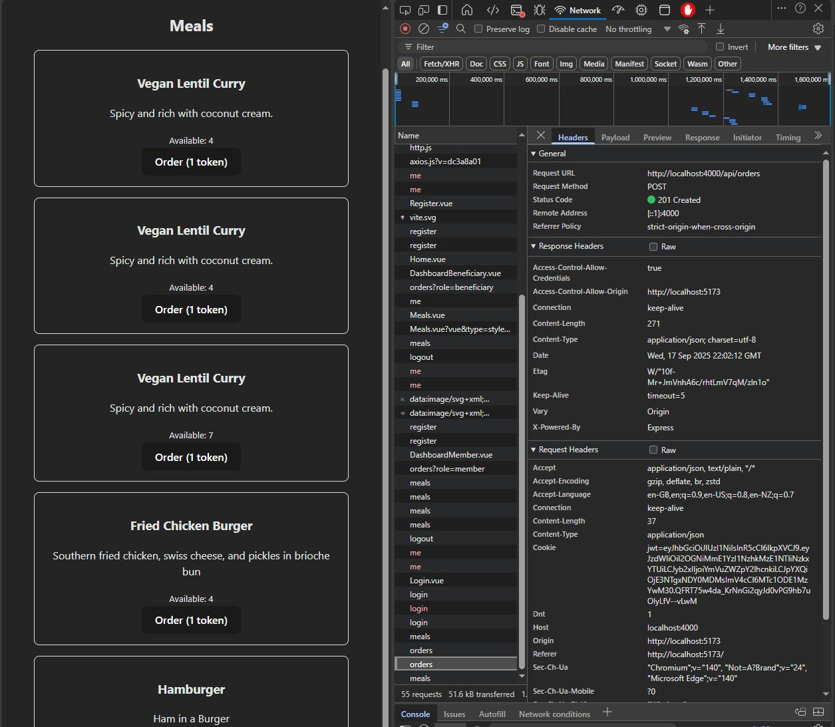

###### Member Accepting Order

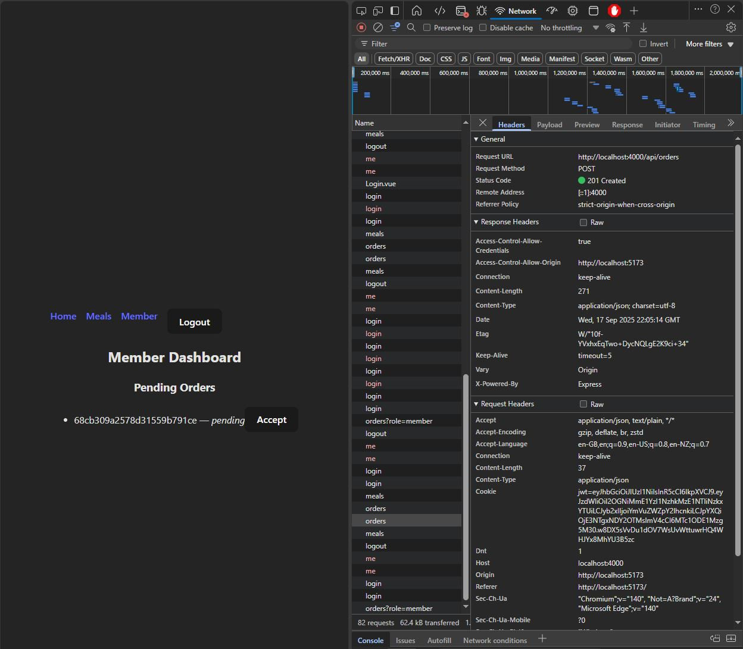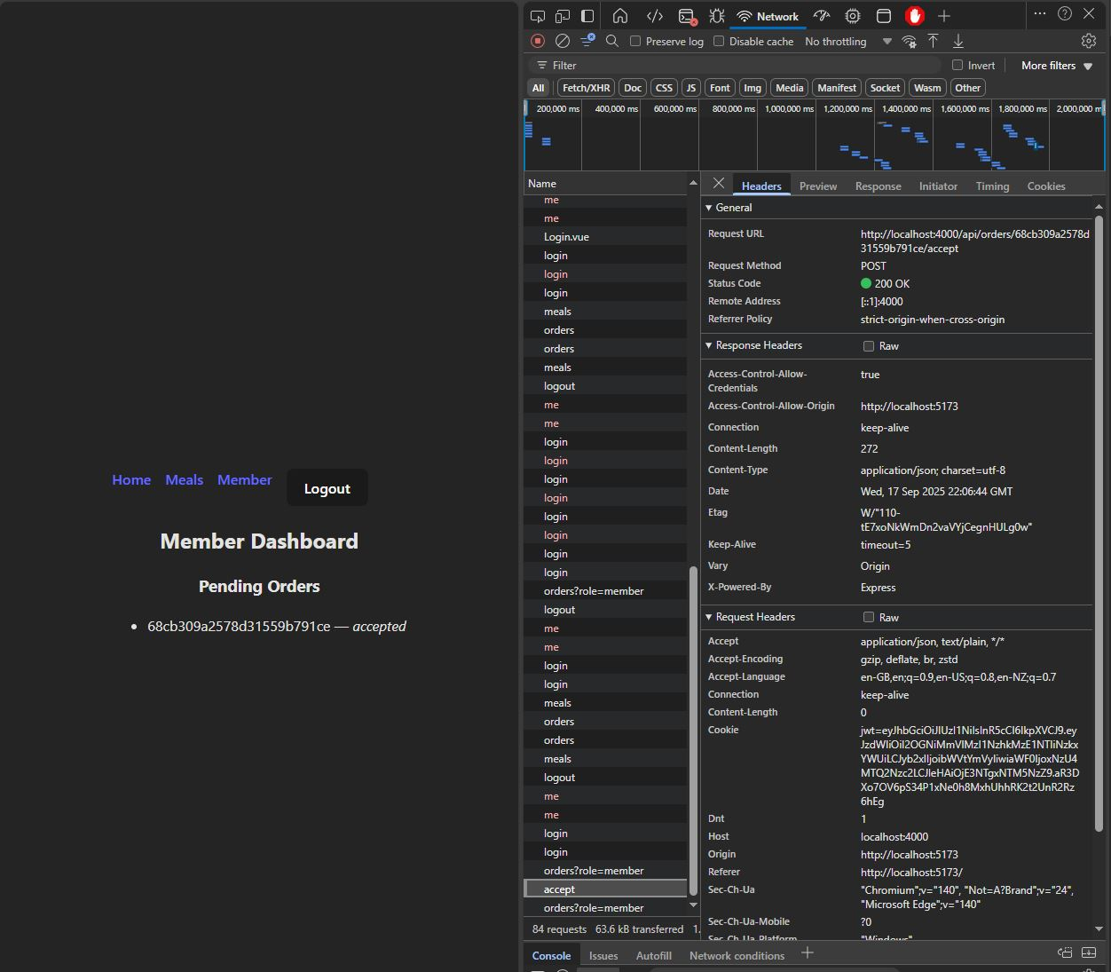

###### Beneficiary Dashboard (Order status and token balance)

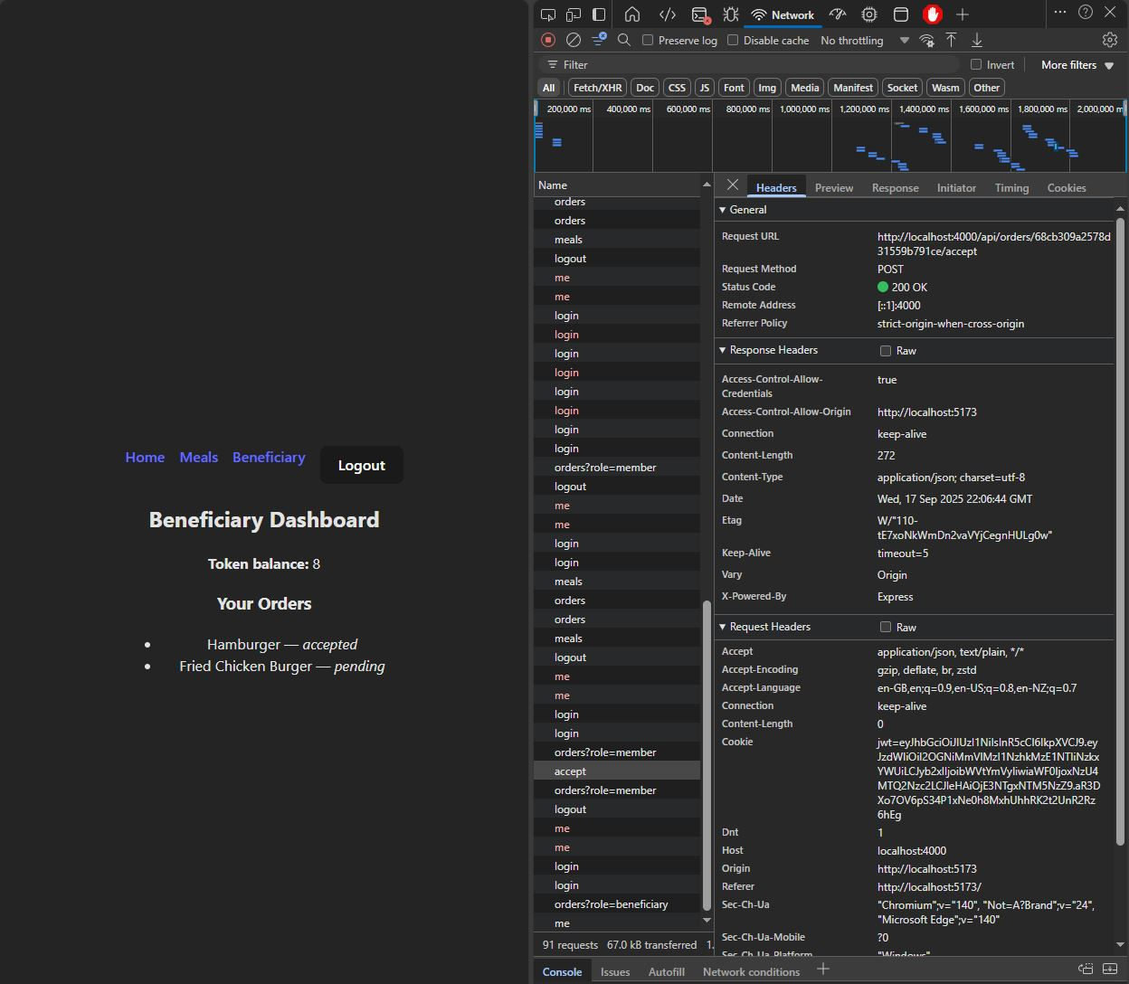

#### Requirement 2 Evaluation

In this MEVN stack prototype the token transactions and meal ordering are handled through the order workflow that connects the beneficiaries, members, and meals into one MongoDB ‘order’ document. When the order is placed by a beneficiary, the Vue client sends a request to the Express API with the meal ID using a cookie-authenticated request. The Express API then validates the request and enforces business rules prior to creating the document in MongoDB using Mongoose. The meal document is then updated with the reduced quantity value, as well as the beneficiaries token balance being decremented by the ‘cost’ value of the meal. Once the updates have been completed in the database, the Vue client then receives the response, then refreshes the client and sends a request to the ‘/auth/me’ endpoint to pull the updated user data from the database. This is then displayed on the Vue frontend in the form of updated token balance, pending orders, and updated meal quantity values on the meals page.

### Requirement 3 – Data Storage and Retrieval

The following screen shots show the MEVN stack prototypes meal listing creation and user data storage system in action. Members can create meal listings by entering the meal details into the ‘Create Meal’ form, which is then submitted, validated, and updated in the database. These meal listings are then displayed and made available for ordering by beneficiaries.

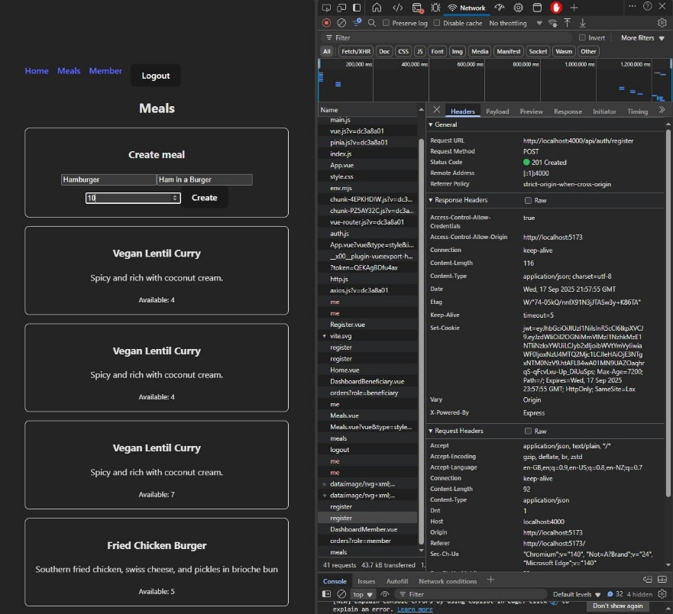

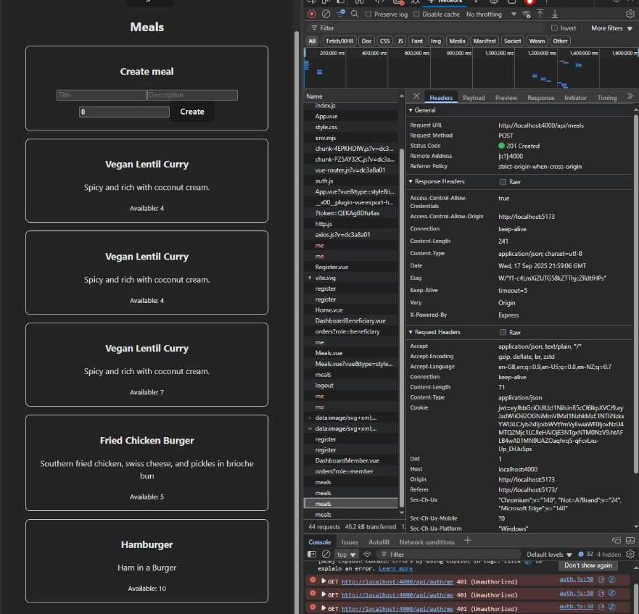

#### Requirement 3 Evaluation

The MEVN prototype handles user generated data storage and retrieval via Mongoose and MongoDB, as well as the routes and endpoints in the Express API. User, Meal, and Order are defined as Mongoose schemas in the Express API models, which are then used to create the documents in the MongoDB database. When the Vue client makes a request through Axios, the Express API uses these models the enforce the structure of the meal listing document, adding the meal listing details and assigning the members ID that created it, this way when Meals are ordered by beneficiaries, the order is linked to the member who created the listing. This process makes managing orders easier and more autonomous instead of having the filter through all the orders to find the ones that are relevant to the user. This also helps promote secure data storage and transfer as personal details of both user types can be found as part of the order document, such as the beneficiaries’ delivery address, name, and email address.

# .NET 8 / Blazor Stack Evaluation

The following sections show the functionality of the .NET 8 / Blazor stack prototype, this prototype does not function as intended as the API and database (LocalDB) and the Blazor frontend have been built but there is some issues with Meal listing creation and Ordering. I’ve attempted to fix the issue but the only functionality that works at this stage is the User registration and login features.

### Requirement 1 – Registration/Login + Account Self-Management

The following screenshot shows the process of registering an account and logging into the account. The Dashboard shows the user details on successful login and JWT tokens are signed to establish an authorized cookie that can be used to determine the users ID and role, this allows certain functionality to be made available to user on the Blazor UI.

###### User Registration Success

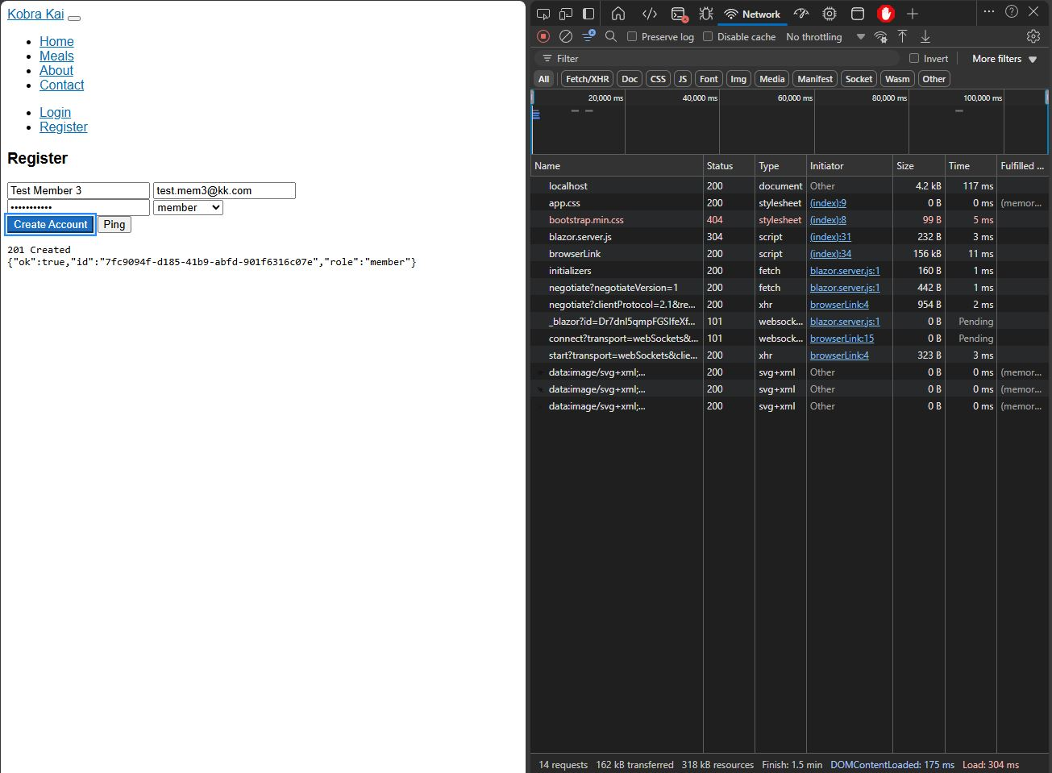

###### User Login Attempt

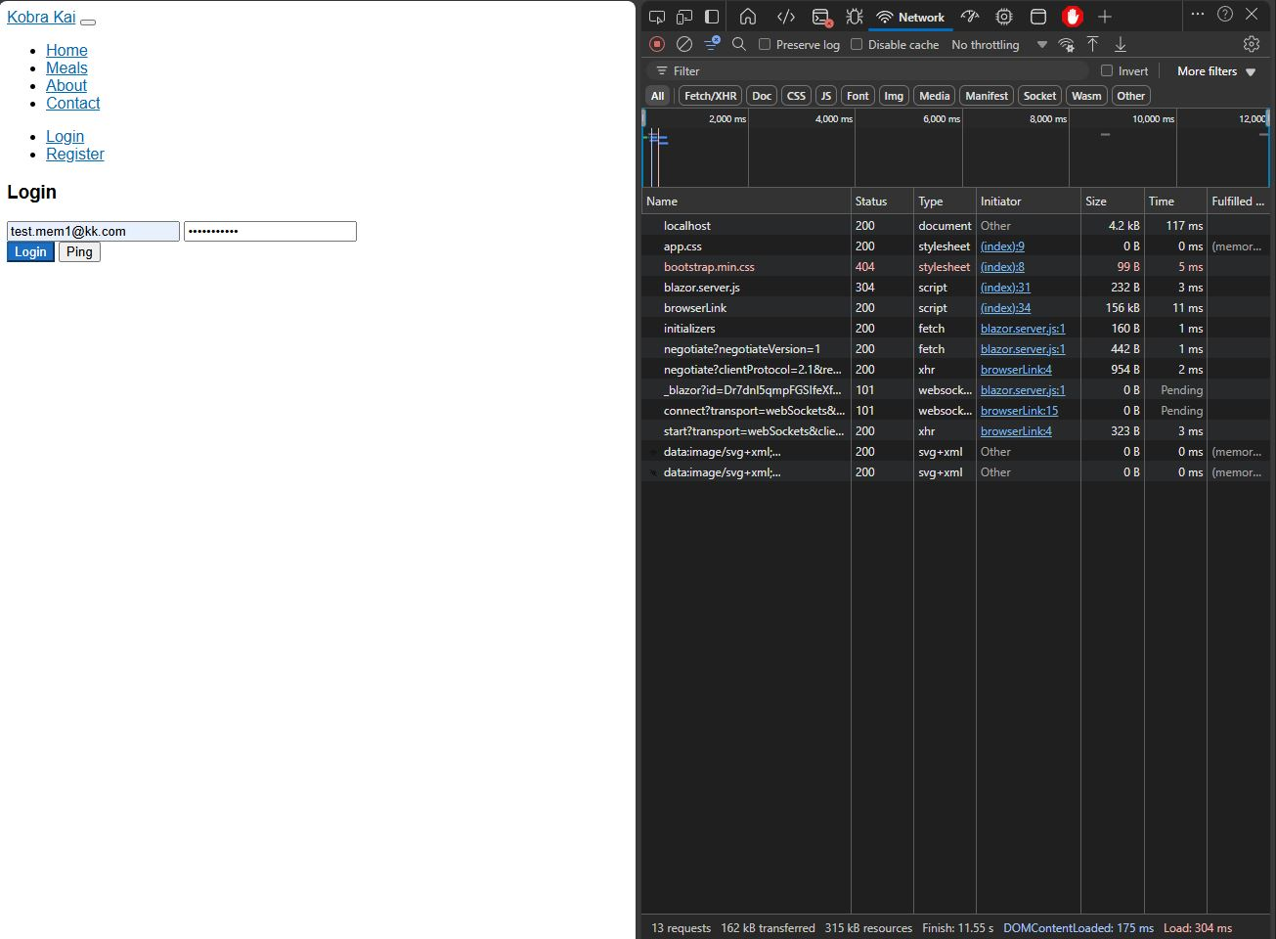

###### User Login Success and Dashboard View



#### Requirement 1 Evaluation

The .NET 8/Blazor stack prototype handles user registration and login though an Auth workflow that takes the users details on registration, validates the fields in the API and signs a JWT token prior to inserting the data into the database. The user can then login to their account using the authenticated credentials which is auth checked against the data in the database, returns the valid request and signs a JWT token to allow for the Blazor frontend to allow role specific functionality to be made available. The user dashboard is then displayed on successful login which displays the users account details, these details are stored locally to be used in Meal listing creation and other role specific features.

Requirement 2 & 3 *–* Token Transaction System, JWT Authentication, Data Storage and Retrieval

This functionality could not be completed in the prototype, the API endpoints are present but there is an issue with the Blazor client not being able to reach the ‘/api/auth/me’ endpoint which is used to check the user Id and role against the JWT token. Essentially, I cannot create Meal lsitings when logged in as a member which also meant that I could not test the Token transaction system for Ordering and handling token transactions. This seems to be an issue with how Blazor handles routing in the newer versions of .NET 8 and Blazor Web App, the end points can be tested using the Swagger UI that was implemented in the API for testing but without authentication the Ordering and Meal endpoints return 404 errors. The following screen shots showcase the issues and responses from the server.

###### Logging in as a Member

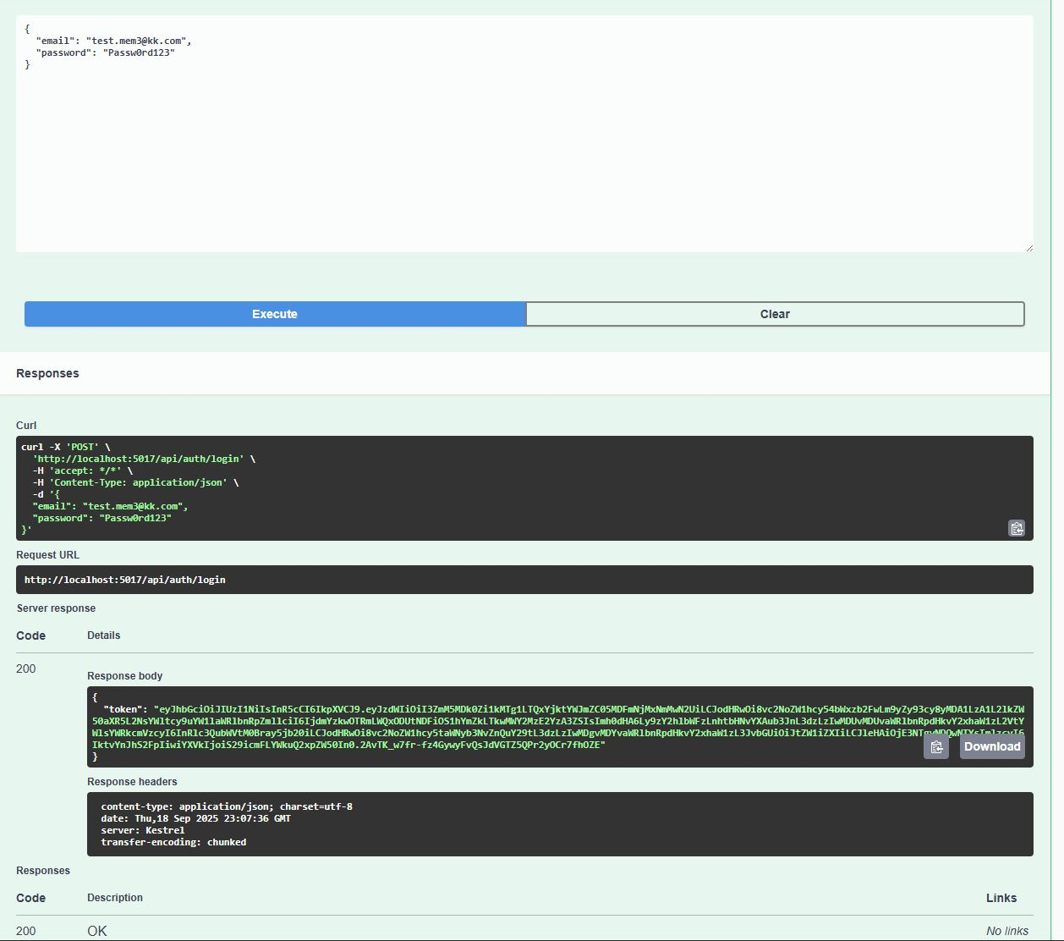

###### /api/auth/me Test in Swagger UI

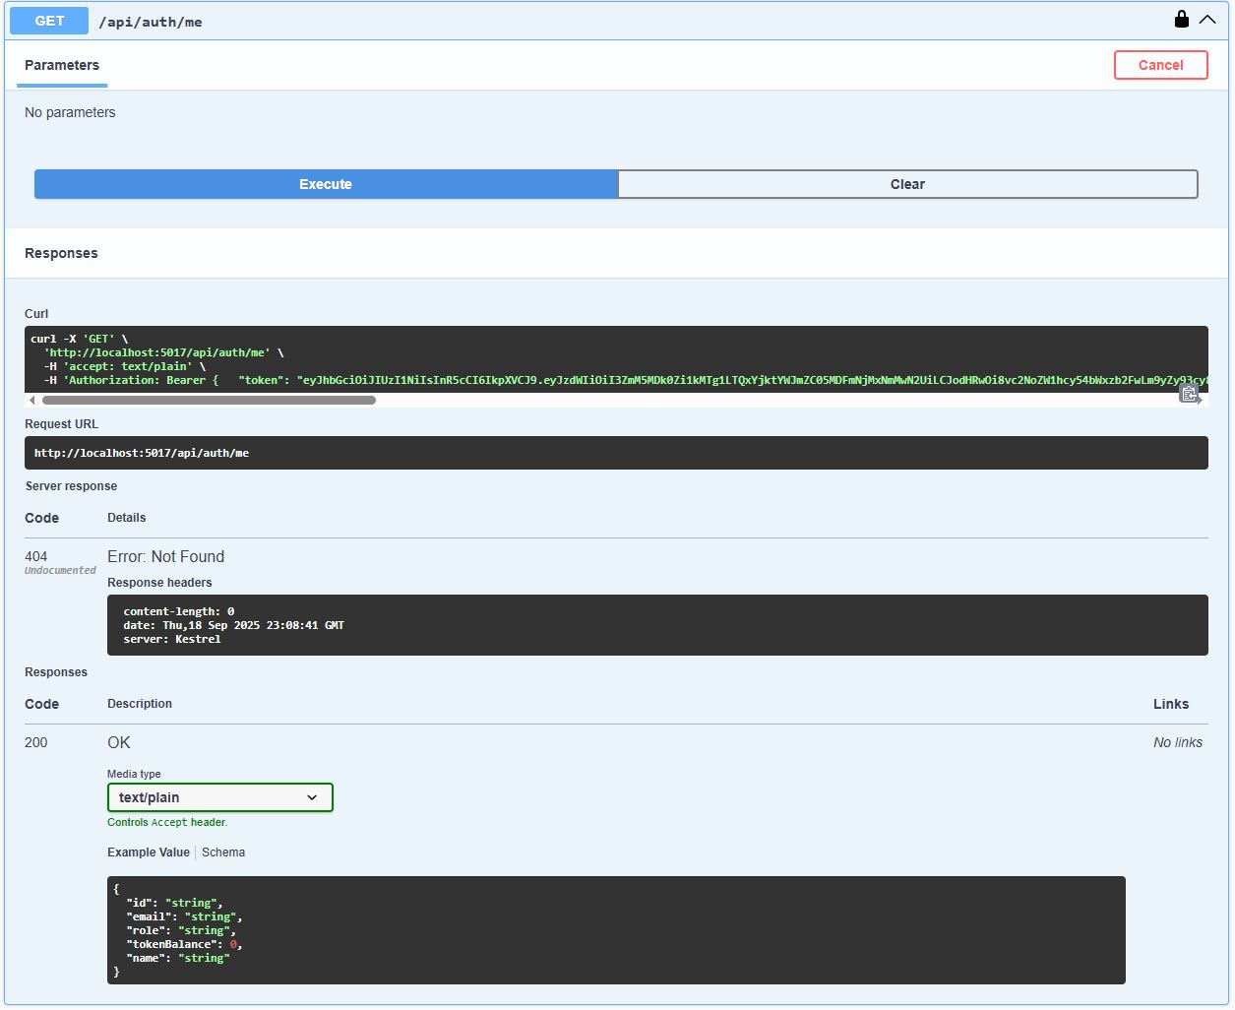

###### /api/meals Meal Create test in Swagger UI after Authorizing

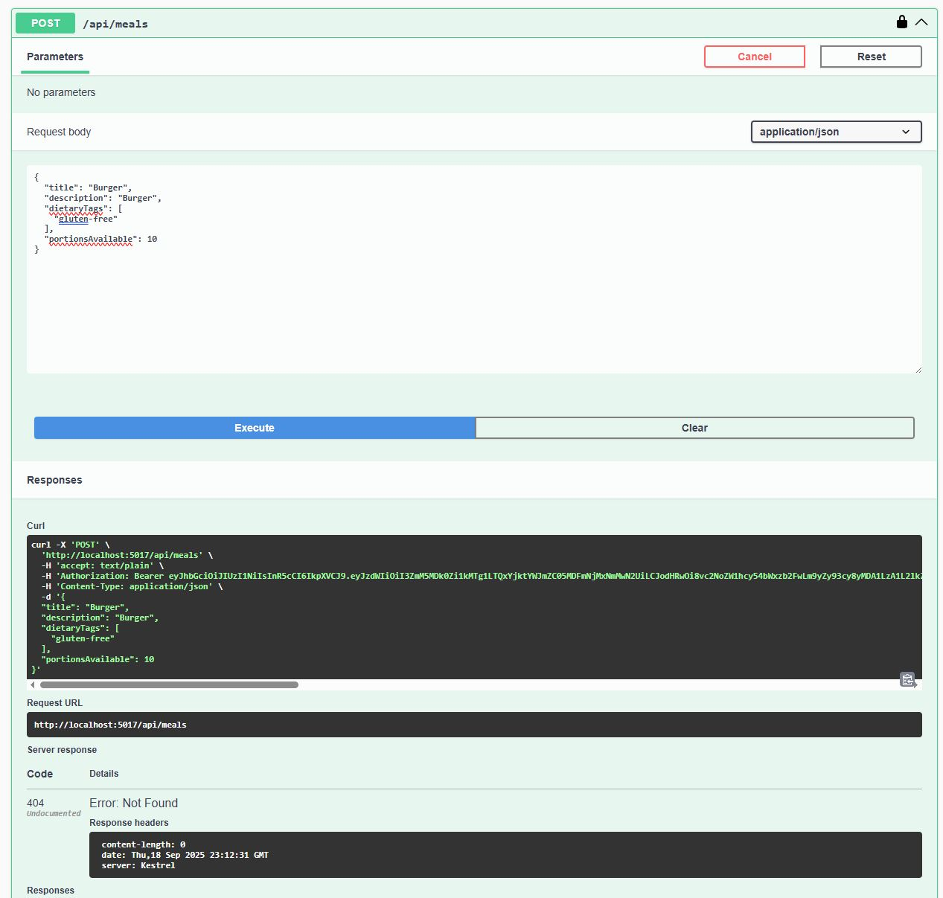

###### /api/meals Meal Get Test in Swagger UI

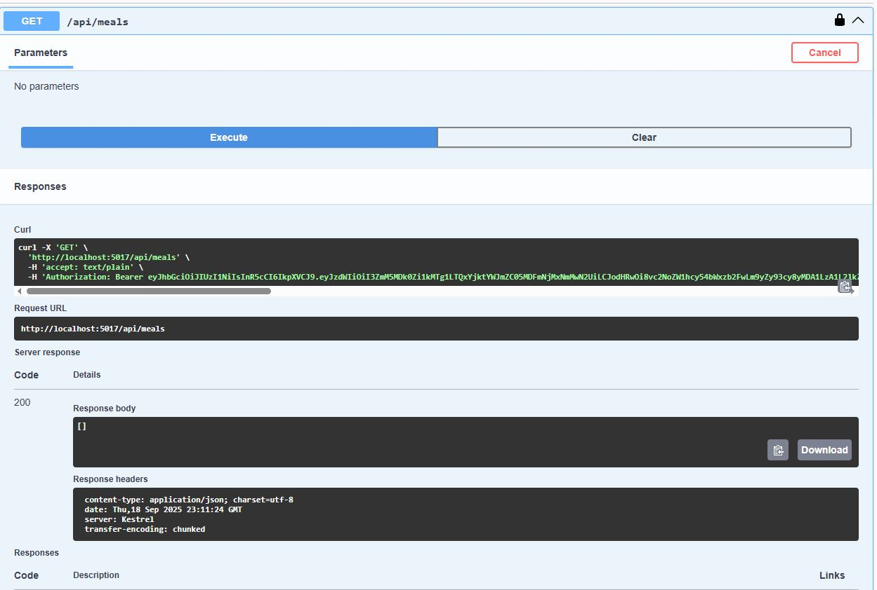

#### Requirement 2 and 3 Evaluation

Due to the large number of issues, I was having getting this functionality to work, I’ve done as much testing as bug fixing as I can do with the required time allocation and I cannot fix the issue. As shown in the Swagger UI tests, the API endpoints are exposed and do return responses, so the API project does work and is available to the client. The issue is coming from how Blazor handles JWT authentication and routing to the API endpoints. Regardless of having a valid JWT token signed, stored, and present, I could not get the system to allow me to POST Meal listing or Create Orders with authenticated users. This problem may be able to be fixed but due to the complexity of this system and how long it is taking to complete, I’m not going to consider the .NET 8 / Blazor stack as a viable candidate for the Kobra Kai project.

I’m not really sure why I was having so many issues with attempting to send POST requests to the API, it definitely has something to do with checking the JWT token against the users data that is retrieved from using the /api/auth/me endpoint, it didn’t really matter what I tried to fix this I was still having the same issue. Unfortunately this prototype is only half finished but it does make my decision making process easier when trying to select the correct stack to use for the project so not a total loss.

# Python / FastAPI Stack Evaluation

The following sections show the Python / Fast API stack prototype functionality and screen shots showcasing the frontend client UI tests that were conducted to evaluate the prototypes viability as an option for the Kobra Kai project.

### Requirement 1 – Registration/Login + Account Self-Management

The following screen shots show the user registration, login, and Account management (dashboard) functionality and the request/response from the server.

###### Beneficiary Registration

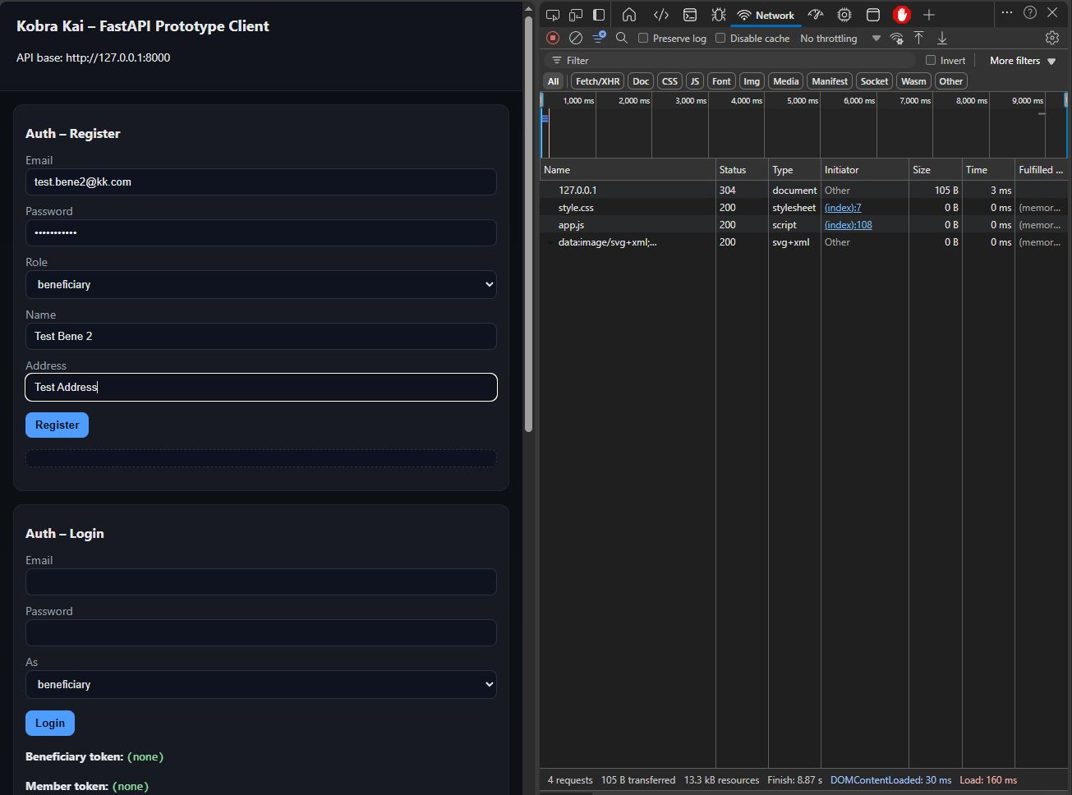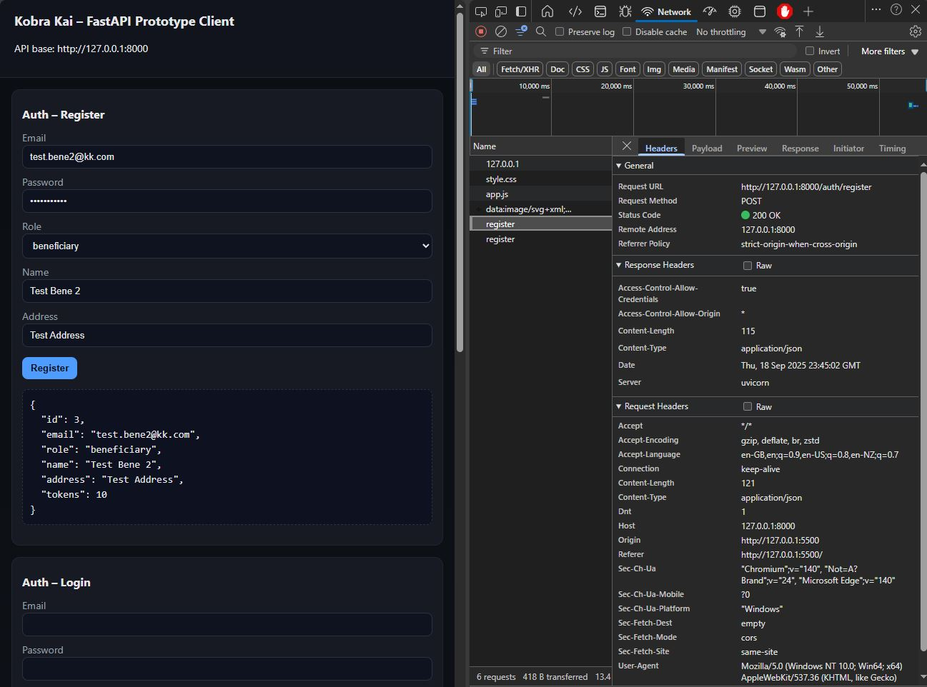

###### Beneficiary Login and Dashboard

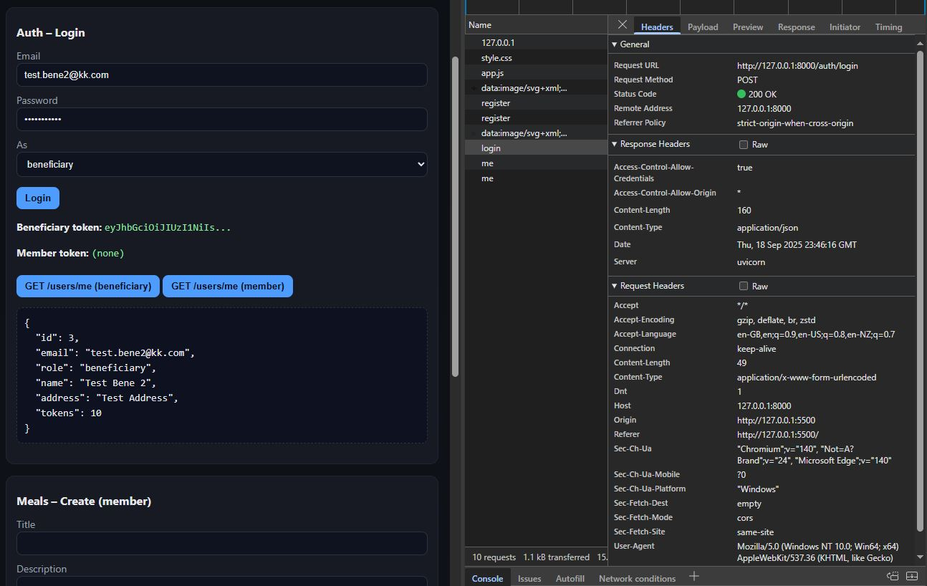

###### Member Registration and Login/Dashboard

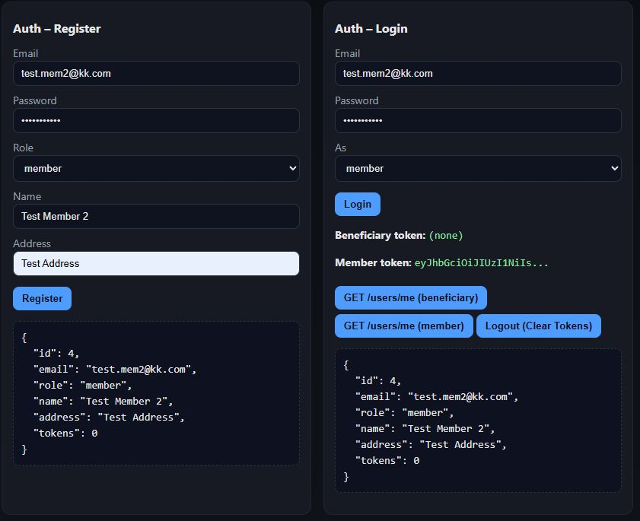

#### Requirement 1 Evaluation

The Python / FastAPI stack prototype implementation uses a secure user registration, login, and state management using JWT. When a user registers for an account, the front end client uses the /auth/register endpoint from the FastAPI, their account is created in the database with role-specific rules and credited with 10 tokens to their account balance. Member users are created in the same way except they are not credited tokens to their account balance but are given role specific access controls to allow for specific functionality on the frontend. Passwords are hashed with bcrpyt and stored, as well as email checks against the database to ensure no duplicate email addresses are used for account creation. Login is also managed through the /auth/login endpoint, which verifies the credentials and signs a JWT with the users ID. This token is then provided to the Authorization header and used in all subsequent requests being made by that user, allowing the FastAPI dependency system top identify the user and enforce the role-based access controls. Orders, and Token balance states are managed in the database and automatically updated during each transaction, ensuring consistency between sessions. The changes are then automatically updated and displayed on the frontend client UI to the user.

Requirement 2 *–* Token Transaction System and JWT Authentication

The following screen shots show the Token Transaction System and JWT authentication being implemented by the prototype, allowing users to place orders, and member users can accept the orders. The beneficiary users token balance is automatically decremented based on the cost value of the meal they are ordering, while Members can accept the order changing the order status from ‘pending’ to delivered. The Meal quantity available is also decremented, keeping the inventory consistent.

###### Beneficiary places order

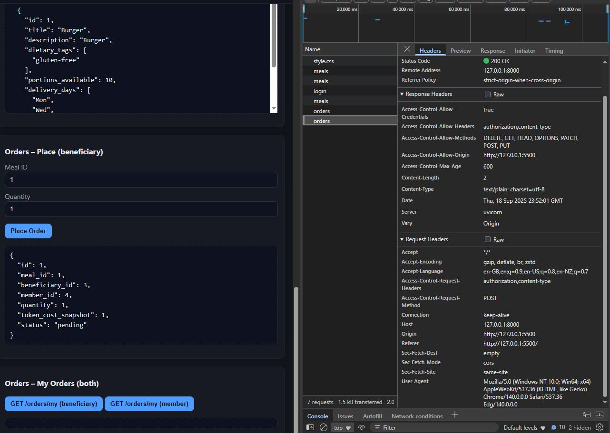

###### Member Accepts the Order

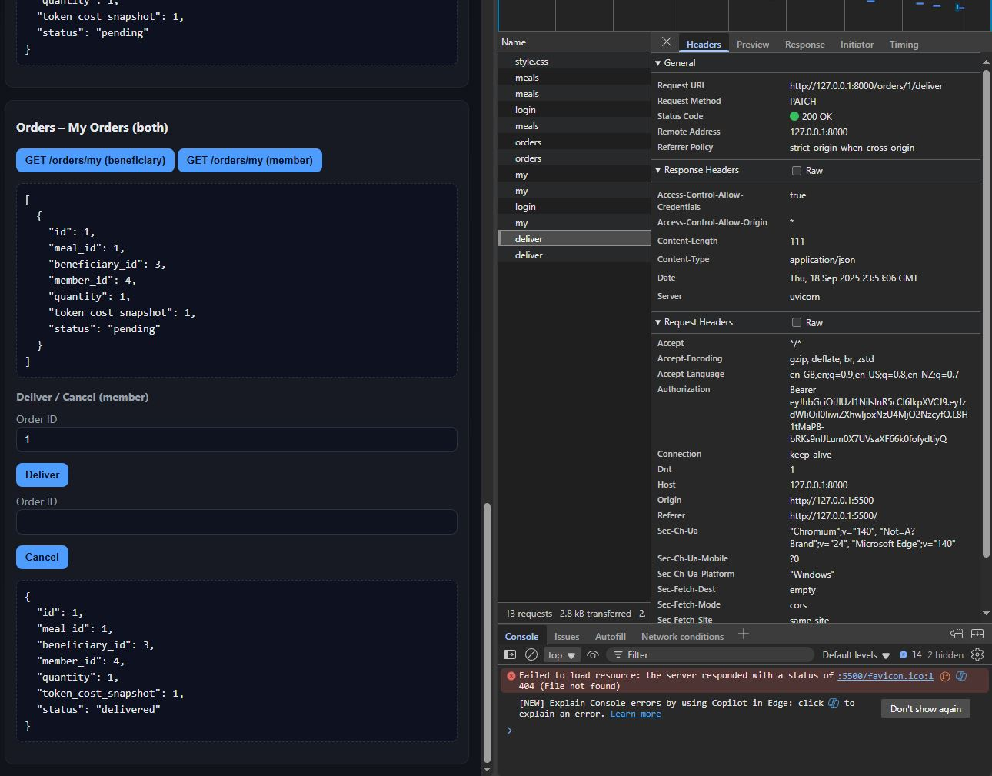

###### Beneficiary Dashboard after Order is accepted

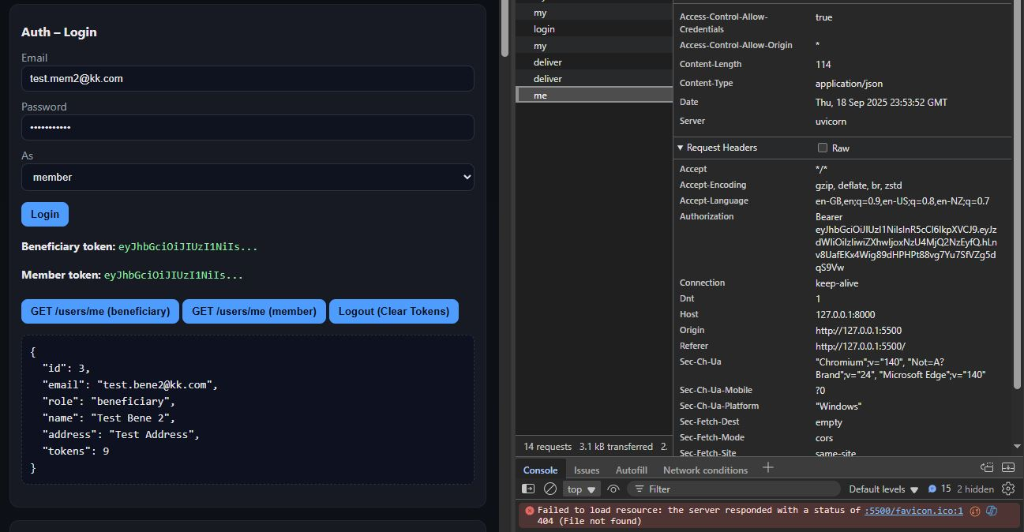

#### Requirement 2 Evaluation

The Python / FastAPI prototype models the token transactions as part of the order workflow to keep the token balances and inventory consistent. When a beneficiary places and order via POST /orders with a meal_id and quantity, the API verifies the meal exists, the quantity is >1 and enough portions are available. It then computes the required tokens and checks the beneficiaries token balance. Once validated, the system performs an atomic update in one commit, deducted the tokens from the users account balance, decrementing the quantity of portions available, and creating the order record with the user Id, meal Id, and member Id. This can then be viewed by the member who created the meal listing and can be accepted, updating the status from ‘pending’ to ‘delivered’ completing the order. There are also functionalities in place to cancel the order for both beneficiaries and members.

### Requirement 3 – Data Storage and Retrieval

The following screenshots show the Python / FastAPI stack prototypes’ data storage and retrieval functionality, specifically for Members creating Meal listings from the front-end UI.

###### Member Creating a Meal

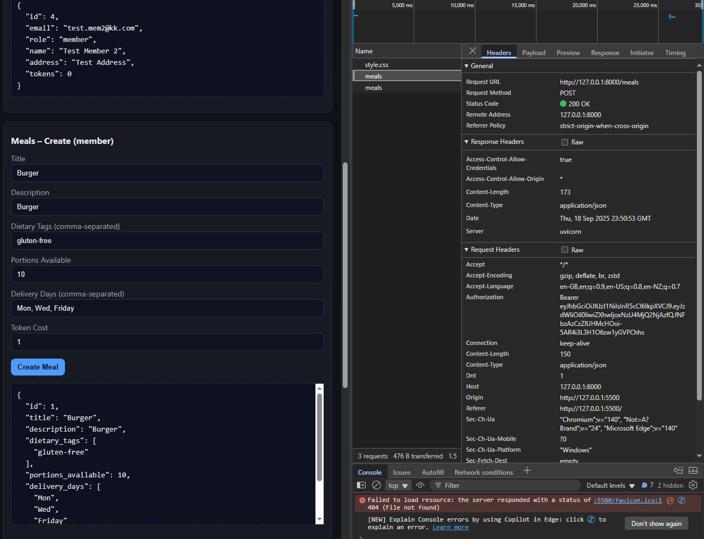

###### Meal Listing retrieved and displayed on frontend UI

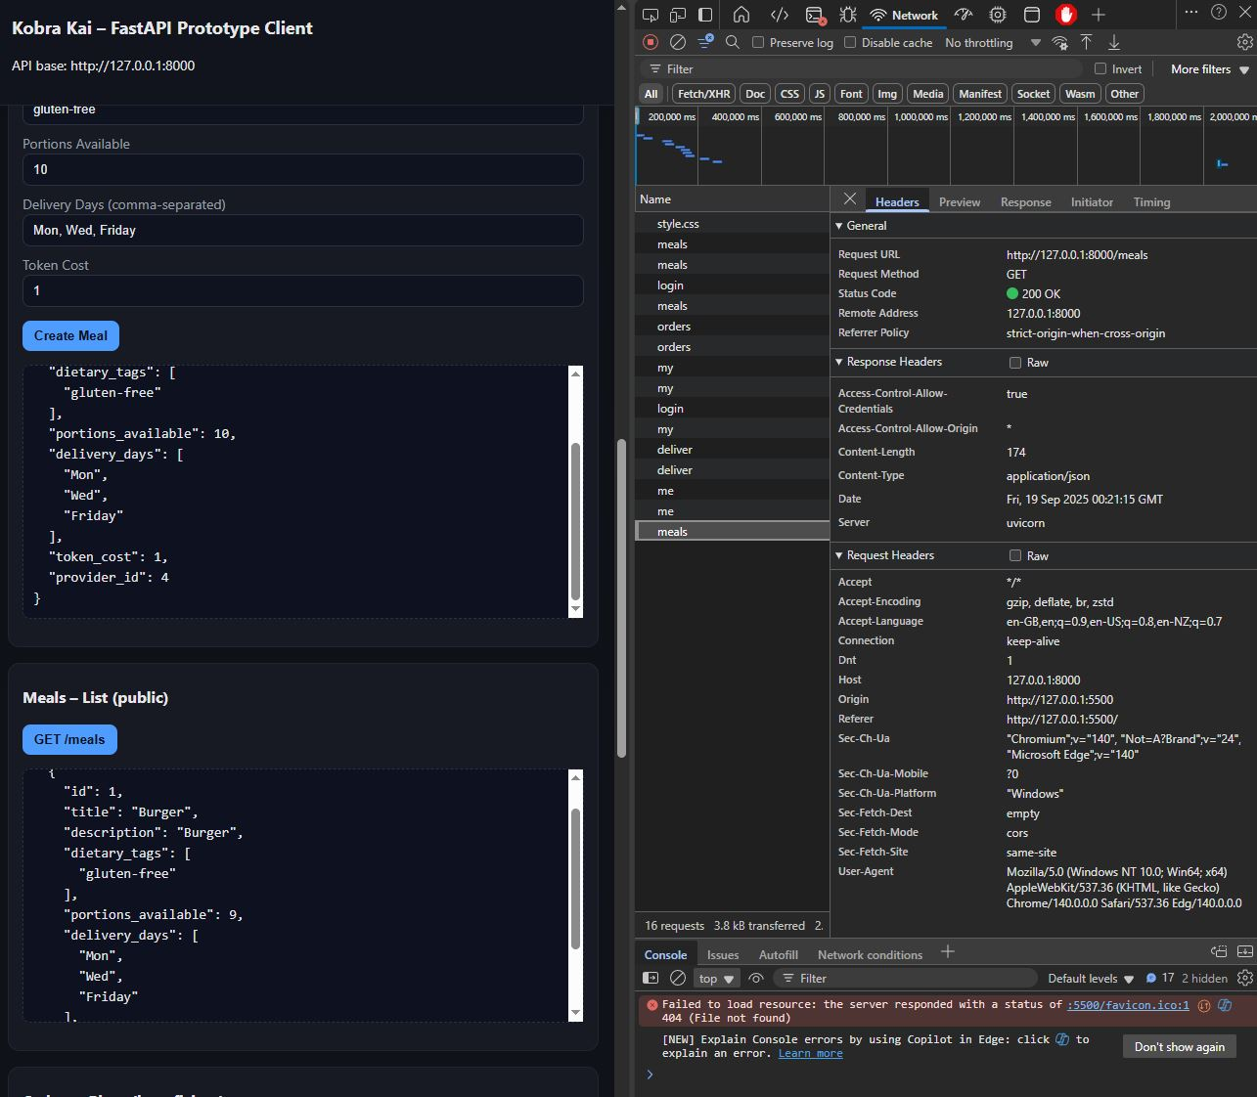

#### Requirement 3 Evaluation

The Python / FastAPI prototype uses a relation database (SQLite for testing) with the SQLModel to create and persist meal listings and linking them to the member who created them. When a member submits a meal listing through the /meals endpoint, the API validates the input and saves the record with the required fields in the database. Each meal entry is stored with a foreign key reference to its provider (member user), ensuring the accountability and ownership of the meal listing. The retrieval is handled through the GET /meals request, which pulls all the meal records from the database and those are used to display them on the frontend UI for the beneficiaries to review and place orders using the meal ID. This functionality is basic and handles well enough in the prototype to showcase the FastAPI and Pythons ability to handle data storage and retrieval.

# Framework/Stack Comparison and Evaluation

This section contains a framework/stack Comparison and Evaluation marking table that outlines each prototypes completeness, complexity, and time to develop, as well as an overall mark. These have been graded based on the prototypes that were created and how easy or difficult they were to implement, the over all grade is to help determine which framework and stack would be the most viable option for the Kobra Kai charity website platform.

#### Marking Grid

|  |  |  |  |  |
| --- | --- | --- | --- | --- |
| ***Framework / Stack*** | ***Prototype Completeness (/5)*** | ***Complexity (/5)*** | ***Time to Develop*** | ***Overall Mark (/10)*** |
| MERN (MongoDB, Express, React, Node) | 5 – Fully working prototype with registration, JWT login, Meal CRUD, and Orders. | 3 – Moderate. Requires setup of React + Express and Mongo Integartion | Medium (Good documentation, wiring frontend/backend takes some time. | 9/10 |
| MEAN (MongoDB, Express, Angular, Node) | 4 – Authentication and CRUD working, but Angular requires more boilerplate. | 4 – Higher complexity; Angular is opinionated with TypeScript structure. | Long (steeper learning curve, slower initial build). | 7/10 |
| MEVN (MongoDB, Express, Vue.js, Node.js) | 4 – Registration/login and CRUD demonstrated, frontend lighter than Angular but more complete. | 2 – Lower complexity; Vue is simple to scaffold and integrate. | Short (fast prototyping, quick learning curve). | 8/10 |
| .NET 8 / Blazor Server | 3 – Authentication tested, CRUD wiring more involved, API integration still in progress and not complete. | 4 – High; requires knowledge of .NET layers, dependency injection, EF Core. | Long (setup/configuration-heavy, but powerful once structured). | 6/10 |
| Python / FastAPI | 4 – API stubs working, registration and JWT implemented, minimal frontend. | 2 – Low complexity for backend but needs external frontend pairing. | Medium (fast backend dev but requires Vue/React/Angular on top for better functionality). | 7/10 |

# Framework/Stack Recommendation

#### Recommendation: MERN (MongoDb, Express, React, Node)

Once completing the framework/stack prototyping exercise and conducting a thorough evaluation of each of the web technologies and the functionality they provide, the MERN stack is the strongest viable candidate for the Kobra Kai website platform. The MERN prototype achieved the highest score based on the requirements for the website, the completeness of the prototype, the complexity of the stack development, and the time to develop marking rubric. The MERN stack prototype, whilst moderately complex to develop, demonstrated successful user registration, user login, JWT authentication, state management, and secure data storage and retrieval. Additionally, the token transaction system leverages JWT authentication to allow users to easily and securely order meals from the platform, whilst simultaneously providing the member users with real-time updates for pending orders that can be viewed, managed, and accepted using the frontend user interface.   
  
The React frameworks component-based architecture and the vast ecosystem of available libraries make it an ideal choice for the Kobra Kai project. The components are well suited for all device types, implementing responsive styling and easy to integrate UI components makes developing the Kobra Kai project easier with a smaller team, and easier to maintain and scale in the future. The MERN stack receives ongoing support and extensive documentation, which allows for easier troubleshooting and bug fixing, which makes development more efficient. In addition to the previous justifications, React is also compatible with my chosen emerging technologies (PWA’s and Push Notifications), making integrating modern technologies and techniques easier to achieve, and hopefully reduce development costs and resources.

The MEVN prototype also scored and performed very strongly, particularly with the time to develop and the level of complexity for the developers. Whilst MEVN was also a very strong candidate, the MERN stack’s robust foundation, vast libraries of components, integration of emerging technologies, and support for long-term growth outweighed the benefits of using a less complex framework such as Vue.

Overall, this evaluation process provided sufficient insights and evidence to support the recommended choice to use MERN as the Kobra Kai stack/framework. Evaluating multiple frameworks and web technologies is a useful tool when choosing the technologies to be used for a project. Without the insights that were gained during this process, development could have been more complicated with the need for additional, time, resources, and manpower to complete the project. MERN was the best choice for this project and that was made clear with the evidence that was gained through the evaluation phase of the project.

Website Development

## Implementing the website and emerging technology

## 12/11/2025

#### Project GitHub: <https://github.com/AlexHerbertGit/Kobra-Kai-Web-Application.git>

#### Functional Implementation of the Kobra Kai Website

This section documents and critiques the implementation and development of the Kobra Kai charity website using the MERN stack (MongoDB, Express.js, React, Node.js). The implementation builds directly on the Information Architecture (IA), CRUD Analysis, and API prototypes developed in the Evaluation phase of the project. The prototype that was developed during evaluation has been extended into a fully functioning, full-stack application that now includes a Progressive Web App (PWA) and web push notifications.

Each of the required features is described in terms of:

* How it has been implemented in the final system.
* Additional work required to develop the system beyond the original prototype.
* A brief critique of the approach taken, including a comparison with alternative frameworks.

In short, the following documentation will detail each step taken to develop the Kobra Kai web platform, its requirements, and integration of an emerging technology to produce a production ready web platform.

#### User Registration, Login, and Account Administration

The user registration and authentication requirements are implemented using a dedicated User collection in MongoDB (MongoDb. 2025), accessed via Mongoose (mongoosejs. 2025) models in the API. Each user document includes fields such as name, email, passwordHash, role (beneficiary or member), address, and token balance. The role field dictates the role-specific behaviours and views throughout the web application, allowing for the different user dashboards, account management, and ordering capabilities to be applied based on the user’s role.

The backend API routes, handled by Express.js expose endpoints such as:

* POST /api/auth/register – Registers a new beneficiary or charity member account.
* POST /api/auth/login – Validates user credentials and issues a JSON Web Token (JWT).
* GET /api/users/me – Returns the user profile for the currently authenticated user.
* PUT /api/users/me – Allows users to update their account details.

Passwords are never stored in plain text, during registration the server hashes the user’s password using Bcrypt (npmjs. 2025) password hashing library, and stores only the hashed password. During login, the submitted password is compared against the stored hash. On successful authentication, the server signs and issues a JWT containing the user ID and role. This token is stored on the client’s local storage and attached to all subsequent API calls via and Authorization: Bearer… header.

On the React front end application, registration and login are implemented as form components that map directly to the API endpoints. Client-side validation ensures that the required fields are present and provide immediate error feedback in the form of prompts displayed in the UI. A global authentication context, known as AuthContext, stores the current user and token and exposes helper methods such as login, logout, and getCurrentUser. Protected routes for user dashboards and account management screens are wrapped in a component that checks for a valid token and redirects unauthorized users to the login screen.

The user account administration is handled via role-specific views/dashboards:

* Beneficiaries can view and update their personal details, see their current token balance, and view the current/in progress/completed orders. Additionally, they can also mark their order as being collected manually as an additional option.
* Charity Members can update their organisation details, manage their meal listings, and view orders placed by beneficiaries. These orders can be accepted and marked as completed, each order is stored and displayed for viewing and administration purposes.

All the account update operations are handled, performed, and authenticated via PUT requests to the API, which validates the incoming payloads before committing the changes to the MongoDB (MongoDB. 2025) “Users” collection.

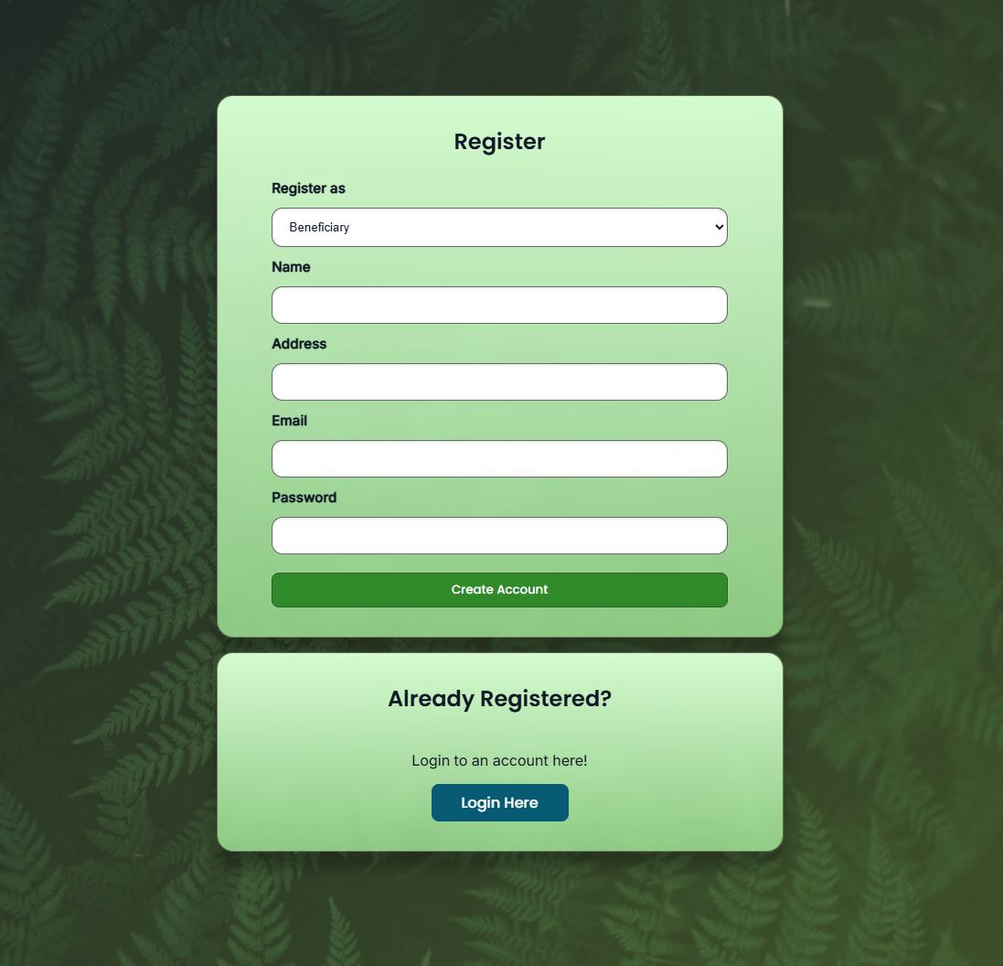

*Registration Form with Account Type Selector*

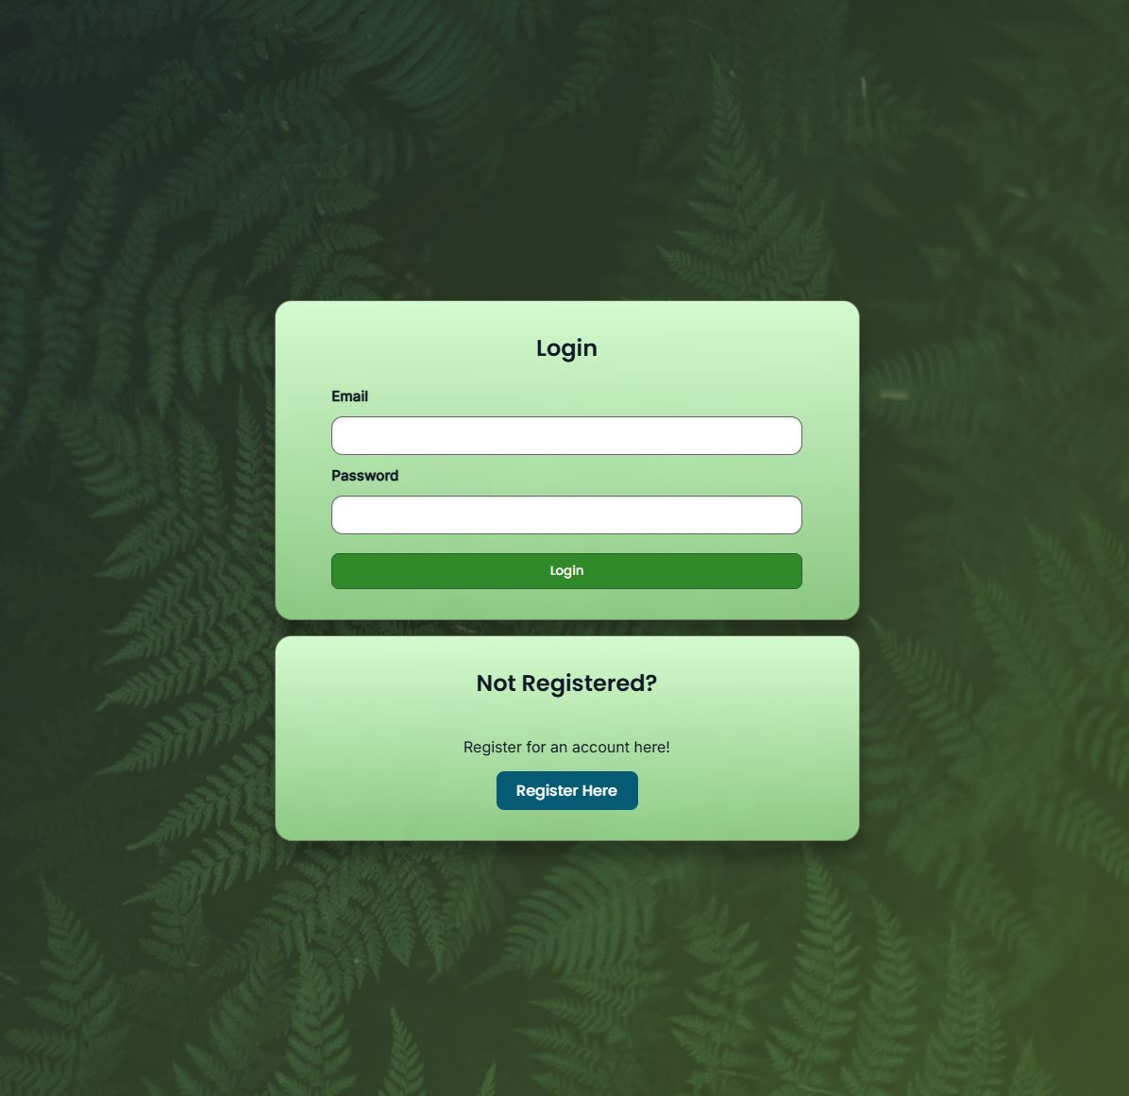

*Login Form with Call to Action*

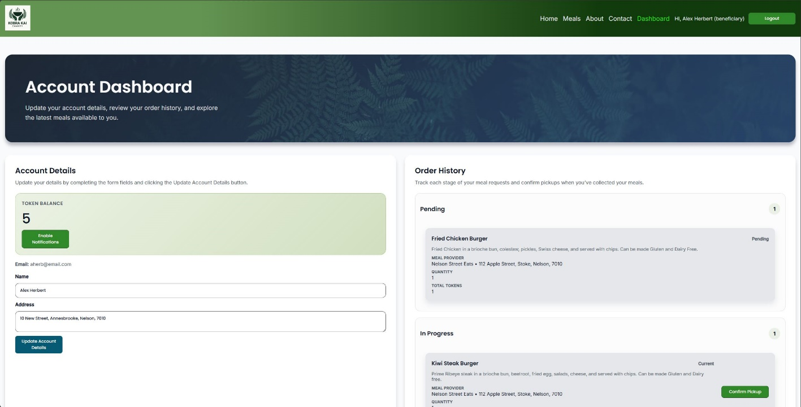

*Beneficiary Dashboard*

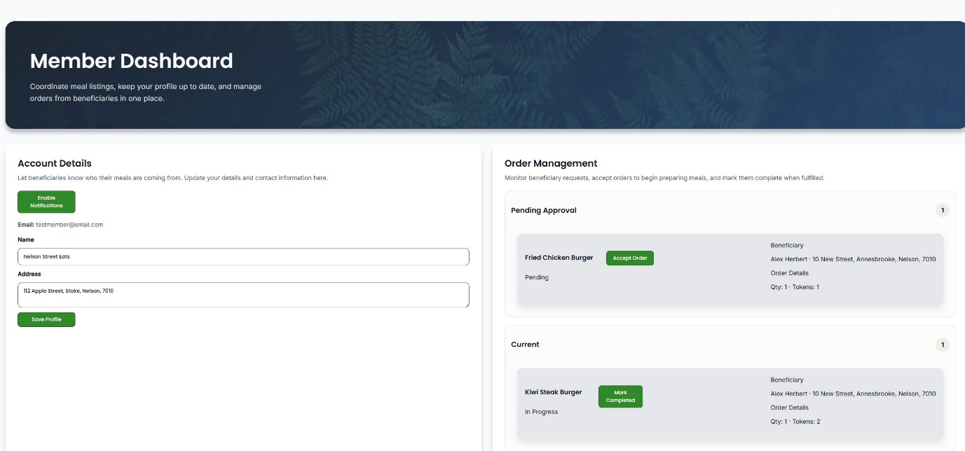

*Member Dashboard*

###### Improvements beyond the prototype

The prototype that was produced during the Evaluation phase of the project contained only basic functionality to showcase the MERN stack’s implementation, these we primarily tested through a basic user interface and Swagger (Swagger. 2025) testing for the API endpoints. The full implementation required the following:

* Refactoring the original API stubs into a production ready authentication and user controllers.
* Implementation of a robust server-side validation and error handling system for registration and login flows.
* Wiring React forms, AuthContext, and protect routes to the API so that authentication state propagates correctly throughout the application.
* Development of additional API endpoints and functions that handle user account updates that reflected immediately on the UI.
* Integrating authentication into the PWA layer so that installed app instances respect the same authentication model as the standard web application.

Overall, the improvements made from the original prototype have made the authentication and user account management system far more robust, with additional validation, password encryption, and additional user account update functionality. These improvements have transformed the prototype to a production-ready web application that could be safely and securely used by the target audience and stakeholders.

###### Critique and Comparison

Using the JWT-based authentication with a React (React. 2025) web application provides a clean separation between the client and the server; this fits well with the charities long-term goals of scaling and possibly integrating with other services. The stateless nature of JWT simplifies the horizontal scaling of the backend systems, as there is no server-side session management or storage to maintain, this is all handled client side via the user’s local storage and web browser on their device.

However, this approach did introduce additional complexity to the client-side application as the React (React. 2025) application must manage token storage, token expiration, and protect against token theft (via XSS for example). An alternative approach would be to use a more traditional server-rendered stack with cookie-based sessions, Laravel and ASP.NET Core with Blazor (Microsoft. 2025) use this approach and were evaluated as potential stacks to be used for this project. These technologies handle session management within the framework and cookies that can be marked HttpOnly for extra security, that approach can simplify the client application authentication logic but adds additional complexity to the server-side logic whilst decoupling the the client and API applications. This is still a solid approach to developing a system like this, but for the initial Kobra Kai website project, this is all handled client side via the React (React. 2025) framework.

In the context of this project and the stakeholders’ requirements, the MERN stack approach is justified, the React framework provides a smoother experience for repeated user interactions, and the JWT-based API matches the design choices made earlier in the IA and CRUD analysis. The trade-off is a slightly steeper implementation curve in exchange for a more flexible and scalable application in the long term.

#### Product/Service Registration and Token Transactions

The Kobra Kai web application models meals as a “Meal” collection in MongoDB (MongoDB. 2025), with documents that include fields such as title, description, dietaryTags, portionsAvailable, deliveryDays, and linked to the provider ID (Member ID). This allows for meal listings to be associated with a charity member who will receive any orders made from the meal listings they have created. A Mongoose schema enforces the required fields and basic constraints so that data transactions are clean and aligned with the expected inputs and payloads.

The backend API routes, handled by Express.js expose endpoints such as:

* POST /api/meals – Create a new meal listing (charity members only).
* GET /api/meals – Retrieve all active meal listings for display on the public “Meals” page.
* GET /api/meals/:id – retrieve details of a single meal listing.
* PUT /api/meals/:id – Update a meal listing (charity member only).
* DELETE /api/meals/:id – Allows users to delete or deactivate a meal listing.

Role-based middleware makes sure that only user with the member role can create and manage meal listings. The React (React. 2025) user dashboard for charity members contains a form to create and edit meals, mapping directly onto the API endpoints. Client-side validation ensures that the required information such as title, description, dietary tags, and token cost are always provided and submitted when creating a meal listing.

Token acquisition for beneficiaries in implemented as part of the user registration system, tokens are automatically assigned to beneficiaries when they register for an account, with the default amount being 10 tokens. Additional tokens can be allocated by administrative users, but this functionality has been left as a placeholder functionality at this stage of the project’s development. Tokens are stored as numeric values in the tokenBalance field in the “Users” collection and surfaced to the user through the dashboard and the Meals page. Once a beneficiary user selects and orders a meal, the token cost is deducted from their account balance, transferred to the Members token balance, whilst simultaneously reducing the number of portions available for the Meal listing and adding the order to both user types of dashboards. This flow of interactions allows the user to easily order meals, view their token balance, and manage their orders via their personal dashboard UI.

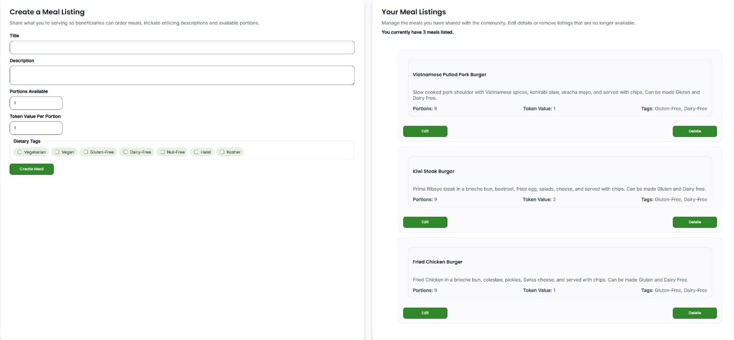

*Member Dashboard Meal Listing Creation Form and List*

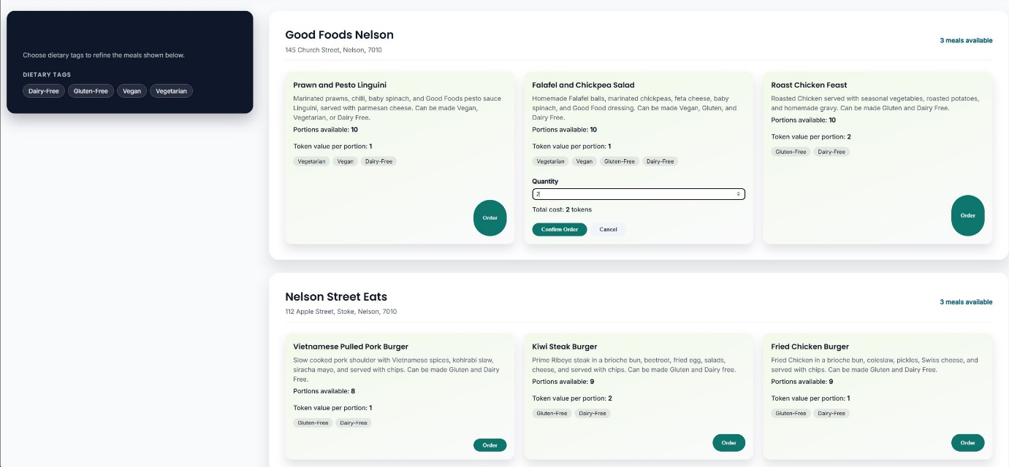

*Meals Page with Ordering and Token Transaction*

###### Improvements beyond the prototype

The prototype that was created in the Evaluation phase of the project modelled users, meals, and tokens conceptually and were verified through CRUD analysis that was translated into the API and tested with Swagger (Swagger. 2025). Converting this into a fully functioning system required the following:

* Implementing full Mongoose (mongoosejs. 2025) schemas for meals with validation rules and indexing for common queries and http requests from the client.
* Building React components to allow members to create, update, and delete meal listings, which are reflected in real-time in the UI.
* Implementing token allocation logic on top of the basic CRUD operations from the prototype, these required safe handling of concurrent requests (e.g preventing token counts becoming negative values).
* Ensuring that the database and client stay in sync when multiple actions occur in quick succession, this was made possible through introducing asynchronous functions that can commit transactions to the database and update the client simultaneously.

Overall, the improvements from the prototype in the final iteration of the Kobra Kai web application were substantial, and provided a more robust and secure meal creation, ordering, and token transaction system. The charity member users can easily create meal listings that are linked to their accounts, as well as being able to edit and modify the listings from the same Dashboard interface. The beneficiary users can view each charity members meal listings individually, as well as filter the meals based on dietary requirements. Both users can track and manage their orders from their respective user dashboards, as well as updating their account details, and viewing their token balance.

###### Critique and Comparison

Storing the users token balance directly in the User document in MongoDB (MongoDB. 2025) keeps the implementation simple and aligns well with the stakeholders’ requirements and business scenario, focusing on CRUD operations for token transactions. However, there are limitations with the current implementation when it comes to auditing and tracking transactions being made by multiple users. The current iteration of this system deducts tokens from beneficiaries when the order meals, and transfers them to the charity members’ token balance, but there is no historical record of these transactions. This would be something that should be implemented in further iterations of the applications development, as traceability and transaction records will be required to maintain healthy business analysis, accounting, and providing a more trustworthy system to the users.

An alternative design for the token transaction system would be to create a TokenTransaction collection in the MongoDB (MongoDB. 2025) database that keeps a record of each transaction that was made with the user IDs attached, with dates, times, transaction amounts, and referenced to the order ID that the transaction was for. This would help keep historical transaction records separate from the User and Order collection records, allowing for more in depth trackability of transactions and keeps the current schema clean and aligned with development best practices. This would also allow for more in-depth business analysis to be conducted, allowing for reporting to be conducted for the charity itself to reveal overviews of the charity operations.

Likewise, a more robust relational database such as PostgreSQL (PostgreSQL. 2025) could be integrated into the current system instead of the non-SQL approach in the current iteration of the application. This would provide a more robust and consistent schema that could be used to enforce stronger token transaction operations. Whilst this would be more ideal in the long-term, this approach does introduce more complexity to the system and would require more development and resources to be allocated to the project.

#### Interactive Elements and User Engagement

The Kobra Kai website utilises several interactive elements to increase user engagement and support the business processes discovered in the IA. The most notable and significant of these are as follows:

* Interactive Meals page – The “Meals” page is implemented as React (React. 2025) component that fetches the meal listings from the database and displays them in sections by the charity member who is providing them. The user can view the details, token cost, and select the amount to order directly from this page, they are also presented with filtering options that allow them to select dietary tags to filter meals by. This filtering happens immediately and is based on the dietary tags that are assigned to the meal listing by the charity member upon creation.
* Role-specific Dashboards – Both beneficiary and charity member dashboards provide functionality and features that are specific to that users’ role and use cases. These dashboards contain forms for account management, meal listing creation, order management sections, and token balance displays.
* Progressive Web App (PWA) Integration – The React (React. 2025) application is enhanced with a web app manifest and service worker, allowing users to install the Kobra Kai site as an app on their device. Key static assets and shell routes are cached, so the core interface remains available when offline, with messaging alerts when certain functionality requires and internet connection.
* Web Push Notifications – High value event notifications such as order placement, order confirmation, and order completion are displayed to the user with web push notifications. This is implemented as an optional feature that can be enabled on the user dashboard, allowing for notifications to be sent to the user when high value actions have been triggered. This is linked to the user account and contains information regarding their web browser version to ensure that the correct notifications are being used and are compatible with the user’s device.

Whilst most of these features and functionality are currently in their most basic iteration, these features add a lot of value to the Kobra Kai website as they align with the user’s needs, as well as providing offline capabilities and interactive push notifications that notify the user when they are not currently on the website itself. This helps to drive engagement and increase ease of use for the target audience, with the intention of maintaining the user base and encouraging new users to want to use the platform.

###### Improvements beyond the prototype

The prototype that was produced during the Evaluation phase did not contain any interactive elements past wireframe designs and planned integrations. Implementation of these features was all completed during the development of the final iteration of the application. The development of these features including the following processes:

* Building the stateful React components for the Meals page and User dashboards that make use of the JWT bearer token to identify the user’s role and ID. This included handling loading states, error handling, and real-time, asynchronous UI updates when changes are made.
* Implementation of the PWA web manifest and service worker, allowing the application to be installed as an app on the user’s device, and enabling the push notifications to be triggered upon high value events (meal ordering, order acceptance, order completion).
* Building role-specific dashboards for different user types, requiring different features and functionality to be accessed based on the user’s role, these dashboards also required account management functionality to allow users to manage their details independently.
* Filtering capabilities on the Meals page required meal listing dietary tags to be accessed client-side as to maintain optimal performance and allow meals to be filtered appropriately and still separated by the meal provider.

Overall, the improvements made from the prototype regarding the interactive elements and user engagement were successful and increased the user experience dramatically from the original prototype. Whilst these features took longer to implement and develop due to no previous work being done in the Evaluation phase, the result is a more fluid, engaging, and intuitive flow of interactions between the user and the React application.

###### Critique and Comparison

The PWA and push notification approach aligns well with the project’s requirements and goals of adding an emerging technology to the system, whilst simultaneously increasing the user experience and engagement. User’s can still receive notifications and information without needing to have the application open on their browser consistently, any high-value alerts are now displayed in the form of a notification on their device, adding additional value to the platform. Building a more advanced user dashboard and meal ordering system using the React framework resulted in a more fluid and user-friendly process, whilst maintaining the structure of the charities operations and without adding layers of complexity to the current system.

However, the PWA and web push notification system did introduce more complexity to the development of the platform as both technologies require a “production” environment to be properly implemented and tested. This did cause issues with the integration of this system as the application is still being hosted and tested in a development environment, meaning that proper testing of those two features was limited and required the build to be ran in a mock production preview environment to get it to work correctly without errors. There is also the risk of notification fatigue if the system is notifying the user to frequently, resulting in them either being ignored or turned off entirely, only end user testing will reveal this feature’s true usability and usefulness long term.

Additionally, some of the functionality and design of the current implementation could be improved to be more suited to mobile devices, and more refined overall to increase the user engagement and experience. The current implementation of the platform includes basic user registration, login, meal order, and account management functionality, which works well for the initial release, but additional user information should be included in the next iteration. These being user client numbers, phone numbers, address fields broken down into a more normalized format, and other user related data that would be useful to the charity. Also, More advanced account management setting could be implemented to allow users to tailor their experience and remove unwanted features such as push notifications, or to allow email confirmations to be sent upon ordering meals, and so on.

Compared to other native app solutions or hybrid app development platforms, the chosen solution is more economical and required less resources in terms of labour and infrastructure to set up. The current iteration is all contained within one React (react. 2025) application and can be maintained and scaled up from one project. The only trade off is that hardware specific capabilities are limited to what the browser exposes, but for the Kobra Kai use case and stakeholder requirements, most of the functionality is focused on ordering and delivering meals, requiring much less in terms of hardware specific functionality and features.

#### Data Storage and Retrieval via Server-Side API and Database

All dynamic data in the Kobra Kai website platform is stored in MongoDB and accessed via the RESTful API implanted using Express.js (npmjs. 2025), The main collections include:

* Users – Beneficiaries and Charity Members data, including token balance.
* Meals – Meal listings provided by members.
* Orders – Order placed by beneficiaries for specific meals.
* PushSubscriptions – Push notification subscriptions and device details are stored here.

Each entity is defined using a Mongoose schema that enforces required fields, data types, and relationships, for example the order documents reference the beneficiary and charity member IDs. This allows for a clean referencing and indexing of different users, meals, and orders so they can be displayed in the UI correctly and with minimal querying logic to the database to be implemented. The Express API is organised into route modules to allow the API endpoints to be accessed by the client application, Controllers contain the CRUD logic that was established during the Evaluation and Analysis phases of the project. Some the core API endpoints that are exposed are as follows:

* POST /api/users – Creates user accounts (registration)
* GET /api/users/:id or /api/users/me – Retrieves specific user account data.
* PUT /api/users/:id – Updates user account details.
* DELETE /api/users/:id – Deletes the user account.
* GET /api/orders/:id – Retrieves specific order details.
* GET /api/meals – Retrieves all meal listings in the collection.

On the frontend, React components use utility modules such as api.js, db.js, and so on as a layer of abstraction to access the database and API endpoints, these ensure that the JSON payloads that are returned are handle correctly by the client. When data is retrieved from the API and database layer, it is stored locally so it can be accessed by the UI components to populate forms, tables, and other UI components that require dynamic data to be access from the database.

###### Improvements beyond the prototype

The core focus when producing the prototype for the MERN stack was to have basic CRUD operations and data storage capabilities to show case the functionality. The final iteration of the database and API needed to have a more comprehensive schema and controller logic to facilitate the more advanced frontend UI features and allow for push notification subscriptions to be enabled and stored. The following are the improvements that were made to this part of the system:

* Full CRDU functionality implement using the CRUD table that was established during the Evaluation phase. API controllers and database schema are fully aligned with the expected CRUD functionalities.
* Error handling was improved with more robust validation logic for user credentials and authentication purposes.
* The database/Mongoose schemas were modified to incorporate a more readable and easier to develop naming convention that made sense and detailed their purpose within the models.

###### Critique and Comparison

Integrating a MongoDB (MongoDB. 2025) database with Mongoose (mongoosejs. 2025) and an Express.js (npmjs. 2025) RESTful API is a perfect fit for the MERN stack and keeps the project coherent, the document model works well for most fo the data structure and data storage needs of the platform. Each request body in the form of a JSON object translates directly the MongoDB (MongoDb. 2025) schema allowing for minimal data conversions to be implemented and can be directly sent or received from the database.

However, a RESTful API and MongoDB (MongoDB. 2025) are not the only solution for a project like the Kobra Kai website, alternative approaches evaluated earlier in the projects’ lifecycle indicate that a strong relational database such as PostgreSQL (PostgreSQL. 2025) could also be used. Using a relational database would be beneficial as it would allow for in depth business analysis tools to be implemented into the system, allowing the Charity staff to conduct reporting and analytics for the charities operations. Relational databases tend to be more aligned with this advanced reporting and analysis as they are more normalized, contain strict table and row insert rules, and can be queried to extract more in-depth information that a non-SQL database like MongoDB.

Given the scope of the project and the stakeholders’ requirements, the MongoDB (MongoDB. 2025) solution was the best fit for the initial production release of the platform and aligns well with the scale of business operations to begin with. The MERN stack approach was more than adequate for the stakeholders’ requirements and resulted in an optimized, user-friendly, and useful web platform that fulfils the needs of both the users and the stakeholders.

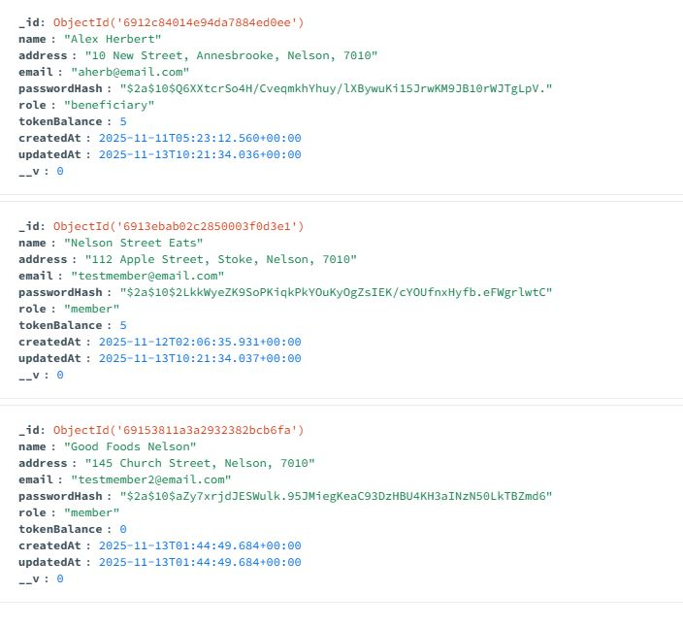

*User Collection MongoDB*

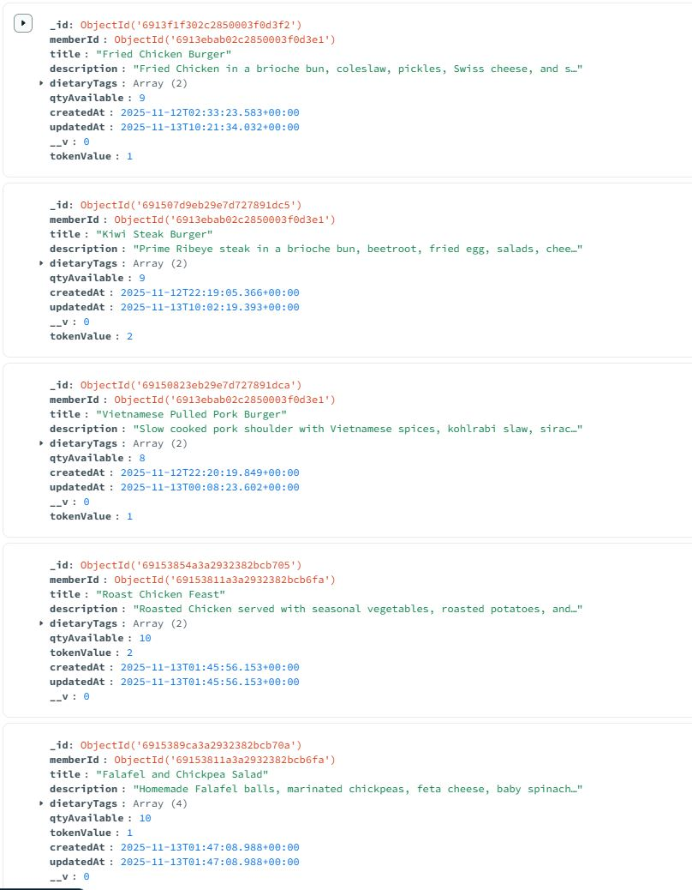

*Meals Collection MongoDB*

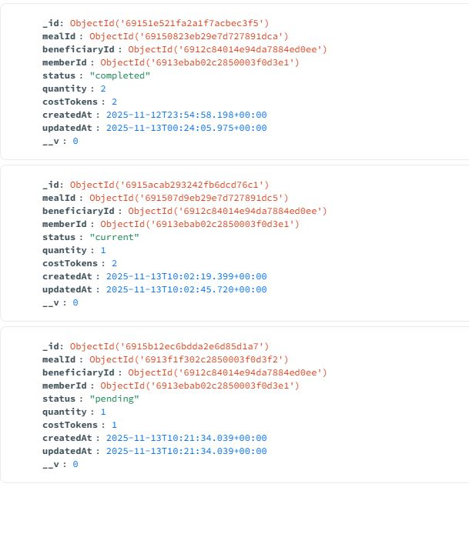

*Orders Collection MongoDB*

#### Functional Implementation Summary

In summary, the implementation and development of the Kobra Kai website satisfies the core functional requirements specified by the stakeholder and user analysis conducted in the early phases of the project. The MERN stack was selected be used to build the web application, combined with PWA and web push notifications that further enhance the website’s value to the end user and stakeholders. The result of the implementation was a full stack web application that allows users to:

* Register as a beneficiary or a charity member.
* Charity members can create meal listings and manage their orders and listings via the dashboard.
* Beneficiaries can view, filter, and order meals as well as manage their accounts and orders via the dashboard.
* Interactive elements such as dashboards, filters, and notifications support and enhance the user experience.
* Token transactions are embedded into the ordering system, allowing the transfer of tokens from beneficiaries to charity members.
* All dynamic data is stored in the MongoDB database and retrieved using the Express.js API server.

The comparisons with alternative approaches highlight where the current implementation is well suited and further justifies the framework and emerging technology selection from the Evaluation phase. The MERN stack proved to be a solid and reliable stack solution for the Kobra Kai website project, due to its versatile, component-based structure and alignment with RESTful API’s and non-SQL databases.

#### Emerging Technology Research and Implementation

Emerging web technologies are new or rapidly evolving tools, standards, or techniques that change how users interact with web applications or software, as well as how developers build them. They often extend the traditional request-response model of web technology by adding capabilities that were previously limited to native mobile or desktop applications, for example offline access, real-time communication, richer graphics, artificial intelligence integration, or hardware integration. Examples of these technologies include WebAssembly (WebAssembly. 2025) for near-native performance in a browser, WebAuthn and passkeys (Passkeys.com. 2025) for passwordless login/authentication, and Progressive Web Apps (PWA) combined with push notifications for native app-like experiences.

For the Kobra Kai project, the chosen emerging technology is the combination of Progressive Web Apps (PWAs) and Web Push notifications. PWAs are web applications built with standard web technologies that can be installed on devices, run offline, and feel like native mobile apps. They rely on a set of modern browser APIs, including:

* Web App Manifest – JSON file that describes the applications name, icons, theme colour, and how it should appear when “installed” on a device.
* Service Worker API – a background script that can intercept network requests, cache assets, and respond to events even when the site is not open in a browser tab.
* Cache and Fetch API – Used inside the service worker to manage offline resources and customize how network requests are handled.

Web Push Notifications build on top of PWA’s and add the ability for the server to deliver messages to the user even when the web app is not currently open, this feature relies on:

* Notifications API – Allows the browser (via the service worker) to display system-level notifications.
* Push API – Lets the service worker subscribe to and receive push messages from a push service (NPMJS. 2025).
* Web Push protocol – Server-side library that send encrypted push messages to the browser using VAPID Keys.

Together these APIs and code libraries provide a bridge between the Kobra Kai MERN stack and browser’s more advanced capabilities. React and the existing REST API remain responsible for core business logic and CRUD operations, while the PWA and push notifications add offline resilience, asynchronous communication, and instability.

#### Rationale for PWA and Push Notification

Progressive Web Apps have been in development/conception since 2015, with the idea being to integrate native/mobile application functionality into web applications that are accessible through a web browser. Whilst PWA’s were first proposed several years ago, they can still be considered and emerging technology as the widespread adoption of the technology has only recently become viable due to support being implemented across all major web browsers and mobile platforms. The following quote from Julian Neagu from his article on Medium explains the key statistics for PWA’s and explains how there are only 54,000 websites currently using the technology, which in comparison with how many websites exist in today’s digital landscape, only a small percentage have adopted and implemented PWA’s.

*“Key Statistics*

1. *The PWA market is set to reach $10.44 billion by 2027.*
2. *The travel industry sees a 3x increase in conversions with PWAs.*
3. *Only 54K websites currently use PWAs.*
4. *PWAs boost conversions by up to 50%.*
5. *PWAs load in under 2 seconds, reducing bounce rates.*
6. *PWAs improve user retention by up to 180%.*
7. *Developing a PWA is 3–8 times cheaper than a native app.*
8. *PWAs cater to over 6.3 billion smartphone users globally.*
9. *PWAs offer offline access and push notifications for an enhanced user experience.*
10. *PWAs have 60% fewer security vulnerabilities than native apps.*

*Data from BuiltWith reveals that as of October 2023, more than 54,097 customer websites are using PWAs.*

*Considering the vast number of websites available globally, PWAs still have immense potential for further adoption.*

*Various sectors, such as e-commerce, media, and travel, have recognized the effectiveness of PWAs in engaging users and boosting conversions.*

*It’s important to note that the current count of 54k PWAs is relatively low when compared to the 200 million active websites as of June 2023.”*

(Julian Neagu. (November 2023). Medium.)

#### PWA and Push Notification Implementation

The implementation of the PWA and push notification technology happened in iterative stages throughout the development of the core web application. The following details the steps that were taken to implement this technology and the difficulties and challenges that arose during that process.

###### Initialisation and Placeholder Implementation

The first stage of implementation was to install the correct npm packages that would be used by the PWA and push notification system to access the browsers more advanced capabilities. These packages include:

* Vite-pwa-plugin – Code library that uses the Vite React scaffolding to enable the PWA functionality.
* Web-push – Allows access to the wep push API, allowing the service worker to display system level messages using the web browser.

Additionally, the PWA relies on a web manifest file that configures the ‘installable’ web application, this file contains all the meta data such as name, description, theme colour, icons in multiple sizes. This manifest was set up early into development to make sure it was set up prior to continuing work on the rest of the application, this was to ensure that if there were any PWA related code that need to be implemented, it would not interfere with development at a later stage. Also, a service worker script was implemented and registered by the React application on startup. The service worker script is responsible for Caching core application shell assets, handling network requests for those assets, and listening for push event triggers from other functionality in the codebase.

###### Push Notification Subscription Storage

In addition to the placeholder PWA and push notification service workers and configuration, the database also needed to have a Mongoose (mongoosejs. 2025) model that allowed users to subscribe to the push notifications. This model includes the user ID, time of subscription, subscription expire date, and the device meta data, additionally, a push controller and push route file was also added to the Express API to allow for connectivity between the client and the database. Together these additions formed the initial backbone and structure of the PWA and push notification systems that would be then used later in development to enable to system and test the functionality.

###### Development and Testing

The development and testing of the PWA system came later into the implementation of the website platform, the core components and functionality were integrated first, once that had been completed work started on the PWA and push notification implementation. The first point was to create a EnablePushNotification component that would be linked to a button on the user dashboard, this would allow the users to select if they wanted to enable to feature but also allowed the developer to test that the service worker was being initialised and registered correctly. This process took a large amount of time and bug fixing to complete as PWA and push notifications require a “production” environment to work correctly. This was an oversight of the developer during the initial research into the technology and resulted in extensive bug fixing and validation to be added to the code base to try and isolate the issue. One problem was that the service worker was not being registered correctly. This was a result of the web-push API and vite pwa plugin not being connected via an HTTPS connection, which is required for it to work correctly. Once this was resolved the service worker could be registered and testing and development could continue.

The next job was to ensure that the push notification subscription was correctly committed to the database for each type of user, which due to the extensive validation and bug fixing that took place early in the process, worked quickly without issues. Once this had been implemented correctly the developer then continued to add push notification trigger events to the existing code base for ordering. This required the order controller functions to trigger a push notification to the user that had either ordered the meal or created the meal listing. This process was relatively error free with some minor validation issues but for the most part the code worked and didn’t interfere with the core functionality. 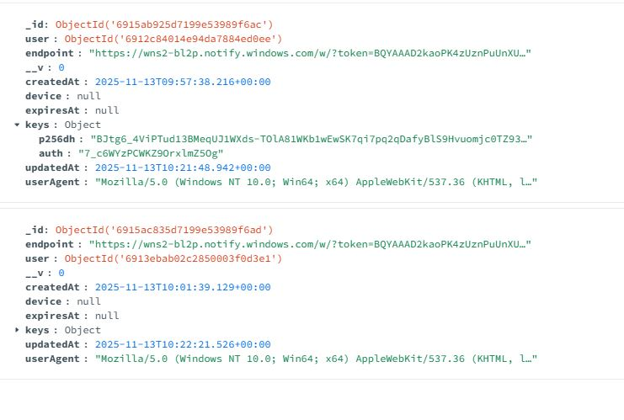

*PushNotification Collection MongoDB*

###### Testing and Potential Issues

The main issue with testing this functionality was that testing the push notifications and instability of the web application using PWA was that the website would need to be hosted in a production environment for it to work. Testing multiple users at once using the same machine conflicted with the JWT authentication system and would not allow for multiple users to be logged in at once using the same machine. At this stage in the development the push notification system is in place and produces no errors but without deploying the application to a live environment, no further testing could be completed. The same is true for the PWA functionality, the build can compile without error when running with npm run build and npm host -- --preview, but without a mobile device that can host the application in a local host environment, I could not test this part of the functionality fully. Unfortunately, the assumption at this stage is that the system does work and does not produce any unexpected errors or issues with the core functionality of the application, but without a live testing environment, no further testing can be conducted on this part of the system.

## Citations and References

Foodbank NZ. (2025). Foodbank NZ Website.

<https://www.foodbank.co.nz>

Bellyful. (2025). Bellyful Website.

<https://bellyful.org.nz>

Unsplash. (2025). Wireframe Images.

<https://unsplash.com>

MongoDB. (2025). MongoDB Community Server.

<https://www.mongodb.com/try/download/community>

Postman. (2025). Postman API Testing.

<https://www.postman.com>

ChatGPT. (2025). Kobra Kai Logo Creation Transcript.

<https://chatgpt.com/share/6895209f-6c7c-800d-8fd4-9c9ff1d99bf4>

MDN web docs. (2025). Server-side web frameworks.

<https://developer.mozilla.org/en-US/docs/Learn_web_development/Extensions/Server-side/First_steps/Web_frameworks?utm_source=chatgpt.com>

Shann Nicol. (16 December 2024). Web Development Frameworks: An Overview.

<https://www.chillybin.co/web-development-frameworks/?utm_source=chatgpt.com>

Microsoft. (06.25.2025). Overview of Progressive Web Apps (PWAs).

<https://learn.microsoft.com/en-us/microsoft-edge/progressive-web-apps>

Passkeys.com. (2025). What is Passwordless Authentication?

<https://www.passkeys.com/what-is-webauthn#:~:text=A%20passkey%20is%20a%20digital,websites%20for%20passkey-based%20authentication>.

Julian Neagu. Medium. (November 2023). Progressive Web App (PWA) Statistics 2024.

<https://medium.com/%40julianneagu/progressive-web-app-pwa-statistics-2023-46950788b513>

WebAssembly. (2025). WebAssembly Documentation.

<https://webassembly.org>

NPMJS. (2025). Web-push npm package documentation.

<https://www.npmjs.com/package/web-push>

MDN Webdocs. (2025). Push API documentation.

<https://developer.mozilla.org/en-US/docs/Web/API/Push_API>

Mongoosejs. (2025). Getting started – Mongoose documentation.

<https://mongoosejs.com/docs>